1. PURPOSE OF REPORT

The purpose of the report is to:
- Provide Members with a further case study on attracting external funding;

- Provide Members with a reminder of the Council’s medium term financial strategy and associated guiding principles;

- Provide members with an update on the draft outturn figures for 2012/13, in relation to;

- General Fund
- Housing Revenue Account
- Capital
- Treasury Management

- Illustrate the latest budget model, the delivery of efficiency savings for 2013/14 and the estimated level of budget savings that may be required over the next few years;

- Provide Members with an update on the Council’s Empty Homes Strategy;

- Provide an update following the recent 2015/16 Spending Review announcement.

2. CASE STUDY

  - Members will recall that in previous budget reports we have identified case studies as examples of good practice. The previous examples related to the new arrangements for the following:

- Generic warden service
- Recycling pilots
- Kettering Borough Trainers
- Partnership work with the Citizens Advice Bureau.
- VAT recovery
- Prevent Strategy funding
- Flexible Working
- Printing Function
- Market
- Managing homelessness
- Staff Sessions
- Attracting External Funding to the Borough

  - The case study in this report highlights another example of the success the Council has achieved through attracting external funding.

Case Study – Empty Properties set to become Affordable Homes

The Council’s Empty Homes Strategy that was approved in January 2013 by the Executive identified a need to maximise opportunities to increase funding for tackling empty homes.

The Council as part of the Empty Homes Strategy in April 2013 submitted a bid to HCA for £206,000 to bring empty properties into use as affordable homes. The Council’s bid was successful and was made up of two parts, the first part of the bid was for £152,000 for the purchase and repair of eight empty homes and the second part of the bid was for £54,000 to lease and repair six homes.

This will enable the Council to bring 14 properties back into use which will reduce housing need, homelessness and help to improve the appearance of residential streets.

In addition these properties will also attract New Homes Bonus.

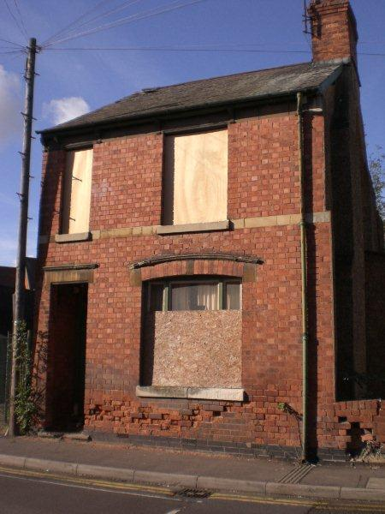
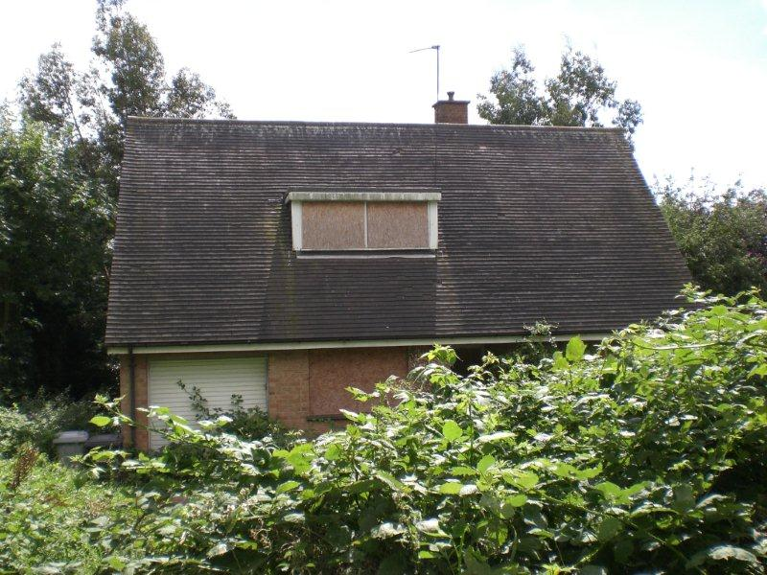

3. BACKGROUND

  - At the March Executive meeting Members approved that the budget delivery framework used in the three previous budget rounds be used for the preparation of the 2014/15 budgets. Specifically, members approved;

“that the same methodology be applied to the formulation of the 2014/15 budget as it applied to the 2013/14 budget, with particular reliance on:-

- the existing guiding principles

- the existing modelling for recovery principles

- the existing budget containment strategy

- the existing eight workstreams”

  - The strategy has to date proved extremely successful and helped provide additional flexibilities from which to address the national funding challenges that face all local authorities.

  - This overall strategy provides the cornerstone on which the Council's long-standing success in both setting a ‘balanced budget’ and delivering within budget are founded. The framework consists of eight workstreams – as illustrated below;


Capital
Review
Service Plans
Fees and
Charges
Review
Prioritisation
Innovation
Group
Staff
Suggestions
Partnership
Working
Lobbying
Budget
Delivery
Framework

  - The financial strategies key ‘guiding principles’ supplemented by the ‘Modelling for Recovery Principles’ and the ‘Budget Containment strategies’ have provided a strong cornerstone for the Council’s medium term financial strategy. For ease of reference, these are reproduced here:-

Financial Strategy Guiding principles:

- Revenue balances should not fall below £1m and overall revenue reserves should not fall below 10% of net revenue expenditure;

- In setting the Council Tax, members should consider the medium term to ensure that a sustainable budgetary position is preserved (with due regard being given to any penalties that might apply);

- The level of household Council Tax to increase each year in line with inflation at least, where the budget is in deficit, to ensure resources remain consistent with budgeted costs;

- When setting the Capital Programme, consideration is given to allocating capital resources to schemes that are beneficial to the Council’s overall revenue budget position;

- To maximise the resources available to the Authority, the Council will actively lobby the Government on relevant issues (e.g. grant distribution/ planning fees).

Modelling for Recovery principles:

- Wherever possible, continue with all planned investments and programmes, to protect the local economy and lever in other investments;

- Given the strength of our Treasury position we should consider debt funding as a means of programme delivery or stimulus – if this can be shown to be sustainable and have a wider economic benefit;

- Organise our fiscal structures and business models to attract and retain the maximum amount of revenue within the local economy;

- To ensure all possible avenues are used within procurement rules to source locally;

- Protect the performance of Council services which come under particular strain;

- Work closely with partners in the voluntary, public and private sectors, to ensure optimum efficiency

Budget Containment Strategy:

- Where a specific grant which funds a specific service is withdrawn, the service stops;

- Where grant funding reduces, which Kettering Borough Council passports through to another organisation, the reduced sum continues to be passported, providing the end recipient organisation feels it can still provide a value-added service at that funding point.
- Where a function is transferred to another provider, the Council leaves all service-provision discussions, including any top-up funding, with the new provider;

- The Council would ordinarily neither seek to buffer nor profit from tax changes.

- The Council should not substitute itself as a provider / funder of services when another public provider cuts such a service.

4 OUTTURN 2012/13

  - This section provides members with a summary of the outturn figures for last financial year (2012/13).

  - The analysis covers the Council’s three main accounts (plus an update on Treasury Management) and is split as follows;

- General Fund
- Housing Revenue Account
- Capital Programme
- Treasury Management

  - The closedown process for the 2012/13 accounts is now complete subject to external audit validation, which will take place between July and September 2013. Once audited the accounts will be formally reported to members in accordance with the statutory requirements.
General Fund Revenue Account
  - Members are reminded that the General Fund account is the account that contains the majority of the Council's everyday service expenditure (excluding spending on council housing).



General Fund Account
Covers: Day to day expenditure and income on services other than Council Housing
Funding sources: Fees & Charges /
Govt Grant / Council Tax

Budget: £51.3m

  - When the Council considered the budget for the 2012/13, the budget delivery framework needed to identify £1.330m of additional efficiency measures to set a balanced budget for the year. This was primarily to deal with the impact of reduced central government ‘core’ grant. Table 1 is an extract from earlier budget reports that shows how the budget ‘gap’ was closed;
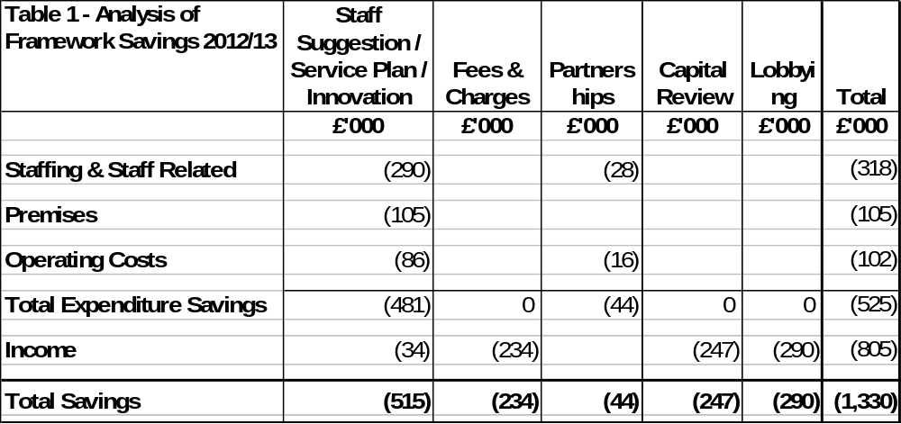

  - In addition to achieving the original challenging efficiency savings target, it was reported in the March Executive report that further savings in the region of £750,000 were estimated in excess of the figures approved at revised budget time. The actual further favourable variance is £902,000 for the reasons outlined below:

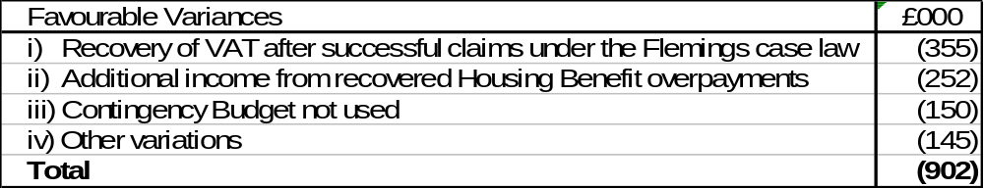
  - The additional sums recovered under Flemings case law have not formed part of any in year projected variances for General Fund as any monies recovered are allocated to the Welfare Reform and Taxation Reserve.

  - The final outturn figures are now subject to validation by external audit. The savings are a combination of some early ‘locking in’ of the savings that are required for 2013/14 and one off items.

  - The early delivery of savings / one-off items has resulted in the Council being in a better position from which to move forward. The key issue for members to be aware of is the implications that this has for the Councils medium term financial strategy and budget projections. In summary, the early delivery of savings has meant that the Council has made a very good start whilst at the same time benefitting from some additional one-off resources that can be put aside to help provide some earmarked resources to assist in actually delivering future ongoing budget reductions. At the same time, in accordance with established council policy, some of the one-off items have been earmarked to help protect the Council against specific business risks / threats.

  - In line with the previously agreed policy position of the Executive Committee, any variance in excess of the original £1.3m target will be used to increase earmarked reserves to help provide additional flexibility and protection against business risks / threats.

  - Overall, the outturn for the General Fund is very encouraging for the following reasons;

- Early implementation of identified savings;
- The budget delivery framework has successfully engaged staff at all levels;
- The early delivery of the savings required for 2013/14 allows attention to be turned to savings for future years;
- Additional flexibility and resources have been secured to help pump prime delivery of future years’ savings and protect against possible future burdens.
  - After taking account of contributions to reserves and balances the Council’s General Fund working balance remained at £1.415m – this is still in line with the Council’s Medium Term Financial Strategy ‘guiding principles’.

  - The savings made give confidence that the Council remains “ahead of the curve” in delivering the Medium Term Financial Strategy and whilst the Council’s delivery of efficiencies and savings is to be commended, the challenges that are faced as we enter each zone of unpredictability (ie, in 2013 and 2015) remain both significant and unprecedented.

Housing Revenue Account

  - Members are reminded that the Housing Revenue Account is a ring-fenced account for day to day income and expenditure relating to the Council's role as a Housing Landlord.

Housing Revenue

Account

Covers: Day to day expenditure and income relating to being a Council Housing landlord

Budget: £14.4m

Funding sources: Council House
Rents

  - The Housing Revenue Account’s budget for 2012/13 was £14.4m. The provisional outturn for 2012/13 was reported to the June meeting as being £100,000 higher than the budget. The actual spend for 2012/13 was £103,000 higher than the budget as previously reported this was largely due to an increase in voids.

  - A total of £103,000 has been used from the Housing Revenue Account balance which is now £558,000. This is still in line with the Council’s Medium Term Financial Strategy which states the account must operate in a surplus position and this is achieved by adopting the principle that an agreed minimum balance of £300,000 should be the primary strategic aim over the medium to long term.

Capital Programme

  - Members are reminded that the Capital Programme is used for the acquisition, improvement and enhancement of the Council’s assets.

Capital Programme
Covers: Expenditure on acquiring, maintaining, enhancing assets
Budget: £6.9m
Funding sources: Govt Grant / borrowing / capital receipts / external contributions

  - Overall, the expenditure during 2012/13 was £4.175m compared to the revised budget of £6.908m (i.e.60% of the approved programme was actually spent).

  - The overall Capital Programme spend will be within 97% of the net budget after taking account of budget carry forwards to 2013/14.

  - The major variations are outlined in Table 2. Appendix A sets out capital budgets to be carried forward to 2013/14, which requires the approval of the Executive.

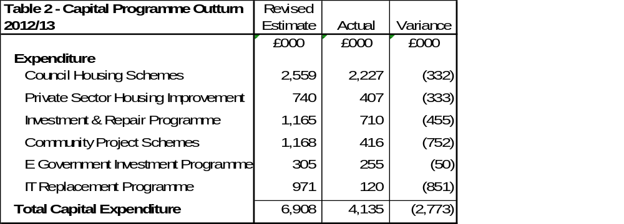
Treasury Management – Current Position

  - The Council’s debt and investment position at the beginning and the end of the year is set at in Table 3:

Table 3 | 31st March 2013 | 31st March 2012

 | Principal | Rate/ Return | Principal | Rate/ Return
Total Investments | £2.411m | 0.74% | £4.075m | 0.78%
Total Debt | £71.933m | 2.55% | £79.903m | 2.38%

 | Rate of Return
Council Portfolio | 0. 74%
Benchmark – 3 Month LIBID | 0.73%

  - The Council’s temporary borrowing for both years represents temporary borrowing for cash flow smoothing, (in line with the Council’s Treasury Management Strategy).

  - As previously reported the Council has for a number of years effectively used its cash reserves to finance General Fund borrowing instead of borrowing money externally. Reserves are therefore not cash-backed and the Council would need to borrow if it wanted to use a significant proportion of its reserves. This strategy is prudent in the current economic climate where investment returns are low and counterparty risk is high.

Compliance with Treasury Limits and Prudential Indicators

  - During the financial year the Council operated within its treasury limits and Prudential Indicators set out in the Council’s Treasury Policy Statement and Annual Treasury Strategy Statement. The outturn for the Prudential Indicators is shown in Appendix B.

5 MEDIUM TERM FINANCIAL FORECAST
5.1 The Council’s latest Medium Term Financial Forecast is shown in Table 4. The forecast has been updated to reflect the fact that we have effectively ‘closed’ the 2012/13 financial year, therefore the forecast comprises the following ‘Zones’.

- Zone of Predictability (2013/14 and 2014/15) – The provisional level of government funding has previously been announced for 2014/15, however there continues to be two significant areas of volatility being the Business Rates Retention Scheme and Council Tax Support which we will continue to monitor closely.

- Zone of Unpredictability A (2015/16) – The headline reductions in Departmental control totals were announced by the Chancellor on 26 June 2013 and further announcements regarding individual allocations are expected later this year.

- Zone of Unpredictability B (2016/17 – 2018/19) – Spending reviews over the next few years will provide the level of funding available for this period.

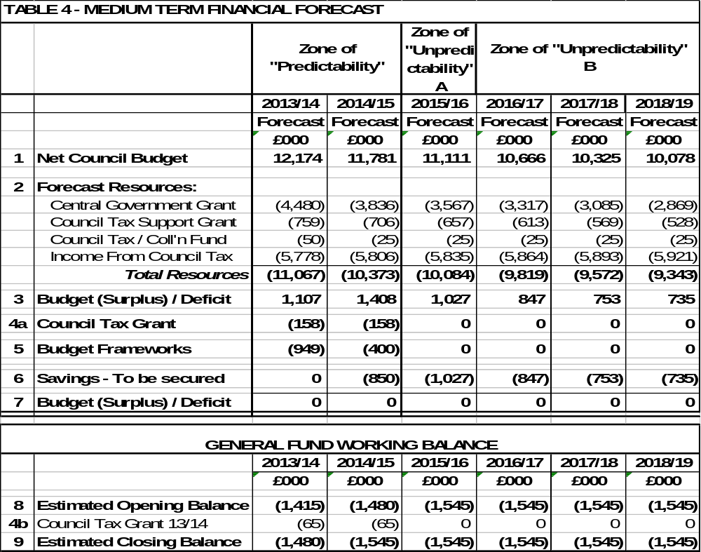

Notes to Medium Term Financial Forecast

1 Net Council Budget – This represents the net expenditure prior to the Budget Framework savings.

2 Forecast Resources – These are the Council's main funding streams (excluding fees and charges which are incorporated into Line 1). This illustrates the significant reduction in Central Government Grant and introduces a new line from 2013/14 for the Council Tax Support grant. Following future government announcements the presentation of this will be reviewed but it is thought likely that overall the figures we are modelling on, may be in the right area but the split between years may be different. To enable the total resources required to balance the budget to be identified, no assumptions have been made regarding future council tax increases. The small increase in revenue each year reflects anticipated housing growth in the borough.

3 Budget (Surplus) / Deficit – This illustrates the gap between the budget and the total resources available before identifying budget framework savings.

4a Council Tax Grant – This is a grant the Council receives from central government for four years in return for freezing Council Tax in 2011/12. This is equivalent to the cash that would have been received if a 2.5% increase had been levied.

4b Council Tax Grant 2013/14 – This is a grant the Council receives from central government for two years in return for freezing Council Tax in 2013/14. This is equivalent to the cash that would have been received if a 1% increase had been levied. A Council Tax Freeze has ongoing implications as an increase in Council Tax generates income year on year.

5 Budget Frameworks – This identifies the total savings required and differs to the table shown in 4.5 as a result of the Council decision earlier in the year in relation to members allowances.

6 Savings to be secured – This identifies the total resources required to balance the budget in future years after 2013/14.

GENERAL FUND – 2013/14

  - From the recent budget process, Members will recall that additional ongoing savings of £949,000 were required for 2013/14. These were identified as detailed in Table 5;
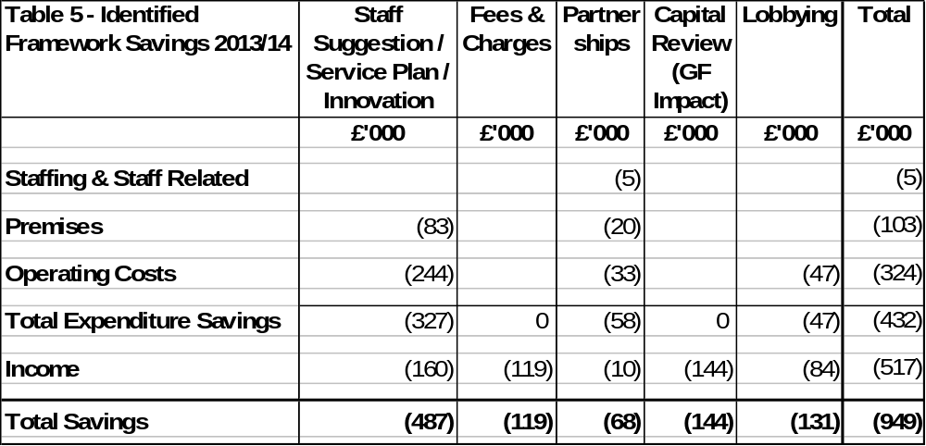
  - The early delivery of framework savings and the additional one-off items has resulted in the Council being in a better position from which to move forward. Of the £949,000 required savings for 2013/14, approximately £350,000 has already been delivered ‘early’ whereas the remainder have been specifically identified and are being delivered as planned. This is very encouraging and has justified the faith that members have shown in the Council's unique budget delivery framework to deliver the savings required.

  - Whilst the savings made give confidence that the Council remains “ahead of the curve” in delivering the Medium Term Financial Strategy. Members have previously been advised about the significant changes to local government funding and the risk transfer from central government to local government. Such risks include:

- Business Rates Volatility
- Council Tax Benefits Volatility

  - During the budget process, members were informed of a number of ‘big ticket’ items. These are typically items of large value that could have a disproportionate impact on the Council's budget if they moved in an adverse fashion. Consequently these are monitored very closely and members and officers may occasionally try to influence (through lobbying) any changes that may take place especially when such changes are triggered through changes in national policy. These items are included in the Councils Swing – o – meter as detailed at Appendix C.

  - As well as monitoring framework savings identified for 2013/14 work continues on identifying savings for the following year – 2014/15. Members are reminded of the current Medium Term Financial Forecast which required an additional £1,250,000 of savings to balance the budget in 2013/14 this is prior to the consideration of Council Tax. Table 6 shows framework savings of £400,000 have already been found for 2014/15:

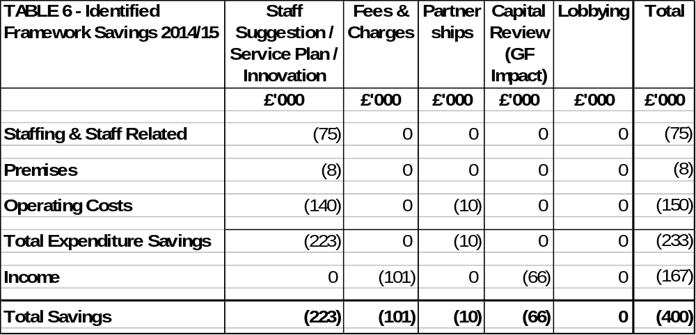
  - It is particularly encouraging that by July 2013 we have identified about a third of the savings needed for 2014/15.

  - The Council’s impressive record in identifying and delivering efficiency savings in the past four years, including the current year (2013/14), are around £5.4m - as illustrated in Table 7;

Table 7 – Efficiency Savings | £000
2010/11 | 1,260
2011/12 | 1,910
2012/13 | 1,330
Total | 4,500
2013/14 | 950
Total  % Cash Savings (Net Budget) | 5,450  50%

  - The scale and delivery of this level of efficiency savings is particularly impressive given that there has been no detrimental impact on the delivery of front line services and when considering the increased costs of utilities and inflation levels. Over the four year period (as detailed in Table 6) the efficiency savings will be equivalent to approximately 50% (65% in real terms) of the Council’s draft net budget (which stands at £11m for 2013/14).

  - Members are reminded that before the efficiency programme commenced a number of years ago, the Council was charging a level of Council tax below the national average yet delivering a level of performance that was above the national average. Despite having to deliver efficiency savings of £5.450m in the past four years, the Council’s level of council tax charged remains below the national average and performance remains above average.

  - Members will recall the following illustration that summarises the Council’s overall position as being a ‘high performing / low cost’ local authority.

HOUSING REVENUE ACCOUNT 2013/14 – CURRENT FINANCIAL YEAR
  - A summary of HRA monitoring at 30th June is shown in Table 8. The Housing Revenue Account is currently projected to come in on budget.
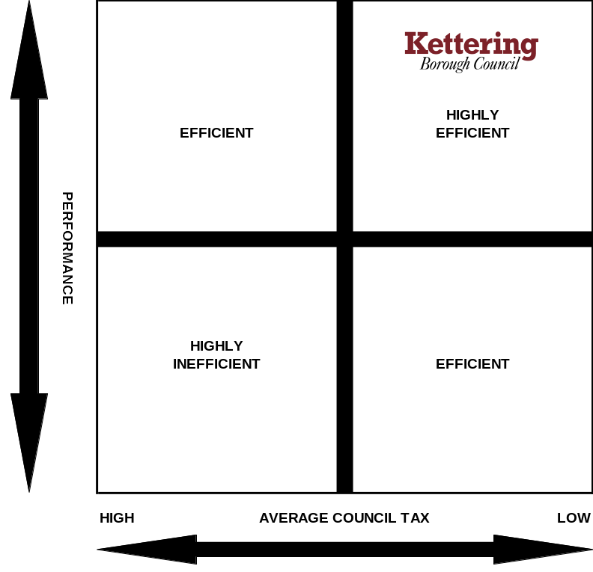
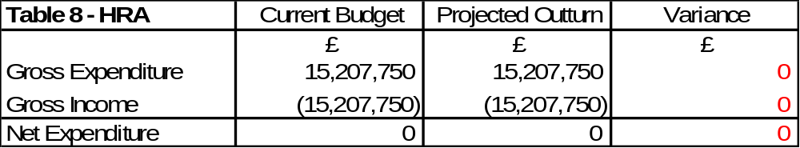

CAPITAL 2013/14 – CURRENT FINANCIAL YEAR

  - A summary of the projected Capital Programme outturn monitoring statement as at 30th June 2013 is shown in Table 9. The carry forward column is subject to Executive Approval.

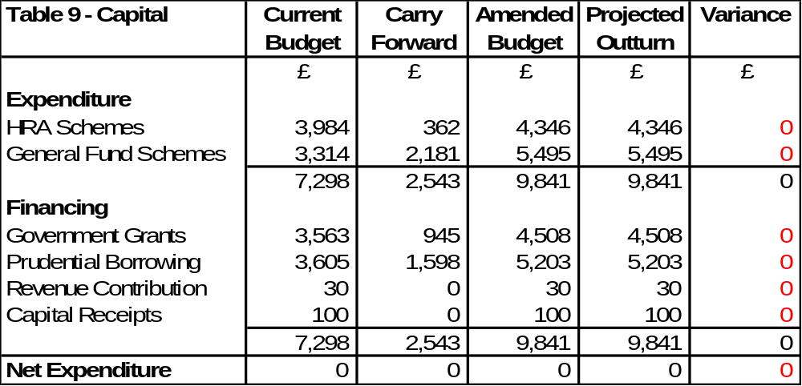
  - The Executive endorsed the Council’s external funding bid to bring empty homes back into use at the April meeting. Following notification from HCA that this bid was successful this is now reflected in the Current Budget in Table 9.

  - The capital programme is currently projected to be ‘on’ budget.

  - There are two further reports relating to the capital programme on this agenda which if agreed by the Executive will be incorporated into the next durable budget report.

6 EMPTY HOMES

  - At its meeting on 16th January, the Executive Committee approved the Empty Homes Strategy which contains the Council’s plans for reducing the number of vacant residential properties within the Borough. In particular, the Empty Homes Strategy identified a need to maximise opportunities to increase funding for tackling empty homes.

  - A report to the April Executive reported that the Homes and Communities Agency invited housing providers to submit bids to bring empty properties into use as affordable homes. A bid for £206,000 was prepared and submitted to bring a number of empty properties back into use as affordable homes. This would reduce housing need and homelessness and help to improve the appearance of residential streets. The properties will also attract New Homes Bonus, however following the Spending Review announcement on 26 June there is likely to be a consultation during the summer on how the New Homes Bonus scheme will operate from 2015/16 further information on NHB is provided at Section 7.4.

  - The Council bid for £206,000 and received notification on 19 June that the bid had been successful. The Council’s bid was in two parts, the first part of the bid was for £152,000 for the purchase and repair of eight empty homes. The second part of the bid was for £54,000 to lease and repair six homes.

  - A summary of the funding proposals (for part 1 of the bid) for the purchase and repair of eight empty homes is summarised in Table 10.

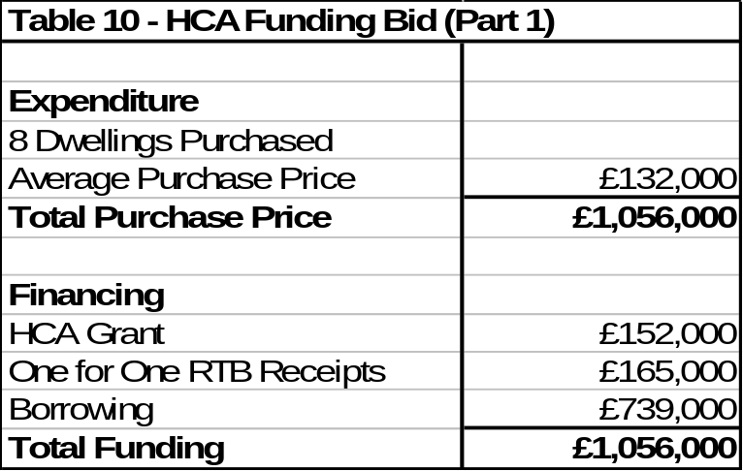

  - The Council is borrowing £739,000 which equates to 70% of the total investment to fund the purchase of eight empty homes. This level of borrowing is affordable within the current business plan and will generate additional rental income for the Housing Revenue Account of around £35,000 per annum and also attract New Homes Bonus.

  - Where a property is brought back into use as social housing, any tenant, will subject to meeting eligibility criteria have access to the right to buy property. In order to protect the Council’s investment, there is a mechanism known as the ‘cost floor’. This ensures that for a set period the property cannot be sold for less than the investment made, this period is currently 15 years.

  - A summary of the funding proposals for the lease and repair of six properties is summarised in Table 11.

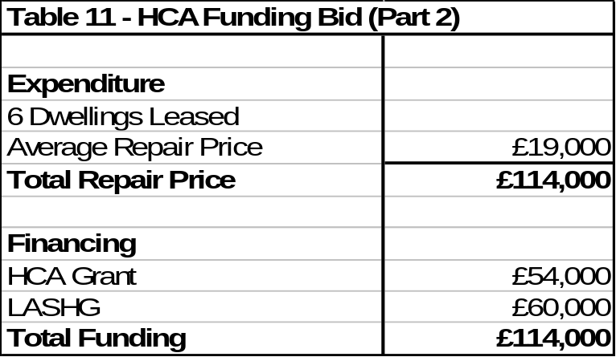

  - The Council has LASHG of £60,000 which it can use to meet the cost of the lease and repair of six properties, therefore this will be funded in full by both the HCA and LASHG grant. The General Fund will receive income of around £3,000 per annum and will also attract New Homes Bonus.

7 LOCAL GOVERNMENT SPENDING ROUND

  - The Chancellor of the Exchequer presented the Local Government Spending Review 2015/16 to Parliament on 26th June 2013. The key announcements likely to impact on Kettering Borough Council are outlined within this section.

  - The announcement contained details on the public sector spending envelope for 2015/16. Appendix D is a summary of a briefing prepared by the LGA. Whilst the Council doe’s not share all the views of the LGA it is nonetheless a useful summary of the key announcements made by the Chancellor.

- 2015/16
The spending review is likely to result in another challenging financial settlement for local government which will see the sector facing a further 10% reduction in funding from 2015/16.

These planned spending reductions will come on top of an average 33% (40% for KBC) reduction in funding between 2010 and 2015. In previous spending rounds Shire Districts have typically fared worse in comparison to other authorities in the local government sector and this is an important point to bear in mind between now and when the provisional settlement for 2015/16 is announced later this year.

- Council Tax Freeze
The Government announced that it will provide further support to freeze council tax for 2014-15 and 2015-16. This will be the equivalent of a 1 per cent council tax increase for councils which freeze their council tax on the same lines as in 2013-14. It will set referendum limits of 2 per cent in both 2014-15 and 2015-16.

Those local authorities that take up the governments offer to freeze council tax face a real terms cut, the impact of this is summarised in Table 12.

Table 12 | Actual / Estimated Inflation Rate | Council Tax Increase | Cumulative Real Terms Reduction
2011/12 | 4.80% | 0.00% | 4.80%
2012/13 | 2.70% | 0.00% | 7.50%
2013/14 | 3.00% | 0.00% | 10.50%
2014/15 | 3.00% | 0.00% | 13.50%
2015/16 | 3.00% | 0.00% | 16.50%

The setting of Council Tax can have significant implications on the sustainability of the Council’s budget in the medium term. Council Tax Freeze grants can only be treated as one-off monies whereas increases in Council Tax are ongoing.

  - The Chief Secretary to the Treasury outlined the government’s infrastructure investment priorities beyond 2015 on 27 June 2013. The key announcements likely to impact on Kettering Borough Council are detailed below. Appendix E is a summary of a briefing prepared by the LGA. Whilst the Council doe’s not share all the views of the LGA it is nonetheless a useful summary of the key announcements.

- Single Local Growth Fund

The Chancellor announced the creation of a Single Local Growth Fund (SLGF) with over £2 billion to be spent under the strategic direction of Local Enterprise Partnerships (LEPs). The announcement indicates where this money will come from and requires the pooling of £400m of New Homes Bonus which is currently retained by the local authorities.

The Government will consult on the mechanism for requiring that a proportion of New Homes Bonus is pooled by local authorities and within LEPS as part of the SLGF. Kettering Borough Council will vigorously defend the retention of all New Homes Bonus locally as promised on the coalition agreement.

Although it is difficult to quantify accurately, the cash impact in Kettering it is likely to be in the order of £600,000 per annum the equivalent of a 10% increase in Council Tax.

- Growth Deals

The Government has committed to negotiating a Growth Deal with every
LEP to give local areas greater resources, powers and influence on the basis of multi-year strategic plans developed by the LEPs. The Government will publish guidance on the strategic plans and the Growth
Deals process during the summer.

- Rent Levels and capital investment in affordable housing

The Government announced a £3.3 billion package to support 165,000 new affordable homes over three years from 2015/16. The Government also announced that from 2015/16 social rents will rise by CPI plus 1% each year for ten years. Currently social rents are rising by RPI plus 0.5%. This will result in lower increases in social rents.

Whilst the investment into social housing is welcomed particular that Council’s as well as housing associations will be able to access the £3.3 billion fund on an equal basis, it is concerning that just one year after the self financing transaction authorities will need to review their plans due to a change in rules on rent levels.

  - The announcements make it plain that the forthcoming years will be extremely difficult. Alongside the 10% cut in local government revenue grant is a further potential reduction as the government propose transferring £400m of NHB to LEPs.

  - When the NHB scheme was introduced back in 2011/12 the bonus was paid for each new property built for a six year period, with 80 per cent coming to districts. Whilst we await consultation on the precise details of the future for NHB, it is concerning that this would impose further financial pressures on districts from 2015-16 and dilute the incentives currently available for delivering housing growth. Once further details are available this will be included in future reports to the Executive.

  - Total spending is predicted to reduce in 2015/16, 2016/17 and 2017/18 at a similar trajectory to what we have experienced during the last Comprehensive Spending Review (CSR).

  - It is important for Members to be aware that annual automatic increments may exist in other parts of the Public Sector but have not been applied to Local Government for a number of years.

8 CONSULTATION AND CUSTOMER IMPACT
8.1 None as a direct consequence of this report. However members are reminded that the formal budget consultation period is from 15th January 2014 to 26th February 2014 when the Council sets its Council Tax for 2014/15. Comments from the consultation process will be reported to the Executive for consideration at it’s meeting on 12th February 2014.

9 POLICY IMPLICATIONS
9.1 None as a direct consequence of this report.
10 USE OF RESOURCES
10.1 None as a direct consequence of this report.

11. RECOMMENDATIONS
That the Executive;

  - Note the success the Council has achieved in attracting external funding;

  - Note the draft out-turn position for 2012/13 for the General Fund, Housing Revenue Account, Capital Programme and Treasury Management;

  - Note the Council’s Medium Term Financial Strategy and associated guiding principles;

  - Endorse the Capital Programme carry forwards (as outlined in Appendix A);

  - Note the current Medium Term Financial Forecast and the progress being made for the delivery of efficiency savings for 2014/15 and future years.

  - Note the announcements regarding future levels of funding for 2015/16 made by the Chancellor in the Spending Review Statement.

  - Vigorously lobby for the retention of New Homes Bonus locally as promised in the coalition agreement.

Background Papers: Previous Reports/Minutes:
Title of Document: Various Monthly Durable Budget Reports Contact Officers: M Dickenson

