1. PURPOSE OF REPORT

To report to Full Council the recommendations from the Executive Committee to enable Full Council to make a formal decision in relation to each of the following;

- The Revised General Fund budget 2012/13;
- The General Fund budget 2013/14;
- The Capital Programme 2012 – 2018;
- The Housing Revenue Account budget 2013/14.
- The Council Tax level for 2013/14.

As part of the formal budget setting process, the Council must approve a statutory ‘Council Tax Resolution’ – this combines the precepts for all the precepting authorities in Kettering Borough (i.e. the County Council, Kettering Borough Council, Police Authority, Town and Parish Councils) and provides a legal basis upon which to issue Council Tax bills and collect the amounts due.

- BACKGROUND

  - On the 16th January 2013, the Executive considered a report containing initial budget proposals for 2013/14. Since that meeting, the budget proposals have been the subject of consultation and have been discussed at a number of meetings including the formal Budget Consultation event on 24th January 2013.

  - At its meeting of 13th February 2013, the Executive gave further consideration to the budget proposals (including consideration of comments that had been made through the consultation process) and made specific budget recommendations to the Council including a recommended level of Council Tax for 2013/14.

  - This report is made up of a number of sections to provide members with a brief resume of the budget setting process and the key issues. The report comprises the following;

Section 2: Background
Section 3: Key Issues Summary & Guiding Principles
Section 4: General Fund Budget & the Medium Term
Section 5: Council Tax Setting
Section 6: Capital Programme
Section 7: Housing Revenue Account
Section 8: Recommendations

Appendix A: Draft Budget Booklet
Appendix B: Budget Consultation Comments
Appendix C: Statutory Officer Report
Appendix D: Formal Council Tax Resolution 2013/14

2.4 It is worth emphasising the extraordinary economic and financial backcloth against which this budget is being considered. The national and world economies continue to experience significant challenges and the very nature of these do have implications for the public sector both in terms of funding and service demands. Capital Markets remain very tight and the medium term prospects for government funding levels will continue to be directly influenced by governments ability to grow the economy and or reduce deficit levels.

- KEY ISSUES SUMMARY / GUIDING PRINCIPLES
  - For ease of reference, this section of the report shows the ‘key issues summary’ and the ‘guiding principles’ that have previously been reported to the Executive Committee in both the January and February budget reports.

2012/13

    - The Council has continued to use its own specific ‘budget delivery framework’ for the consideration and subsequent delivery of the £1.3m of savings required for the General Fund for 2012/13.

    - Once the budget was approved in February 2012, the challenge was to turn the ‘paper based savings exercise’ into reality so that the £1.3m of savings were actually delivered.

    - From the information contained in the budget report (and previously reported to the Executive Committee through a series of Durable Budget Reports) it can be seen that the original savings target of £1.3m is being delivered successfully.

    - In addition to the original target, the Council is currently projecting a further £750,000 under-spend during 2012/13, these are a combination of some early delivery of the on-going savings required to balance the budget in 2012/13 (c£150,000) and a number of one-off items (c£600,000). As previously approved by the Executive, this underspend will be put into reserves to help the Council protect itself from the many service and budget pressures that exist in the post April 2013 world.

2013/14

    - The national landscape is changing significantly from 1 April 2013 with the introduction of the Business Rates Reform and Localisation of Council Tax Benefit. This brings greater uncertainty and volatility to future projections. Hence the importance of the strategy identified in 3.1.4 above.

    - The Council needs to continue its excellent track record of delivering budget savings to balance the budget for 2013/14.

    - Prior to the consideration of any council tax increase, it is estimated that £949,000 of savings will be required. We will start 2013/14 in a similar position to 2012/13 in that the continued use of the Council’s successful budget delivery framework which has resulted in the Council already having secured some of the on-going savings required for 2013/14. The remaining savings have also been identified and the Council is confident that these will be delivered during 2013/14. Whilst these are paper based savings at this stage the track record in delivery of planned savings should give confidence.

    - A capital programme of in excess of £6m is not inconsiderable for a District Council of Kettering’s size and no doubt a welcome boost to the local economy. It represents £1 of capital investment into our local economy for every £1 of council tax collected. Of course this is in addition to around £11m of revenue expenditure the Council puts into the local economy.

    - The Council uses the budget “swingometer” as detailed at Appendix A – Section 1 to highlight and assess the sensitivity of the most volatile and material budgets. The “swingometer” shows some significant swings reflecting the economic climate. It must be stressed however that the Council has an excellent track record of spending at or around budget, even when faced with significant in year pressures, and a strong balance sheet with a level of reserves sufficient to cover the risks outlined in the “swingometer”.

The Medium Term

2014/15 and Beyond

    - Assumptions have been made for future levels of government grant (and other funding changes) and a decrease of 13% has been applied for 2014/15 following the provisional settlement and further annual decreases in overall funding of 7% for 2015/16 and beyond. This will need to be reviewed when more information becomes available. A 1% change in grant amounts to £35,000.

    - The current economic times are unprecedented. Therefore the delivery of the budget is dependent upon successfully tracking the other budget assumptions that have been made (eg, inflation and interest rates) and it must be recognised that any major changes in such variables can have a significant impact on the Council’s budget figures and resultant levels of required savings.

    - Based upon the assumptions applied, the future years’ budgets would require ongoing year on year savings of:

2014/15 £1,250,000
2015/16 £1,027,000
2016/17 £ 847,000
2017/18 £ 753,000

    - The new system of government funding effectively transfers significant risks from central to local government. Such risks include;

- Business Rate Volatility

Future changes in business rates yield will have a direct impact on a significant proportion of the grant received by the council in the future. The Council has most of the risk of any downward movement whilst can retain a small element of any increased yield. This is a new element of risk for the council and will need to be monitored very closely.

Business rate appeals will also impact on the Council's future funding – again this is a new risk for local authorities and will need to be monitored.

- Council Tax Benefits Volatility

It is anticipated that future levels of council tax support funding will be reduced in line with the reductions in central government core grant. It is also likely that the council will have to bear the cost of increased caseload over the medium term – given the current economic outlook this is a real and present risk.

Other Considerations

    - The projections in all years rest on the Executive’s adherence to the “Guiding Principles” the “Modelling for Recovery Principles” and the “Budget Containment Strategies” (para 3.6).

    - Depending on the decisions taken in relation to Council Tax, year on year savings of these magnitudes have and will continue to take capacity out of the organisation. The priority has been front line delivery and accordingly members may notice a reduction in some areas of internal delivery, as well as our capacity to influence longer term strategic issues.

    - Many of the changes to be implemented are untested and it is inevitable some transition turbulence may be experienced even with the focus on protecting front line service delivery.

    - All the council’s partners, elected councillors and staff should feel proud of reaching this point. However we must maintain this extraordinary effort if we are to continue to achieve our ambitious objectives.

  - From the key issues summary, members will appreciate that the strategies the Council has adopted over the past few years have resulted in the authority being in a much better shape than many others. In Kettering, our approach ensured that the Council was able to pro-actively deal with the challenges faced through: -

- Having high level strategic financial capability (in addition to the Council’s operational resources);

- Anticipating and influencing major ‘Big Ticket’ items;

- Having a well motivated and flexible workforce that is pro-actively delivering change.

  - These have allowed us to develop and deliver the strategies necessary to deal with changing financial circumstances including such things as

- establishing (and sticking to) budget guiding principles;

- developing a budget delivery solution that suited KBC;

- finding innovative methods of service delivery.

The Guiding Principles

3.4 The financial strategies key ‘guiding principles’ supplemented by the ‘Modelling for Recovery Principles’ and the ‘Budget Containment strategies’ have provided a strong cornerstone for the Council's medium term financial strategy. For ease of reference, these are reproduced here;

Financial Strategy Guiding principles:

- Revenue balances should not fall below £1m and overall revenue reserves should not fall below 10% of net revenue expenditure;

- In setting the Council Tax, members should consider the medium term to ensure that a sustainable budgetary position is preserved (with due regard being given to any penalties that might apply);

- The level of household Council Tax to increase each year in line with inflation at least, where the budget is in deficit, to ensure resources remain consistent with budgeted costs;

- When setting the Capital Programme, consideration is given to allocating capital resources to schemes that are beneficial to the Council’s overall revenue budget position;

- To maximise the resources available to the Authority, the Council will actively lobby the Government on relevant issues (e.g., grant distribution/ planning fees).

Modelling for Recovery principles:

- Wherever possible, continue with all planned investments and programmes, to protect the local economy and lever in other investments;

- Given the strength of our Treasury position we should consider debt funding as a means of programme delivery or stimulus – if this can be shown to be sustainable and have a wider economic benefit;

- Organise our fiscal structures and business models to attract and retain the maximum amount of revenue within the local economy;

- To ensure all possible avenues are used within procurement rules to source locally;

- Protect the performance of Council services which come under particular strain;

- Work closely with partners in the voluntary, public and private sectors, to ensure optimum efficiency

Budget Containment Strategy:

- Where a specific grant which funds a specific service is withdrawn, the service stops;

- Where grant funding reduces, which Kettering Borough Council passports through to another organisation, the reduced sum continues to be passported, providing the end recipient organisation feels it can still provide a value-added service at that funding point.
- Where a function is transferred to another provider, the Council leaves all service-provision discussions, including any top-up funding, with the new provider;

- The Council would ordinarily neither seek to buffer nor profit from tax changes.

- The Council should not substitute itself as a provider / funder of services when another public provider cuts such a service.

- GENERAL FUND BUDGET AND THE MEDIUM TERM
  - This section provides a summary of the key issues (and resultant budget figures) for the following;

- Revised Budget 2012/13
- Draft Budget 2013/14
- Medium Term Forecast (and associated key issues)

Revised Budget 2012/13

  - The detail of the revised estimate figures for 2012/13 can be seen by reference to the draft budget booklet (Appendix A).

  - Members are reminded that in the current financial year (2012/13) the General Fund required budget savings of £1.3m to be achieved in order to deliver a balanced budget position for the year.

  - Using the Council's ‘budget delivery framework’ and ‘guiding principles’ the Council is currently on track to successfully deliver the £1.3m required. Turning what was a paper based exercise into reality has not been an easy task however by sticking to the guiding principles and through using the eight workstreams (that form the budget delivery framework) the approach is proving a successful one.

  - The savings that have been delivered through the budget delivery framework are summarised in Table 1:

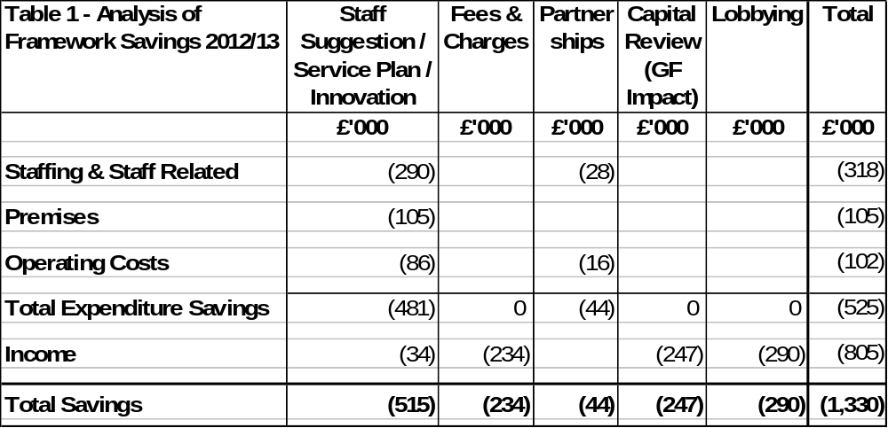

  - As previously reported to the Executive Committee, in addition to the successful delivery of £1.3m of required savings, the Council is currently projecting an underspend of around £750,000. This is a combination of some early delivery of the on-going savings required to balance the budget in 2013/14 (c£150,000) and a number of one-off items (c£600,000).

  - The Executive Committee have previously confirmed its previous policy position that any budget savings in excess of the £1.3m original target be used to supplement earmarked reserves to help provide additional flexibility and protection against current and new business risks and threats that exist due to the unprecedented changes that will take place to the local government finance arrangements from April 2013. Part of this includes the risk transfer from central government around such issues as Business Rates (yields and appeals) and Council Tax support (caseload and future grant levels).

Draft Budget 2013/14

  - The draft budget figures for 2013/14 can be seen by reference to the Draft Budget Booklet at Appendix A.

  - The Executive Committee considered the draft budget figures and comments that had been made during the budget consultation period when it met on 13 February 2013. The comments are reproduced at Appendix B for information.

  - The draft budget that the Executive recommended for consideration by Council forms part of the medium term financial forecast that is shown in Table 2:

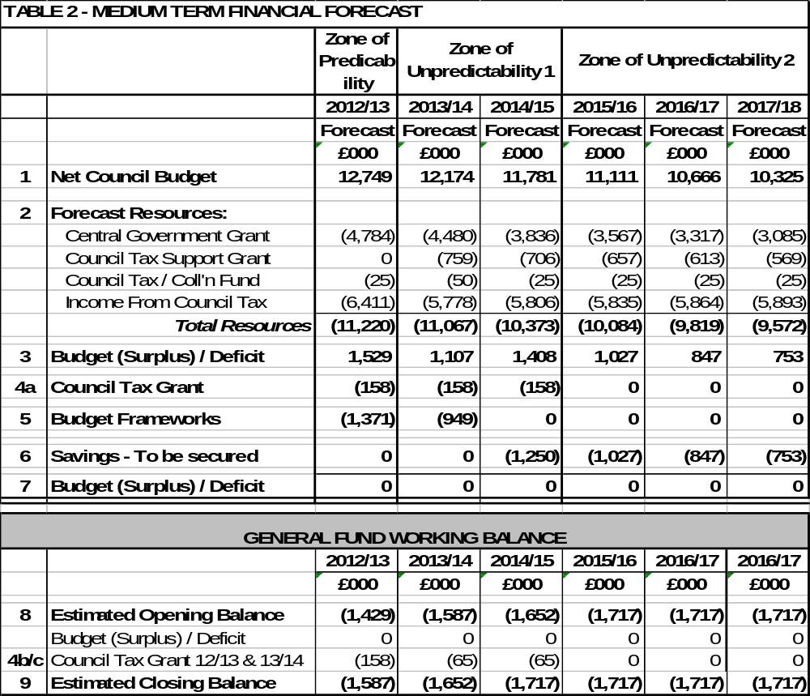
Notes to Medium Term Financial Forecast

1 Net Council Budget – This represents the net expenditure prior to the Budget Framework savings.

2 Forecast Resources – These are the Council's main funding streams (excluding fees and charges which are incorporated into Line 1). This illustrates the significant reduction in Central Government Grant and introduces a new line from 2013/14 for the Council Tax Support grant. Following future government announcements the presentation of this will be reviewed but it is thought likely that overall the figures we are modelling on, may be in the right area but the split between years may be different. To enable the total resources required to balance the budget to be identified, no assumptions have been made regarding future council tax increases. The small increase in revenue each year reflects anticipated housing growth in the borough.

3 Budget (Surplus) / Deficit – This illustrates the gap between the budget and the total resources available before identifying budget framework savings.

4a Council Tax Grant – This is a grant the Council receives from central government for four years in return for freezing Council Tax in 2011/12. This is equivalent to the cash that would have been received if a 2.5% increase had been levied.

4b Council Tax Grant 2012/13 – This is a grant the Council receives from central government for one year in return for freezing Council Tax in 2012/13. This is equivalent to the cash that would have been received if a 2.5% increase had been levied.

4c Council Tax Grant 2013/14 – This is a grant the Council receives from central government for two years in return for freezing Council Tax in 2013/14. This is equivalent to the cash that would have been received if a 1% increase had been levied. A Council Tax Freeze has ongoing implications as an increase in Council Tax generates income year on year.
5 Budget Frameworks – This identifies the total savings required and differs to the table shown in 4.5 as a result of the Council decision earlier in the year in relation to members allowances.

6 Savings to be secured – This identifies the total resources required to balance the budget in future years after 2013/14.

  - When considering the draft budget for 2013/14 and the medium term issues and risks, the Executive decided to recommend a 0% Council Tax increase for 2013/14. This is now embedded in the figures used in Table 2. Further information about Council Tax setting is provided in Section 5.

  - By reference to Table 2, it can be seen from line 5 that the Council will need to deliver ongoing budget savings of £949,000 in order to deliver a balanced budget for the year. As previously reported to the Executive Committee, the budget delivery framework has continued to be used in order to identify where the £949,000 will be delivered from. Table 3 summarises how a balanced budget will be delivered;

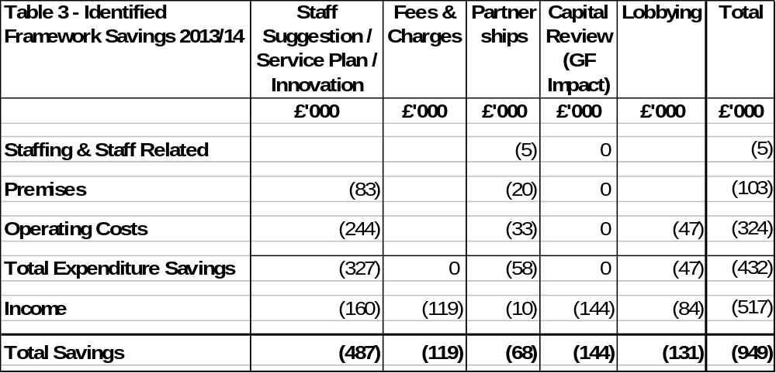

  - The Council will need to continue its excellent track record of delivering savings if it is to continue to deliver a balanced budget for 2013/14. As previously mentioned in this report, the Council starts from an ‘advanced’ position due to the early delivery during 2012/13 of some of the ongoing revenue savings that will be required for 2013/14. When considering the Council’s track record of delivering savings, the following table (reproduced from previous budget reports) succinctly highlights the point;

Table 4 – Efficiency Savings | £000
2010/11 | 1,260
2011/12 | 1,910
2012/13 | 1,330
Total | 4,500
2013/14 | 950
Total  % Cash Savings (Net Budget) | 5,450  50%

  - As previously reported, turning a paper based exercise into reality is not an easy one. However, based on the Council's track record - confidence levels are high that this is achievable. It will however require renewed focus on key priorities and an acceptance by all that if a 0% council tax increase is approved it will continue to take capacity out of the organisation. The priority has been front line delivery and accordingly members may notice a reduction in some areas of internal delivery, as well as our capacity to influence longer term strategic issues.

  - Despite the levels of efficiency savings that have been delivered over the past few years, the Council’s performance in priority areas remains above average whilst Council tax is below the national average. This is an achievement that the Council is rightly proud of and one that has not happened by accident – continued focus on ‘added value’ rather than expenditure (and service) cuts has been the key to remaining in this position.

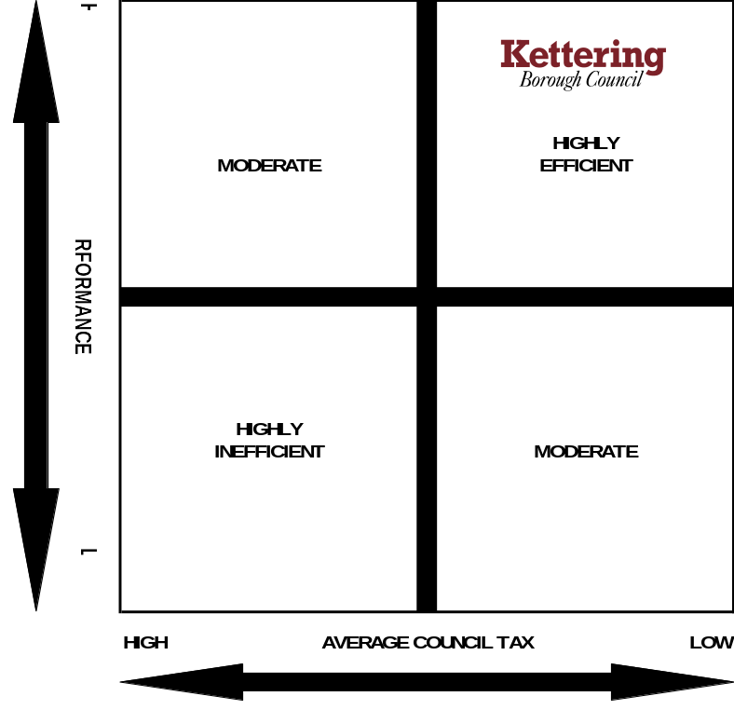

  - The scale and delivery of this level of efficiency savings is particularly impressive given that there has been no detrimental impact on the delivery of front line services and when considering the increased costs of utilities and inflation levels. Over the four year period (as detailed in Table 4) the efficiency savings will be equivalent to approximately 50% (65% in real terms) of the Council’s draft net budget (which stands at £11m for 2013/14).

  - Members are reminded that before the efficiency programme commenced a number of years ago, the Council was charging a level of Council tax below the national average yet delivering a level of performance that was above the national average. Despite having to deliver efficiency savings of £5.450m in the past four years, the Council’s level of council tax charged remains below the national average and performance remains above average.

  - Members have a statutory duty to consider the medium term when setting a budget and level of Council Tax for 2013/14.

  - The projections for all years rest on the Executives adherence to the “Guiding Principles” the “Modelling for Recovery Principles” and the “Budget Containment Strategies” as well as maintenance of our best practice approach to generating fees and charges.

Medium term Forecast

  - Table 2 provides indicative forecasts for the financial years 2014/15 to 2017/18. Given the unprecedented levels of change from April 2013, these figures must be treated as working estimates at the present time – they will require amendment and refinement throughout the year as more information becomes available.

  - Based upon the assumptions used in the budget model, the following indicative budget gaps will require attention in the medium term;

2014/15 £1,250,000
2015/16 £1,027,000
2016/17 £ 847,000
2017/18 £ 753,000

  - It should be noted that the above figures are calculated prior to the consideration of any Council Tax increase for the years 2014/15 to 2017/18. The table simply provides a working financial base position from which to understand the level of the resultant budget gap for information purposes.

  - Members should be aware that the indicative savings levels for the period 2014/15 onwards are subject to a number of high level assumptions. One of these is about the potential level of government grant. CLG in the 2013/14 provisional settlement provided indicative figures for 2014/15 which shows the grant reducing in 2014/15 by 13%. For the purpose of modelling the 2014/15 grant assumes a 13% reduction.

  - For the purpose of modelling from 2015/16 we have assumed an overall annual cash reduction of 7% each year for 2015/16 up to and including 2017/18 (from 2015/16 only the RSG element which accounts for around half of the total grant will be subject to similar reductions to those of the current Comprehensive Spending Review) - when more detail is announced about the local government resource review we will be in a better position to review this. It is thought likely that overall the figures we are modelling on, may be in the right area, however, the split between years may be different.

  - When setting a balanced budget (and council tax) for 2012/13, members need to give due consideration to all material issues and risks - including those clearly outlined in this report and the reports that were submitted to the January and February Executive Meetings.

- COUNCIL TAX SETTING (2013/14)

  - The following illustration was used at the recent budget consultation meeting and serves to remind members of the relative size of the Council tax figures that are under consideration
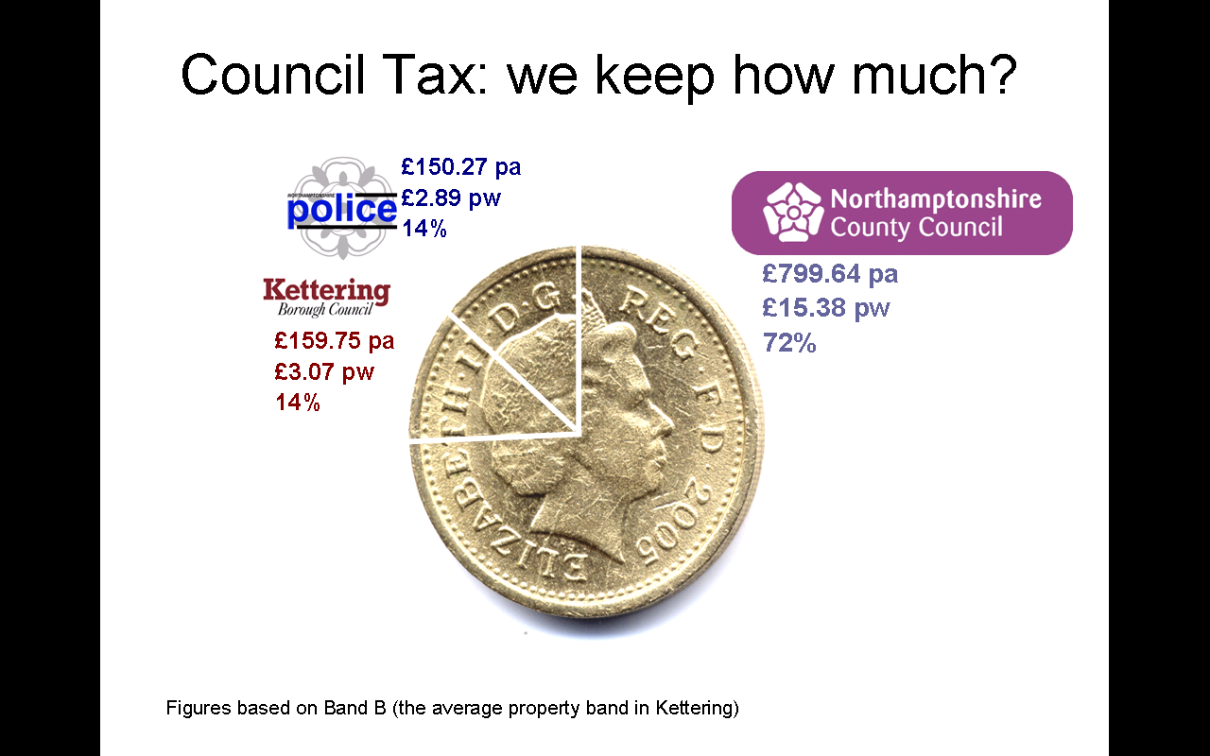

  - When deciding upon a preferred level of Council Tax for 2013/14, the Executive Committee were advised to have regard to the following;

- The medium term financial projections for the Council’s General Fund budget (statutory requirement)

- The advice of its officers

- The financial (and business) risks that face the authority in the medium term.

  - The Executive Committee have recommended that a 0% increase in Council Tax for 2013/14 be considered by Council at this meeting.

  - Members are reminded that each 1% increase in Council tax equates to about £58,000 of ongoing income to the Council’s Council tax yield.

  - If the current rate of inflation is used as a reference point, in effect local residents have experienced a real terms reduction in their local council tax for Kettering Borough Council during the year as a result of the Council decision to have a 0% increase from 2011/12. If the Council were to levy a similar level of increase into the medium term, further real terms reductions would be experienced by council tax payers at the same time as the Council having to deal with its own inflationary pressures (eg, utility bills) and deliver significant levels of ongoing efficiency savings. Table 5 summarises the real terms impact this has when compared to Council Tax freezes.

Table 5 | Actual / Estimated Inflation Rate | Council Tax Increase | Cumulative Real Terms Reduction
2011/12 | 4.80% | 0.00% | 4.80%
2012/13 | 2.70% | 0.00% | 7.50%
2013/14 | 3.00% | 0.00% | 10.50%
2014/15 | 3.00% | 0.00% | 13.50%

  - In previous years, the government have set ‘capping’ criteria that councils were encouraged to comply with. From 2012/13, the provisions of the Localism Act will instead be applied. For district councils, this means that any local authority that wishes to increase its council tax by more than 2.0% for 2013/14 will have to have a local referendum to approve the increase.

  - The Government will provide a grant for two years. The scheme will be based on a grant equivalent to a 1.00% increase for those preceptors who levy a 0% increase and will be calculated before adjustments are made for Council Tax Support. (i.e. £65,000 in our case). This grant has not been included in the base budget for 2013/14 and 2014/15 due to its short term nature, it has however been included as an adjustment to the working balance for transparency purposes only at this stage. In reality, the grant will be used in accordance with the current policy to supplement smoothing reserves subject to the £949,000 savings target being met during 2013/14.

  - When considering the medium term, the potential scale of change from April 2013 has clearly been outlined in previous budget reports. The scale of change is unprecedented in size as are the potential financial implications for local authorities.

  - Recent announcements also indicate that the trajectory of future grant reductions for the next spending review period (which covers 2015/16 to 2018/19) will be similar to those experienced in the previous four year period. The Council will need to keep the assumptions in the Medium Term Financial Strategy under review. An announcement regarding funding for the period 2015/16 – 2018/19 is likely to be made before the end of June 2013.

  - Although through this budget process members will only be setting a level of council tax for 2013/14, this should be done by reference to the medium term and the risks faced.

  - At the meeting of 13th February 2013, the Executive recommended a 0% increase in Council Tax for 2013/14. The table below illustrates the proposed levels of council tax for each council tax band for Kettering Borough Council’s budget based upon this recommendation for the Executive;

Band | A | B* | C | D | E | F | G | H
Increase per week (rounded to nearest pence) | 0.00p | 0.00p | 0.00p | 0.00p | 0.00p | 0.00p | 0.00p | 0.00p
Proposed Weekly Council Tax for 2013/14 | £2.63 | £3.07 | £3.51 | £3.95 | £4.83 | £5.70 | £6.58 | £7.90
Proposed Annual Council Tax for 2013/14 | £136.93 | £159.75 | £182.57 | £205.39 | £251.03 | £296.67 | £342.32 | £410.78
Increase | 0% | 0% | 0% | 0% | 0% | 0% | 0% | 0%
* Represents the average level of the household bill within the District relating purely to Kettering Borough Council’s budget.

Council Tax Resolution

  - The figures included in the above table are in relation to the proposed levels of Council Tax for this Council only. The Council Tax for the County Council and the Police Authority will be set by meetings of those authorities on the 21st and 5th February respectively. Once these precept figures are available, they will be combined with the precept figure for this council into a formal Council Tax Resolution that requires approval by the Council. This is considered in more detail below. The resolution will constitute Appendix D of this report and will be distributed at the Council meeting itself due to the date of the County Council meeting.
  - At the time of writing this report, the County Council have not approved their budget (or precept) for 2013/14. The recommendation to be made to the relevant Committee is for a 0% increase. The Police Authority approved a 0% Council Tax increase on the 5th February 2013. The table below illustrates what the average Council Tax Bill would be if the County Council approves its recommendation:

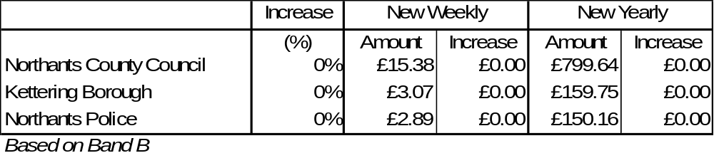
  - The table illustrates that all taxpayers in the borough will pay the same level of Council Tax as in 2010/11 for the main precepting authorities.
  - The following Town / Parish Council’s have notified the Borough Council that they are levying a local precept for 2013/14 and these amounts will be included in the formal Council Tax Resolution;

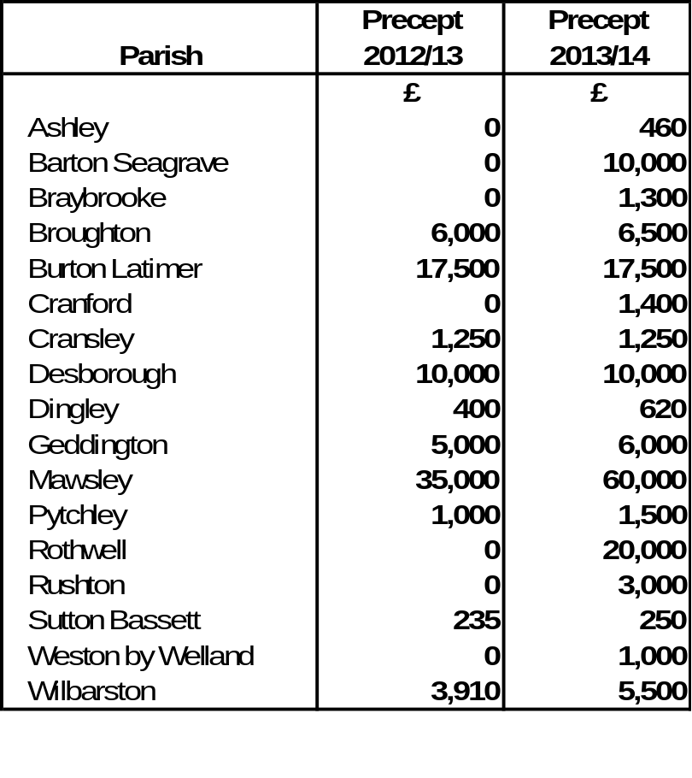

- CAPITAL PROGRAMME (2013/14)

  - The detailed capital budgets for the period 2012 – 2018 are contained at Appendix A (Section 2).

  - The draft Capital Programme was reported to the Executive as part of the initial budget proposals in January and has since been the subject of consultation and further review. There are no changes to the draft capital programme reported to the January Executive.

  - The programme is summarised in Table 5.

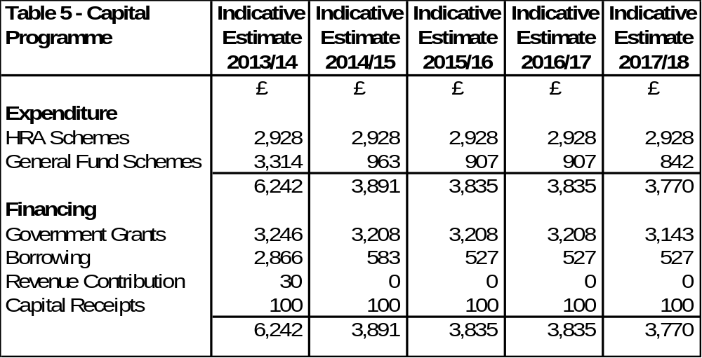

  - There are no changes to the draft capital programme reported to the January Executive.

  - The financing estimate for external borrowing for 2013/14 is £2.866m. The revenue impact of borrowing in 2013/14 is included in the revenue budgets. Members are reminded that the majority of this borrowing relates to the Crematorium – Mercury Abatement scheme, which is estimated to generate significant revenue savings over and above the borrowing costs incurred.

  - A capital programme of in excess of £6m is a significant programme for a District Council and is a welcome boost to the local economy. To put this into context, although the capital programme is not funded from Council Tax receipts, the level of the programme is slightly greater than the amount of income we receive in Council Tax each year.

- HOUSING REVENUE ACCOUNT (2013/14)
  - The Housing Revenue Account (HRA) budget for 2013/14 is contained at Appendix A (Section 3).
  - The Tenants Forum meeting was held on the 31st January 2013 and they recommended an increase in the average level of housing rents for 2013/14 of 4.75%. This rent increase figure is effectively derived from formula from central government that is directly impacted upon by the ongoing requirements to achieve rent convergence with private sector rents.

  - In accordance with the Council’s Constitution, although the Executive will be recommending the HRA budget for 2013/14 to full Council for approval, the Executive meeting on 13th February 2013 formally approved an increase of 4.75% in the average level of Council housing rents for 2013/14. The increase is effective from 1st April 2013 and will result in the average weekly rent increasing to £75.58. This level of increase ensures the Council is on target to achieve rent convergence by 2015/16 in line with the Government’s target. The draft HRA budget included an average rent increase of 4.75%.

8. RECOMMENDATIONS

That Council approve:

- The General Fund budget for 2013/14 (as detailed at Appendix A Section1);

- The Capital Programme for 2012 – 2018 (as detailed at Appendix A Section 2);

- The HRA budget for 2013/14 (as detailed at Appendix A Section 3);

- The Council Tax Resolution for 2013/14 (as detailed at Appendix D);

That Council receive:

- The Medium Term Financial Forecast (as detailed in the Budget Book at Appendix A Section 1);

- The report of the Statutory Officer (as detailed in Appendix C).

Background Papers: Previous Reports/Minutes:
Title of Document: Estimate Working Papers Ref: Exec Report 16/1/13, 13/2/13
Contact Officers: M Dickenson

