Community Infrastructure Levy:
Viability Study
Prepared for
Kettering Borough Council

September 2012

Contents
1 Executive Summary 3
2 Introduction 6
3 Methodology and appraisal inputs 10
4 Development appraisals 13
5 Appraisal outputs 24
6 Assessment of the results 29
7 Conclusions and recommendations 49

Appendices
Appendix 1 Private residential sales values
Appendix 2 Residential appraisal results
Appendix 3 Commercial appraisal results

Contact details:

Anthony Lee MRTPI MRICS
Director – Development Consulting
BNP Paribas Real Estate
5 Aldermanbury Square
London EC2V 7BP

Tel: 020 7338 4061
Fax: 020 7404 2028
Email: anthony.lee@bnpparibas.com

Executive Summary

This report tests the ability of a range of development types throughout Kettering Borough Council’s (‘the Council’s’) administrative area to yield contributions to infrastructure requirements through the Community Infrastructure Levy (‘CIL’). Levels of CIL have been tested in combination with the Council’s other planning requirements, including the provision of affordable housing.

Methodology

The study methodology compares the residual land values (‘RLV’) of a range of generic developments to a range of benchmark land values. If a development incorporating a given level of CIL generates a higher value than the benchmark land value, then it can be judged that the proposed level of CIL will be viable.

The study utilises the residual land value method of calculating the value of each development. This method is used by developers when determining how much to bid for land and involves calculating the value of the completed scheme and deducting development costs (construction, fees, finance and CIL) and developer’s profit. The residual amount is the sum left after these costs have been deducted from the value of the development, and guides a developer in determining an appropriate offer price for the site.

The housing and commercial property markets are inherently cyclical and the Council is testing its proposed rates of CIL at a time when values have fallen below their peak but have subsequently recovered to some degree. Despite this recovery, there is some uncertainty as to the likely short term trajectory of house prices. We have allowed for this by running a sensitivity analysis which inflates sales values by 10% and build costs by 5%. This analysis is indicative only, but is intended to assist the Council in understanding the levels of CIL that are viable in today’s terms but also the impact of changing markets on viability. We have also tested a fall in sales values of 5%, to enable the Council to take a view on the impact of any adverse movements in sales values in the short term. Our commercial appraisals incorporate sensitivity analyses on rent levels and yields.

Key findings

The key findings of the study are as follows:
- The results of this study are reflective of current market conditions, which are likely to improve over the medium term. It is therefore important that the Council keeps the viability situation under review so that levels of CIL can be adjusted to reflect any future changes. The CIL regulations do not prescribe any particular triggers for a review, but we would advise that the Council should monitor sales values, build costs, and developer activity (i.e. applications for planning permission, site purchases etc) as key indicators of the health of the market and its reaction to CIL. In this regard we are of the opinion that the Council should consider formally reviewing their Charging Schedule by at least 2016 and potentially earlier if the market is perceived to have changed significantly.
- The ability of residential schemes to make CIL contributions varies depending on area and the current use of the site. Taking a broad view across our appraisals, the maximum rates suggested are as follows:
  - High Value Villages NN14 (Geddington, Grafton Underwood, Newton, Cranford, Loddington), High Value villages East NN16, NN18 (Weekly, Little Oakley, Warkton) and the LE16 Villages (Wilbarston, Stoke Albany, Sutton Bassett, Dingley, Braybrooke, Weston by Welland, Brampton Ash, Thorpe Underwood): £100 per square metre; and
  - Elsewhere: Nominal rate only.

- The Council will need to consider whether the quantum of development that is expected in the high value villages in NN14, NN16, NN18 and the LE 16 village areas justifies adopting a differential rate. If very little development is expected in these areas, the Council may wish to set a nominal rate on all residential developments across the Borough.
- As developments elsewhere are unviable in many circumstances, a nominal CIL rate should be set so that the impact on viability (and deliverability) is modest. We suggest a nominal rate of between £30 to £50 per square metre could be accommodated through a very modest additional increase in sales values.
- The Council has already granted outline planning permission for the Sustainable Urban Extension to the east of Kettering and as such contributions towards infrastructure requirements have been secured through Section 106 agreements. However, it is important that a CIL is set for the areas covering the SUEs (whether consented or not) to address situations where purchasing developers submit new planning applications for parcels of land. If the Urban Extensions are broken up in this way, it would be difficult for the Council to secure pooled Section 106 contributions from individual developers.
- Care homes, Extra Care housing and other residential institutions are unlikely to be sufficiently viable to absorb any CIL contributions.
- At current rent levels, Office development across the Borough is unlikely to come forward in the short to medium term as the capital values generated are insufficient to cover development costs. We therefore recommend that the Council sets a nil rate for office development.
- Residual values generated by Retail developments in Kettering Town Centre are shown to be viable, although surplus residual values are vulnerable to small changes in rents and yields. However, to a degree retail development will involve the re-use of existing retail space, so the differential in value between current and newly developed space is modest in areas where rents are low. We consider that developments would, however, be able to accommodate a CIL charge of circa £60 per square without a significant impact on viability.
- Retail development in the small towns and larger villages is clearly unviable in the current market as rents are so low that a scheme would not generate a positive residual value. We therefore suggest a nil rate on retail outside of Kettering town centre.
- Retail warehouse/superstores/retail parks (which for the purposes of CIL could be defined using the Sunday Trading law threshold of 280 square metres) are likely to be viable across the Borough with a maximum CIL rate of £211 per square metre. After allowing a buffer, which we consider to be appropriate to deal with site specific issues, the Council might consider setting a CIL of £125 per square metre. We consider that there is sufficient justification for the Council to set different CIL rates for retail based on the viability evidence and consider 280 square metres to be an appropriate threshold, however, the Council would need to satisfy itself that the current CIL regulations permit differential rates for the same use class.
- Alternatively should the Council wish to adopt a simpler approach to their charging schedule, they would be able to apply a rate of £60 per square metre on such space, inline with that applied to Kettering Town Centre.
- Our appraisals of developments of industrial and warehousing floorspace (B2/B8) indicate that these uses are unlikely to generate positive residual land values. We therefore recommend a zero rate for industrial floorspace.
- D1 and D2 uses often do not generate sufficient income streams to cover their costs. Consequently, they require some form of subsidy to operate. This type of facility is very unlikely to be built by the private sector. We therefore suggest that a nil rate of CIL be set for D1 uses.

For residential schemes, the application of CIL of up to £50 per square metre is unlikely to be an overriding factor in determining whether or not a scheme is viable. When considered in context of total scheme costs, a CIL of £50 per square metre is a very modest amount, accounting for circa 2% of total gross development values. Some schemes would be unviable even if a zero CIL were adopted. We therefore recommend that the Council pays limited regard to these sites, in terms of rate setting

Introduction

This study has been commissioned to contribute towards an evidence base to inform Kettering Borough Council’s CIL Preliminary Draft Charging Schedule (‘PDCS’), as required by Regulation 14 of the CIL Regulations April 2010 (as amended in 2011). The aims of the study are summarised as follows:
- to test the impact upon the economics of residential development of a range of levels of CIL;
- for residential schemes, to test CIL alongside the Council’s requirements for affordable housing and other planning obligations; and
- to test the ability of commercial schemes to make a contribution towards infrastructure through CIL.

In terms of methodology, we adopted standard residual valuation approaches to test the impact on viability of a range of levels of CIL. However, due to the extent and range of financial variables involved in residual valuations, they can only ever serve as a guide. Individual site characteristics (which are unique), mean that conclusions must always be tempered by a level of flexibility in application of policy requirements on a site by site basis. It is therefore essential that levels of CIL are set so as to allow a sufficient margin to allow for these site specific variations.

Policy Context

The CIL regulations state that in setting a charge, local authorities must aim to strike “what appears to the Charging Authority to be an appropriate balance” between revenue maximisation on the one hand and the potentially adverse impact upon the viability of development on the other. The regulations also state that local authorities should take account of other sources of available funding for infrastructure when setting CIL rates. This report deals with viability only and does not consider other sources of funding (this is considered elsewhere within the Council’s evidence base).

Local authorities must consult relevant stakeholders on the nature and amount of any proposed CIL. Following consultation, a charging schedule must be submitted for independent examination.

The regulations allow a number of reliefs and exemptions from CIL. Firstly, affordable housing and buildings with other charitable uses (if controlled by a charity) are subject to relief. Secondly, local authorities may, if they choose, elect to offer an exemption on proven viability grounds. The exemption would be available for 12 months, after which time viability of the scheme concerned would need to be reviewed. To be eligible for exemption, regulation 55 states that the Applicant must enter into a Section 106 agreement (and the costs of complying with the agreement must exceed the amount of CIL that would have been payable); and that the Authority must be satisfied that granting relief would not constitute state aid.

The CIL regulations enable local authorities to set differential rates (including zero rates) for different zones within which development would take place and also for different types of development.

The 2010 regulations set out clear timescales for payment of CIL, which varied according to the size of the payment, which by implication is linked to the size of the scheme. The 2011 amendments to the regulations allow local authorities to set their own timescales for the payment of CIL if they choose to do so. This is an important issue that the Council will need to consider, as the timing of payment of CIL can have an impact on an Applicant’s cashflow (the earlier the payment of CIL, the more interest the Applicant will bear before the development is completed and sold).

Several local authorities have undertaken viability assessments and have drafted CIL charging schedules, which they have submitted for independent examination. To date, a number of charging authorities (including the Mayor of London, Portsmouth, Newark and Sherwood, Huntingdon, Wandsworth, Shropshire, Bristol, Poole and Redbridge) have been through the examination process and are at various stages of implementation.

Economic and housing market context

The historic highs achieved in the UK housing market by mid 2007 followed a prolonged period of real house price growth. However, a period of ‘readjustment’ began in the second half of 2007, triggered initially by rising interest rates and the emergence of the US sub prime lending problems in the last quarter of 2007. The subsequent reduction in inter-bank lending led to a general “credit crunch” including a tightening of mortgage availability. The real crisis of confidence, however, followed the collapse of Lehman Brothers in September 2008, which forced the government and the Bank of England to intervene in the market to relieve a liquidity crisis.

The combination of successive shocks to consumer confidence and the difficulties in obtaining finance led to a sharp reduction in transactions and a significant correction in house prices in the UK, which fell to a level some 21% lower than at their peak in August 2007 according to the Halifax House Price Index. Consequently, residential land values fell by some 50% from peak levels. One element of government intervention involved successive interest rate cuts and as the cost of servicing many people’s mortgages is linked to the base rate, this financial burden has progressively eased for those still in employment. This, together with a return to economic growth early 2010 (see May 2012 Bank of England GDP fan chart below, showing the range of the Bank’s predictions for GDP growth to 2015) has meant that consumer confidence has started to improve to some extent.

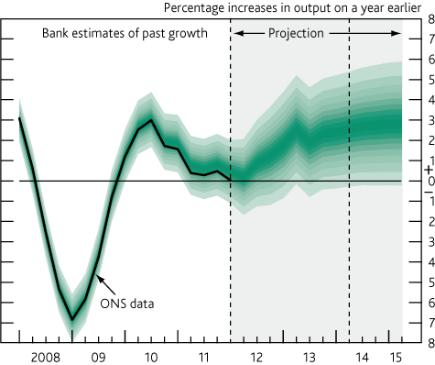

Source: Bank of England

Throughout the first half of 2010 there were some tentative indications that improved consumer confidence was feeding through into more positive interest from potential house purchasers. Against the background of a much reduced supply of new housing, this would lead one to expect some recovery in prices. However it is evident that this brief resurgence has abated, with the Halifax House Price Indices showing a fall of 0.1% in the year to April 2012. The Halifax attributes at least some of the recent recovery in sales values to first time buyers seeking to purchase prior to the reintroduction of Stamp Duty from 1 April 2012.

The balance of opinion is that house prices will remain flat in the short term, with continuing high levels of unemployment likely to result in increased repossessions and increased supply of homes into the market. At the same time, demand is expected to remain subdued, due to the continuing difficulties consumers face in securing mortgages.

Figure 2.12.1: House prices in Northamptonshire
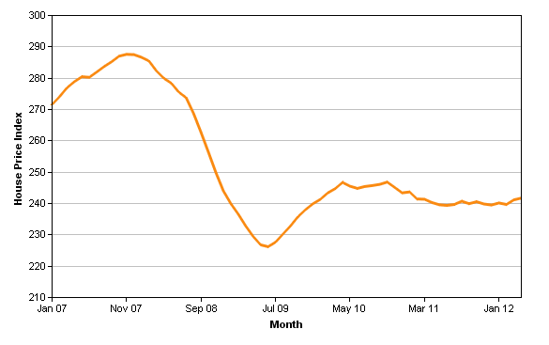
Figure 2.12.2: Sales volumes in Northamptonshire
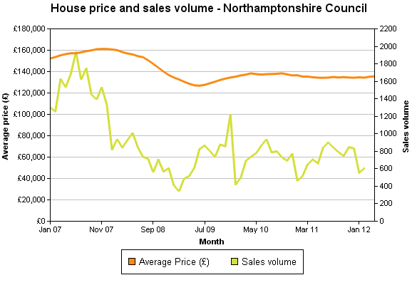

Source: Land Registry

According to Land Registry data, residential sales values in Northamptonshire have recovered since the lowest point in the cycle in June 2009. Prices increased by 8.5% between June 2009 and July 2010, but fell back by 1.5% by April 2012. In April 2012, sales values were 15.9% lower than the November 2007 peak value.

The future trajectory of house prices is currently uncertain, although Savills’ current prediction is that values are expected to increase over the next five years. Medium term predictions are that properties in the mainstream East Midlands markets will grow over the period between 2012 to 2016. Savills predict that values in mainstream East Midlands markets (i.e. non-prime) will fall by 1.5% in 2012, but increase by 0.5% in 2013, 2% in 2014, 3% in 2015 and 5% in 2016. This equates to cumulative growth of 9.2% between 2012-2016 inclusive, compared to a UK average of 6% cumulative growth over the same period.

Local Policy context

In addition to financing infrastructure, the Council expects residential developments to provide a mix of affordable housing tenures, sizes and types to help meet identified housing needs and contribute to the creation of mixed, balanced and inclusive communities. The Council expects developments to provide 30% affordable housing on-site, with a tenure mix of 65% rented and 35% shared ownership. The Council’s requirements are applied flexibly, having regard to individual site circumstances, including viability of development.

Development context

Developments in Kettering range from small in-fill sites to major sustainable urban extension (SUE) schemes, including the East of Kettering SUE. There are significant variations in residential sales values between different parts of the Council’s area, with the villages to the north west of the Borough (such as Wilbarston, Stoke Albany, Sutton Bassett, Dingley, Braybrooke, Weston by Welland) with the highest values and Kettering and the surrounding area with the lowest values. Outside Kettering, commercial development is more limited in scale. The Borough’s prime retail centre is performing well and the smaller retail centres in the smaller towns and larger villages are performing reasonably well. There is limited office and industrial development in parts of the Borough.

Methodology and appraisal inputs

Our methodology follows standard development appraisal conventions, using assumptions that reflect local market and planning policy circumstances. The study is therefore specific to Kettering and reflects the Council’s planning policy requirements.

Approach to testing development viability

Appraisal models can be summarised via the following diagram. The total scheme value is calculated, as represented by the left hand bar. This includes the sales receipts from the private housing and the payment from a Registered Social Landlord (‘RSL’) for the completed affordable housing units. The model then deducts the build costs, fees, interest, CIL (at varying levels) and developer’s profit. A ‘residual’ amount is left after all these costs are deducted – this is the land value that the Developer would pay to the landowner. The residual land value is represented by the brown portion of the right hand bar in the diagram.
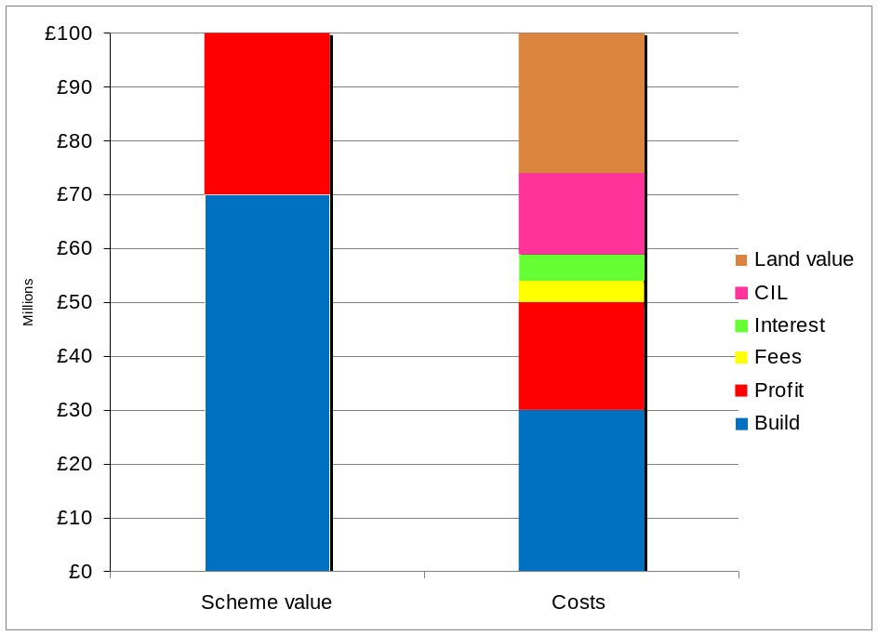

The Residual Land Value is normally a key variable in determining whether a scheme will proceed. If a proposal generates sufficient positive land value (in excess of current use value), it will be implemented. If not, the proposal will not go ahead, unless there are alternative funding sources to bridge the ‘gap’.

Ultimately, the landowner will make a decision on implementing a project on the basis of return and the potential for market change, and whether alternative developments might yield a higher value. The landowner’s ‘bottom line’ will be achieving a residual land value that sufficiently exceeds ‘existing use value’ or another appropriate benchmark to make development worthwhile. The margin above current use value may be considerably different on individual sites, where there might be particular reasons why the premium to the landowner should be lower or higher than other sites.

Clearly, however, landowners have expectations of the value of their land which often exceed the value of the current use. CIL will be a cost to the scheme and will impact on the residual land value. Ultimately, if landowners’ expectations are not met, they will not voluntarily sell their land and (unless a Local Authority is prepared to use its compulsory purchase powers) some may simply hold on to their sites, in the hope that policy may change at some future point with reduced requirements. It is within the scope of those expectations that developers have to formulate their offers for sites. The task of formulating an offer for a site is complicated further still during buoyant land markets, where developers have to compete with other developers to secure a site, often speculating on increases in value.

Viability benchmark

The CIL Regulations provide no specific guidance on how local authorities should test the viability of their proposed charges. However, there is a range of good practice generated by both the Homes and Communities Agency and appeal decisions that assist in guiding planning authorities on how they should approach viability testing for planning policy purposes.

In 2009, the Homes and Communities Agency published a good practice guidance manual ‘Investment and Planning Obligations: Responding to the Downturn’. This defines viability as follows: “a viable development will support a residual land value at level sufficiently above the site’s existing use value (EUV) or alternative use value (AUV) to support a land acquisition price acceptable to the landowner”.

A number of planning appeal decisions provide guidance on the extent to which the residual land value should exceed existing use value to be considered viable:

Barnet & Chase Farm: APP/Q5300/A/07/2043798/NWF
“the appropriate test is that the value generated by the scheme should exceed the value of the site in its current use. The logic is that, if the converse were the case, then sites would not come forward for development”

Bath Road, Bristol: APP/P0119/A/08/2069226
“The difference between the RLV and the existing site value provides a basis for ascertaining the viability of contributing towards affordable housing.”

Beckenham: APP/G5180/A/08/2084559
“without an affordable housing contribution, the scheme will only yield less than 12% above the existing use value, 8% below the generally accepted margin necessary to induce such development to proceed.”

Oxford Street, Woodstock: APP/D3125/A/09/2104658
“The main parties’ valuations of the current existing value of the land are not dissimilar but the Appellant has sought to add a 10% premium. Though the site is owned by the Appellants it must be assumed, for valuation purposes, that the land is being acquired now. It is unreasonable to assume that an existing owner and user of the land would not require a premium over the actual value of the land to offset inconvenience and assist with relocation. The Appellants addition of the 10% premium is not unreasonable in these circumstances.”

It is clear from the planning appeal decisions above and HCA good practice publication that the most appropriate test of viability for planning policy purposes is to consider the residual value of schemes compared to the existing use value plus a premium. As discussed later in this report, our study adopts a range of benchmark land values, reflecting differing circumstances in which sites are brought forward.

The recent examination on the Mayor of London’s CIL charging schedule considered the issue of an appropriate land value benchmark. The Mayor had adopted existing use value, while certain objectors suggested that ‘Market Value’ was a more appropriate benchmark. The Examiner concluded that:

“The market value approach…. while offering certainty on the price paid for a development site, suffers from being based on prices agreed in an historic policy context.” (para 8) and that “I don’t believe that the EUV approach can be accurately described as fundamentally flawed or that this examination should be adjourned to allow work based on the market approach to be done” (para 9).

In his concluding remark, the Examiner points out that

“the price paid for development land may be reduced [so that CIL may be accommodated]. As with profit levels there may be cries that this is unrealistic, but a reduction in development land value is an inherent part of the CIL concept. It may be argued that such a reduction may be all very well in the medium to long term but it is impossible in the short term because of the price already paid/agreed for development land. The difficulty with that argument is that if accepted the prospect of raising funds for infrastructure would be forever receding into the future. In any event in some instances it may be possible for contracts and options to be re-negotiated in the light of the changed circumstances arising from the imposition of CIL charges. (para 32 – emphasis added).

HCA and CLG sponsored guidance on testing the viability of local planning requirements is due to be published in draft form on 21 June 2012. This guidance also recognises current or existing use value plus a margin as a suitable benchmark for testing CIL The guidance issued by the Local Housing Delivery Group (‘LHDG’) on 22 June 2012 advocates the use of current use value plus an appropriate premium as a benchmark for testing CIL and local plan policy requirements.

It is important to stress, however, that there is no single threshold land value at which land will come forward for development. The decision to bring land forward will depend on the type of owner and, in particular, whether the owner occupies the site or holds it as an asset; the strength of demand for the site’s current use in comparison to others; how offers received compare to the owner’s perception of the value of the site, which in turn is influenced by prices achieved by other sites. Given the lack of a single threshold land value, it is difficult for policy makers to determine the minimum land value that sites should achieve. This will ultimately be a matter of judgement for each individual Charging Authority.

Development appraisals

Residential development

We have appraised a series of generic developments, reflecting both the range of sales values/capital values and also sizes/types of development and densities of development across the area. The inputs to the appraisals are based on research on the local housing market.
Residential sales values

Residential values in the area reflect national trends in recent years but do of course vary between different sub-markets. We have considered comparable evidence of transacted properties in the area and also properties on the market to establish appropriate values for testing purposes. This exercise indicates that developments in the Borough will attract average sales values ranging from circa £1,544 to £2,246 per square metre.

Sales values vary between different parts of the Borough, with the villages to the north and west of the Borough with the highest values and the mid section of the Borough including Rothwell and Kettering having the lowest values. The average values identified in Table 4.3.1.are based on average prices for Houses in the specified areas. These average values have been extrapolated to determine the average values of each development typology assessed (see table 4.10.1) i.e. this weights the values of the units proposed in each site type. (See Appendix 1 for the average values we have assumed in our appraisals).
Table 4.3.1: Average sales values
Location | Ave price of Houses per sq m
Rothwell and Desborough | £1,544
Kettering | £1,632
Burton Latimer and Barton Seagrave | £1,719
Low Value Villages NN14 East (Broughton, Mawsley, Pytchley, Rushton, Thorpe Malsor, Cransley) | £1,737
High Value Villages NN14 (Geddington, Grafton Underwood, Newton, Cranford, Loddington) | £2,158
High Value villages East NN16, NN18 (Weekly, Little Oakley, Warkton ) | £2,158
LE 16 Villages (Wilbarston, Stoke Albany, Sutton Bassett, Dingley, Braybrooke, Weston by Welland, Brampton Ash, Thorpe Underwood ) | £2,246

As noted earlier in the report, Savills predict that sales values will increase over the medium term. Whilst this predicted growth cannot be guaranteed, we have run a sensitivity analysis assuming growth in sales values of 10%, accompanied by 5% increase in costs (the latter assuming a pick up in construction activity and higher labour and materials costs). We have also modelled a fall in prices of 5%, to provide the Council with an indication of the impact a reverse in values would have on viability.

Affordable housing tenure and values

The Council’s policy position is that all new residential development should provide affordable housing, targeting 30% affordable housing subject to viability. The Council has advised that they seek a tenure mix of 65% rented housing and 35% intermediate housing.

The Council is currently formulating its approach to the ‘Affordable Rent’ tenure and the likely outcome is currently uncertain. In view of the benefits caps under the Universal Credit, it is possible that rent levels cannot be increased to a significantly higher level than target rents. We have therefore assumed that the rented element of schemes will be provided as social rent at target rents.

The CLG/HCA ‘2011-2015 Affordable Homes Programme – Framework’ (February 2011) document clearly states that RSLs will not receive grant funding for any affordable housing provided through planning obligations. Consequently, all our appraisals assume nil grant. We recommend that the Council revisits this assumption when it next reviews its charging schedule, by which time a new funding programme may have been introduced by central government.

For shared ownership units, we have assumed that RSLs will sell 30% initial equity stakes and charge a rent of 2.75% on the retained equity. A 10% charge for management is deducted from the rental income and the net amount is capitalised using a yield of 5.25%.

Residential development types, density and mix

We have run appraisals applying a density which is typically encountered in the Borough. We have had regard to the density of development indicated by the Council’s Core Strategy, which identifies that the Council support development at a range of densities with an overall net density of at least 35 dwellings per hectare.

Table 4.10.1 summarises the different development typologies selected for testing purposes. These are intended to reflect the range of developments across the Borough.

Table 4.10.1: Development typologies

Site Type | Number of units | Housing type | Development density units per ha | Net developable area (ha) | Gross site area (ha)
1 | 1 | House | 35 | 0.03 | 0.03
2 | 3 | House | 35 | 0.09 | 0.09
3 | 10 | Houses | 35 | 0.29 | 0.29
4 | 20 | Houses | 35 | 0.57 | 0.82
5 | 50 | House | 35 | 1.43 | 1.43
6 | 250 | Houses | 35 | 7.14 | 10.20
7 | 700 | Houses | 35 | 20.0 | 28.57

Table 4.10.2: Unit Mix
Site type | 2 bed house | 3 bed house | 4 bed house
Unit size | 75 sqm | 95 sqm | 115 sqm
1 | - | - | 100%
2 | 33% | 67% | -
3 | 30% | 40% | 30%
4 | 30% | 40% | 30%
5 | 30% | 40% | 30%
6 | 30% | 40% | 30%
7 | 30% | 40% | 30%

Residential build costs

We have applied residential build costs having regard to advice from active agents in the area following the developer’s workshop and build costs for the residential schemes from the RICS Building Cost Information Service (BCIS), which is based on tenders for actual schemes. However, adjustments to the base costs are necessary to reflect the specification of development in the Borough. Our approach is set out below.

The mean BICS base cost for houses is £837 per square metre, excluding external works and fees. Agents advised that in their experience build costs in North Northamptonshire started at about 875 per sq m and went up to £1,000 per square metre. We have therefore applied a build cost of £875 per square metre. After a 15% allowance for external works has been added, the final build cost is £1,006 per square metre. We have assumed a gross to net ratio of 100% for houses.

A summary of residential build costs is provided in Table 4.13.1.
Site type | BCIS base – quarter 2 2012 | Base cost | Adjusted cost | External works | All-in cost
1-7 | Houses - generally | £837 | £875 | 15% | £1,006
Table 4.13.1: Build costs

An additional 6% allowance is included across all tenures for meeting Code for Sustainable Homes level 4, which is reflective of the findings of work undertaken by Cyrill Sweett on behalf of CLG.
Professional fees

In addition to base build costs, schemes will incur professional fees, covering design, valuation, highways consultants, planning, EPCs, NHBC and so on. Our appraisals incorporate a 10% allowance, which is at the higher end of the range for most schemes.
Finance

We have adopted an interest rate of 7%, with no additional allowance for fees, which we consider to be an optimistic assumption for developments of this nature in the current market. It should be noted that although a bank would not provide 100% of the funding required for Development it is conventional to assumed finance on all costs in order to reflect the opportunity cost (or in some cases the actual cost) of committing equity to the project.
Marketing and disposal costs

We have adopted a marketing and sales agent fee of 3% of market GDV and legal fees of £600 per residential unit.
Stamp Duty and acquisition costs

We have adopted the following acquisition costs:

- Stamp Duty Land Tax at 4%;
- Agent fees as 1%; and
- Legal fees at 0.8%.
Section 278 and residual Section 106 costs

Our appraisals incorporate an allowance per unit to address any Section 278 and residual Section 106 costs as advised by the Council. These costs are set out in Table 4.38.1 below.
Development and sales periods

Development and sales periods vary between type of scheme. However, our sales periods are based on an assumption of a sales rate of 3 units per month. This is reflective of current market conditions, whereas in improved markets, a sales rate of up to 5 units per month might be expected. The build and sales periods for each scheme type are summarised in Table 4.38.1 below.

Developer’s profit

Developer’s profit is closely correlated with the perceived risk of residential development. The greater the risk, the greater the required profit level, which helps to mitigate against the risk, but also to ensure that the potential rewards are sufficiently attractive for a bank and other equity providers to fund a scheme. In 2007, profit levels were at around 15-17% of development costs. However, following the impact of the credit crunch and the collapse in interbank lending and the various government bailouts of the banking sector, profit margins have increased. It is important to emphasise that the level of minimum profit is not necessarily determined by developers (although they will have their own view and the Boards of the major housebuilders will set targets for minimum profit).

The views of the banks which fund development are more important; if the banks decline an application by a developer to borrow to fund a development, it is very unlikely to proceed, as developers rarely carry sufficient cash to fund it themselves. Consequently, future movements in profit levels will largely be determined by the attitudes of the banks towards development proposals.

The near collapse of the global banking system in the final quarter of 2008 is resulting in a much tighter regulatory system, with UK banks having to take a much more cautious approach to all lending. In this context, and against the backdrop of the current sovereign debt crisis in the Eurozone, the banks may not allow profit levels to decrease much lower than their current level of 20%.

Our assumed return on the affordable housing GDV (Gross Development Value) is 6%. A lower return on the affordable housing is appropriate as there is very limited sales risk on these units for the developer; there is often a pre-sale of the units to an RSL prior to commencement. Any risk associated with take up of intermediate housing is borne by the acquiring RSL, not by the developer. A reduced profit level on the affordable housing reflects the GLA ‘Development Control Toolkit’ guidance and Homes and Communities Agency’s guidelines in its Economic Appraisal Tool.

Phasing of CIL payments

The Council is yet to formulate its instalment policy. For testing purposes, we have assumed that any CIL due will be split into three equal instalments, payable at the months shown in Table 4.38.1.

Benchmark land values for the residential analysis

Benchmark land values, based on the current use value or alternative use value of sites are key considerations in the assessment of development economics for testing planning policies and tariffs. Clearly, there is a point where the Residual Land Value (what the landowner receives from a developer) that results from a scheme may be less than the land’s current use value. Current use values can vary significantly, depending on the demand for the type of building relative to other areas. Similarly, subject to planning permission, the potential development site may be capable of being used in different ways – as a hotel rather than residential for example; or at least a different mix of uses. Current use value or alternative use value are effectively the ‘bottom line’ in a financial sense and therefore a key factor in this study.

We have arrived at a broad judgement on the likely range of benchmark land values. On previously developed sites, the calculations assume that the landowner has made a judgement that the current use does not yield an optimum use of the site; for example, it has fewer storeys than neighbouring buildings; or there is a general lack of demand for the type of space, resulting in low rentals, high yields and high vacancies (or in some cases no occupation at all over a lengthy period). We would not expect a building which makes optimum use of a site and that is attracting a reasonable rent to come forward for development, as residual value may not exceed current use value in these circumstances.

In considering the value of sites in existing commercial use, it is necessary to understand the concept of ‘yields’. A yield is basically a method of expressing a return on an investment. Yields form the basis of the calculation of a building’s capital value, based on the net rental income that it generates. Yields are used to calculate the capital value of any building type which is rented, including both commercial and residential uses. Yields are used to calculate the number of times that the annual rental income will be multiplied to arrive at a capital value. That is to say a yield identifies how many times over a purchaser will be willing to pay for the right to receive the rental income from a property.

Yields reflect the confidence of a potential purchaser of a building in the income stream (i.e. the rent) that the occupant will pay. They also reflect the quality of the building and its location, as well as general demand for property of that type. As such, the lower the covenant strength of the occupier (or potential occupiers if the building is currently vacant), and the poorer the location of the building, the greater the risk that the tenant may not pay the rent. If this risk is perceived as being high, the yield will be high, resulting in a lower number of years rent purchased (i.e. a lower capital value). The reverse of this is would be a good quality building let to a tenant with a strong covenant. In this situation the perceived risk of default and re-letting the premises would be low and accordingly the yield applied would be low. This would be reflected in a higher capital value being achieved for the property as a purchaser would be willing to pay for a greater number of years of rent.

Over the past four years, yields for commercial property have ‘moved out’ (i.e. increased), signalling lower confidence in the ability of existing tenants to pay their rent and in future demand for commercial space. This has the effect of depressing the capital value of commercial space. However, as the economy recovers, we would expect yields to improve (i.e. decrease), which will result in increased capital values. Consequently, current use values might increase, increasing the base value of sites that might come forward, which may have implications for landowners’ decisions on releasing sites for alternative uses.

Redevelopment proposals that generate residual land values below current use values are unlikely to be delivered. While any such thresholds are only a guide in ‘normal’ development circumstances, it does not imply that individual landowners, in particular financial circumstances, will not bring sites forward at a lower return or indeed require a higher return. If proven current use value justifies a higher benchmark than those assumed, then appropriate adjustments may be necessary. As such, current use values should be regarded as benchmarks rather than definitive fixed variables on a site by site basis.

The four benchmark land values used in this study have been selected to provide a broad indication of likely land values across the Borough, but it is important to recognise that other site uses and values may exist on the ground. There can never be a single threshold land value at which we can say definitively that land will come forward for development, especially in urban areas.

It is also necessary to recognise that a landowner will require an additional incentive to release the site for development. The premium above current use value would be reflective of specific site circumstances (the primary factors being the occupancy level and strength of demand from alternative occupiers). For policy testing purposes it is not possible to reflect the circumstances of each individual site, so a blanket assumption of a 20% premium has been adopted to reflect the ‘average’ situation.

Benchmark Land Value 1: This benchmark is based on a ‘residential land value’ of £100,000 per gross acre, which was identified as the level below which landowners would not sign up to an option agreement by the active developers and agents who attended the stakeholders workshop. The resulting land value benchmark is £247,000 per gross Hectare.

Benchmark Land Value 2: This benchmark assumes secondary office space on a hectare of land, with 40% site coverage and 4 storeys. The rent assumed is based on lettings of second hand offices in the Borough (£54 per square metre), capitalised at a yield of 9%. We have assumed a £431 per square metre allowance for refurbishment and a letting void/rent free period of two and a half years. The capital value of the building would be £914,000, to which we have added a 20% premium, resulting in a benchmark of £1.096 million.

Benchmark Land Value 3: This benchmark assumes lower value secondary industrial space on a hectare of land, with 60% site coverage and one storey. The rent assumed is based on lettings of secondary industrial floorspace in the Borough (£32 per square metre), capitalised at a yield of 10%. We have assumed an £172 per square metre allowance for refurbishment and a letting void/rent free period of two and a half years. The capital value of the building would be £507,000, to which we have added a 20% premium, resulting in a benchmark of £608,000.

Benchmark Land Value 4: This benchmark assumes a community building or similar facility, which could include buildings owned by the Council and other public sector bodies, and community/charity groups. We have assumed site coverage of 50% across a hectare of land, with a single storey building. The rent assumed is based on our estimate of £11 per square metre, capitalised at a yield of 10%. We have assumed a £43 per square metre allowance for refurbishment and a letting void of one year. The capital value of the building would be £289,000, to which we have added a 20% premium, resulting in a benchmark of £347,000.

We would draw readers’ attention to the comments on land values in Examiner’s report on the Mayor of London’s CIL, which indicates that owners will need to adjust their expectations to accommodate allowances for infrastructure.

Our residential appraisal inputs are summarised in Table 4.38.1.

Table 4.38.1: Residential appraisal assumptions for each site type
Appraisal input | Source/Commentary | Site type number and assumptions
 |  | 1 | 2 | 3 | 4 | 5 | 6 | 7
Number of units |  | 1 | 3 | 10 | 20 | 50 | 250 | 700
Base construction costs  (£s per sq metre) | Advice from active developers and agents compared to BCIS adjusted for location  Based on gross areas before external works.  Additional adjustments as set out in Table 4.13.1 | £875 | £875 | £875 | £875 | £875 | £875 | £875
External works  (% of build costs) | Based on average scheme cost. | 15% | 15% | 15% | 15% | 15% | 15% | 15%
Contingency (% of build cost) | Industry norm (5%) | 5% | 5% | 5% | 5% | 5% | 5% | 5%
Professional fees (% of build) | BNPPRE assumption | 10% | 10% | 10% | 10% | 10% | 10% | 10%
Construction period (months) | We assume that developers will build at the rate they are able to sell. | 6 | 6 | 12 | 24 | 24 | 40 | 45
Sales period (months) | Determined by ability of market to absorb new development | 1 | 1 | 1 | 7 | 17 | 36 | 58
Sale start (month from commencement) | Linked to later stages of construction period | 6 | 6 | 10 | 20 | 12 | 12 | 12
Sales rate (units per month) | Reflective of current market, could improve. Multiple outlets assumed on larger sites. | 1 | 1 | 3.3 | 2.8 | 2.9 | 3 | 3
Profit on private  (% of GDV) | BNPPRE assumption – reflective of current funder requirements | 20% | 20% | 20% | 20% | 20% | 20% | 20%
Profit on affordable  (% of GDV) | Reduced risk due to pre-sale to RSL | 6% | 6% | 6% | 6% | 6% | 6% | 6%
Phasing of CIL payments | BNPPRE assumption – equal splits, paid in months shown in table | 1 / 1 / 1 | 1 / 1 / 1 | 1 / 1 / 1 | 1 / 12 / 18 | 1 / 12 / 18 | 1 / 12 / 24 | 1 / 12 / 36
Density and site area  (ha, developable area) | Core Strategy | 35uph  0.03 ha | 35 uph  0.09 ha | 35 uph  0.29 ha | 35 uph  0.57 ha | 35 uph  1.43 ha | 35 uph  7.14 ha | 35uph  20 ha
Residual onsite S106 / Greenfield infrastructure cost / Brownfield abnormal cost | Advice from Council and BNPPRE assumptions | - | - | £1,365 per unit  And £5k per unit | £1,365 per unit  And £5k per unit | £1,365 per unit  And £5k per unit | £1,365 per unit  And £20k per unit | £1,365 per unit  And £20k per unit

Commercial development

We have appraised a series of hypothetical commercial developments, reflecting a range of use classes at average rent levels achieved on lettings of commercial space in actual developments (As set out in table 4.43.1). In each case, our assessment assumes an intensification of the existing use on the site, based on the same type of commercial development. In each case, the existing use value assumes that the existing building is half the size of the new development, with a lower rent and higher yield reflecting the secondary nature of the building.
Commercial rents and yields

Our research on lettings of commercial floorspace indicates a range of rents achieved, as summarised in table 4.43.1. This table also includes our assumptions on appropriate yields to arrive at a capital value of the commercial space. There has been some large retail development activity over the past few years i.e. development of the PC world unit at Northfield Avenue in 2009/2010. New build office developments are likely to attract a premium rent above second hand rents, but we would expect this to be relatively modest. The rents and yields adopted in our appraisals are summarised in Table 4.43.1.

Our appraisals of commercial floorspace test the viability of developments on existing commercial sites. For these developments, we have assumed that the site currently accommodates the same use class and the development involves intensification of that use. We have assumed lower rents and higher yields for existing space than the planned new floorspace. This reflects the lower quality and lower demand for second hand space, as well as the poorer covenant strength of the likely occupier of second hand space. A modest refurbishment cost is allowed for to reflect costs that would be incurred to secure a letting of the existing space. A 20% landowner premium is added to the resulting existing use value as an incentive for the site to come forward for development. The actual premium would vary between sites, and be determined by site-specific circumstances, so the 20% premium has been adopted as a ‘top of range’ scenario for testing purposes.

Commercial build costs

We have sourced build costs for the commercial schemes from the RICS Building Cost Information Service (BCIS), which is based on tenders for actual schemes. These costs vary between different uses and exclude external works and fees (our appraisals include separate allowances for these costs). Costs for each type of development are shown in Table 4.43.1.

Profit

In common with residential schemes, commercial schemes need to show a risk adjusted profit to secure funding. Profit levels are typically around 20% of developments costs and we have incorporated this assumption into our appraisals.

Table 4.43.1: Commercial appraisal assumptions for each use
Appraisal input | Source/Commentary | Retail – Kettering Town Centre (A1-A5) | Retail – Small Towns & Larger Villages (A1-A5) | Retail warehouse / superstore / retail park (A1) | Industrial / warehousing  (B2/B8) | Offices  (B1)
Total floor area (sq ft) | Generic scheme | 3,000 | 3,000 | 30,000 | 30,000 | 30,000
Rent (£s per sq ft) | Based on average lettings sourced from Focus, EGI and Local Agents | £30 | £12 | £15 | £5 | £8
Rent free/void period (years) | Based on information from local agents and BNPRE experience | 2 years | 2 years | 2 years | 2 years | 2 years
Yield | BNPPRE prime yield schedule and local agents | 7% | 7.75% | 6.75% | 9% | 8%
Purchaser’s costs (% of GDV) | Stamp duty 4%, plus agent’s and legal fees | 5.75% | 5.75% | 5.75% | 5.75% | 5.75%
Demolition costs (£s per sq ft of existing space) | Based on BNPPRE experience | £5 | £5 | £5 | £5 | £5
Gross to net (net as % of gross) | Based on BNPPRE experience | 82% | 82% | 82% | 90% | 82%
Base construction costs  (£s per sq ft) | BCIS costs. Offices – ‘generally’ for air conditioned offices.  ‘Generally’ figure for industrial and town centre retail. | £85 | £85 | £75 | £60 | £123
External works  (% of build costs) | Based on BNPPRE experience | 10% | 10% | 10% | 10% | 10%
Contingency (% of build costs) | Based on BNPPRE experience | 5% | 5% | 5% | 5% | 5%
Letting agent’s fee | (% of first year’s rent) | 10% | 10% | 10% | 10% | 10%
Agent’s fees and legal fees | (% of capital value) | 1.75% | 1.75% | 1.75% | 1.75% | 1.75%
Interest rate | Based on BNPPRE experience | 7% | 7% | 7% | 7% | 7%
Professional fees (% of build) | BNPPRE assumption, relates to complexity of scheme | 10% | 10% | 10% | 10% | 10%

Table 4.43.1 (continued) Commercial appraisal assumptions for each use – existing uses

Appraisal input | Source/Commentary | Retail – Kettering Town Centre | Retail – Small Towns and Larger Villages | Retail warehouse / superstore / retail park (A1) | Industrial / warehousing  (B2/B8) | Offices
Profit (% of costs) | BNPPRE assumption | 20% | 20% | 20% | 20% | 20%
Rent on existing floorspace | Reflects poor quality second hand space of same use, low optimisation of site etc and ripe for redevelopment | £10 to £20 | £3.50 to £10 | £3.50 to £10 | £3.50 - £8 | £3.50 - £7.50
Yield on existing floorspace | BNPPRE assumption, reflecting lower covenant strength of potential tenants, poor quality building etc | 7.75% - 8% | 8.5% - 9% | 9% - 10% | 9% - 10% | 9% - 10%
Rent free on existing space | Years | 3 | 3 | 3 | 3 | 3
Refurbishment costs (£s per sq ft) | General allowance for bringing existing space up to lettable standard | £50 | £50 | £50 | £50 | £50
Fees on refurbishment (% of refurb cost) | BNPPRE assumption | 7% | 7% | 7% | 7% | 7%
Landowner premium | BNPPRE assumption – in reality the premium is likely to be lower, therefore this is a conservative assumption | 20% | 20% | 15% – 20% | 15% – 20% | 15% – 20%

Appraisal outputs

Residential appraisals

The full outputs from our appraisals of residential development are attached as Appendix 2. We have modelled seven generic site types, reflecting different types of development, which are tested in each of the eight sub-market areas identified in Section 4 and against four land value benchmarks. These types are summarised in table 5.1.1 below.

Table 5.1.1: Development types
 | Number of units | Housing type | Development density units per ha | Net developable area (ha) | Gross site area (ha)
1 | 1 | Houses | 35 | 0.03 | 0.03
2 | 3 | Houses | 35 | 0.09 | 0.09
3 | 10 | Houses | 35 | 0.29 | 0.29
4 | 20 | Houses | 35 | 0.57 | 0.82
5 | 50 | Houses | 35 | 1.43 | 1.43
6 | 250 | Houses | 35 | 7.14 | 10.20
7 | 700 | Houses | 35 | 20.0 | 28.57
Scenarios tested
- 1. Base sales and base costs (including Code for Sustainable Homes Level 4); 30% affordable housing (excluding Site type 1 and 2 and 3 in urban areas) with rented element let at target rents;
- 2. Sales fall by 5%;
- 3. Sales increase by 10% and costs increase by 5%;
- 4. As (1) with 20% affordable housing;
- 5. As (1) with 10% affordable housing; and
- 6. As (1) with 0% affordable housing (excluding Site type 1 and 2 and 3 in urban areas).

We assume that all development types will meet Code for Sustainable Homes level 4. Level 4 is reflected through a 6% adjustment to our base build costs for all tenures.

For all types of site, we have run two sensitivity analyses; firstly, with sales values falling by 5%; and secondly, with sales values increasing by 10% and build costs also increasing by 5%. This analysis is provided for illustrative purposes and may assist the Council in understanding how viability might be affected by movements in sales values (up and down) over time. However, the future trajectory of the housing market is inherently uncertain and predictions cannot be relied upon.

The residual land values from each of the scenarios above in each of the seven housing market areas are then compared to four benchmark land values (‘BLVs’) based on the assumptions set out in paragraphs 4.32 to 4.37. This comparison enables us to determine whether the imposition of CIL would have an impact on development viability. In some cases, the equation RLV less BLV results in a negative number, so the development would not proceed, whether CIL was imposed or not. We therefore focus on situations where the RLV is greater than BLV and where (all other things being equal) the development would proceed. In these situations, CIL has the potential to ‘tip the balance’ of viability into a negative position.

Commercial appraisals

Our research on rents achieved on commercial lettings indicates a range of rents within each main use class. Our commercial appraisals therefore model base position and test the range of rates (higher and lower than the base level) and changes to yields. This enables us to draw conclusions on maximum potential rates of CIL. For each use class tested (B1, B2/B8, retail etc), we have run appraisals of a quantum of floorspace, each with rent levels reflecting the range identified by our research.

Presentation of data
Residential appraisals results

The results for each site are presented in six spreadsheets, as follows:
- Base sales values, CSH level 4 on all tenures;
- Sales values -5%;
- Sales values + 10%, build costs + 5%;
- Scenario 1 with reduced affordable housing (20%);
- Scenario 1 with reduced affordable housing (10%); and
- Scenario 1 with reduced affordable housing (0%).

A sample of the format of the results is provided below. This sample relates to site type 1.
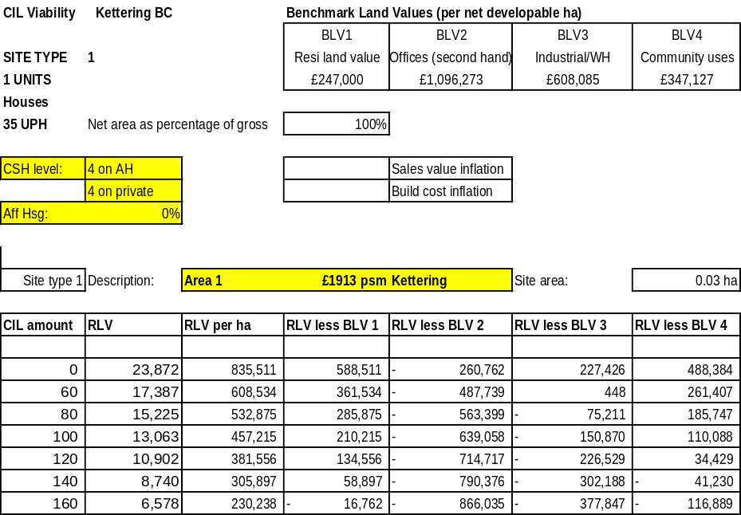

Each spreadsheet provides residual values at varying amounts of CIL, starting at £0 and increasing to £500 per square metre. Whilst CIL applies to net additional floor area only, our appraisals assume that it is applied to the whole development (excluding affordable housing). This reflects a worst case scenario, as many sites in the Borough will have existing buildings, although not necessarily occupied.

Separate data tables are provided in each spreadsheet for each of the housing market areas:
- Area 1: Rothwell;
- Area 2: Kettering;
- Area 3: Desborough and Rothwell
- Burton Latimier and Barton Seagrave
- Area 4: Low Value Villages NN14 East (Broughton, Mawsley, Pytchley, Rushton, Thorpe Malsor, Cransley);
- Area 5: High Value Villages NN14 (Geddington, Grafton Underwood, Newton, Cranford, Loddington);
- Area 6: High Value villages East NN16, NN18 (Weekly, Little Oakley, Warkton); and
- Area 7: LE 16 Villages (Wilbarston, Stoke Albany, Sutton Bassett, Dingley, Braybrooke, Weston by Welland, Brampton Ash, Thorpe Underwood).

The RLV is converted to a per hectare rate and compared to the four benchmark land values (see paragraphs 4.32 to 4.43). This is shown in the columns headed ‘RLV less BLV1, BLV2’ etc. A positive number indicates that the development is viable, as the developer will receive a normal level of development profit and the land value will be sufficient for the site to come forward.

The numerical data is then displayed in four graphs, one for each threshold land value. The graphs show the amount by which the RLV exceeds BLV (or is less than BLV) for each level of CIL. In the illustrative example below (Chart 5.12.1), the graph shows that the maximum viable level of CIL would be £140 per square metre, but that above this level, higher levels of CIL would render the scheme unviable. It is important to note that the charts do not have the same scale and the reader needs to bear this in mind if comparing one chart to another.

Chart 5.11.1: Illustrative example of data chart

Commercial appraisal results

The commercial appraisal results are more straightforward, due to the narrower range of variables that need to be considered in comparison to residential development. The appraisals include a ‘base’ rent level, with sensitivity analyses which model rents above and below the base level (an illustration is provided in Chart 5.12.1). The maximum CIL rates are then shown per square metre, against three different current use values (CUV) (see paragraphs 4.25 to 4.34). Chart 5.12.2 provides an illustration of the outputs in numerical format, while Chart 5.12.3 shows the data in graph format. In this example, the scheme could viably absorb a CIL of between £0 and £139 per square metre, depending on the current use value. The analysis demonstrates the significant impact of very small changes in yields (see appraisals 4 and 6, which vary the yield by 0.25% up or down) on the viable levels of CIL.

Chart 5.12.1: Illustration of sensitivity analyses
 | £s per sqm | Yield | Rent free
Appraisal 1 | £129.16 | 7.75% | 2.00 years
Appraisal 2 | £139.93 | 7.75% | 2.00 years
Appraisal 3 | £150.69 | 7.75% | 2.00 years
Appraisal 4 | £161.46 | 8.00% | 2.00 years
Appraisal 5 (base) | £161.46 | 7.75% | 2.00 years
Appraisal 6 | £161.46 | 7.50% | 2.00 years
Appraisal 7 | £182.98 | 7.75% | 2.00 years
Appraisal 8 | £193.75 | 7.75% | 2.00 years
Appraisal 9 | £204.51 | 7.75% | 2.00 years
Appraisal 10 | £20.00 | 7.75% | 2.00 years

Chart 5.12.2: Maximum CIL rates – numerical format
 | Change in rent from base | CUV 1 | CUV 2 | CUV 3
Appraisal 1 | -25% | £0 | £0 | £0
Appraisal 2 | -15% | £0 | £0 | £0
Appraisal 3 | -7% | £0 | £0 | £0
Appraisal 4 | 0% | £66 | £3 | £0
Appraisal 5 (base) | - | £139 | £76 | £0
Appraisal 6 | 0% | £210 | £148 | £0
Appraisal 7 | 12% | £386 | £323 | £149
Appraisal 8 | 17% | £510 | £447 | £273
Appraisal 9 | 21% | £633 | £570 | £396
Appraisal 10 | 25% | £757 | £694 | £520

Chart 5.12.3: Maximum CIL rates – graph format
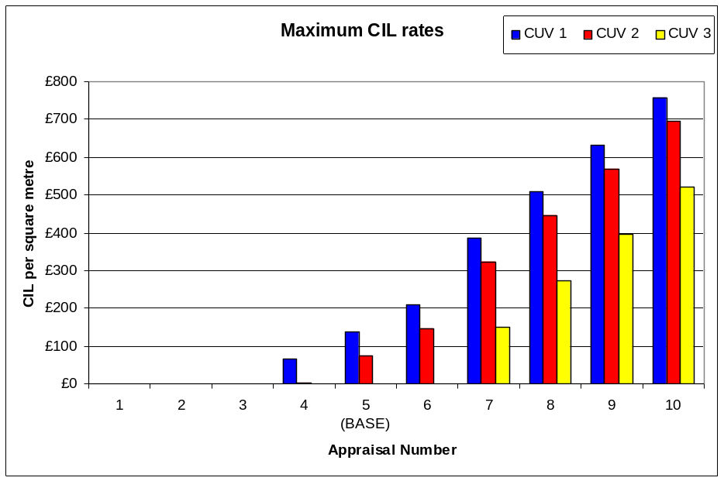

Assessment of the results

This section should be read in conjunction with the full results attached at Appendix 2 (residential appraisal results) and Appendix 3 (commercial appraisal results). In these results, the residual land values are calculated for scenarios with sales values and capital values reflective of market conditions across the Borough. These RLVs are then compared to benchmark land values.

The CIL regulations state that in setting a charge, local authorities must “aim to strike what appears to the charging authority to be an appropriate balance” between revenue maximisation on the one hand and the potentially adverse impact of CIL upon the viability of development across the whole area on the other. Our recommendations are that:
- Firstly, councils should take a strategic view of viability. There will always be variations in viability between individual sites, but viability testing should establish the most typical viability position; not the exceptional situations.
- Secondly, councils should take a balanced view of viability – residual valuations are just one factor influencing a developer’s decision making – the same applies to local authorities.
- Thirdly, while a single charge is attractive, it may not be appropriate for all authorities, particularly in areas where sales values vary between areas.
- Fourthly, markets are cyclical and subject to change over short periods of time. Sensitivity testing levels of CIL to ensure they are robust in the event that market conditions improve over the life of a Charging Schedule is essential.
- Fifthly, local authorities should not set their rates of CIL at the limits of viability. They should leave a margin or contingency to allow for change and site specific viability issues.

The early examinations have seen a debate on how viability evidence should translate into CIL rates. It has now been widely recognised that there is no requirement for a Charging Authority to slavishly follow the outputs of residual valuations. At Shropshire Council’s examination in public, Newark & Sherwood Council argued that rates of CIL should be set at the level dictated by viability evidence which would (if followed literally) have resulted in a Charging Schedule with around thirty different charging zones across the Shropshire area. Clearly this would have resulted in a level of complexity that CIL is intended to avoid. The conclusion of this debate was that CIL rates should not necessarily be determined solely by viability evidence, but should not be logically contrary to the evidence. Councils should not follow a mechanistic process when setting rates – appraisals are just a guide to viability and are widely understood to be a less than precise tool.

Assessment – residential development

As CIL is intended to operate as a fixed charge, the Council will need to consider the impact on two key factors. Firstly, the need to strike a balance between maximising revenue to invest in infrastructure on the one hand and the need to minimise the impact upon development viability on the other. CLG guidance recognises that CIL may make some developments unviable. Secondly, as CIL will effectively take a ‘top-slice’ of development value, there is a potential impact on the percentage or tenure mix of affordable housing that can be secured. This is a change from the current system of negotiated financial contributions, where the planning authority can weigh the need for contributions against the requirement that schemes need to contribute towards affordable housing provision.

In assessing the results, it is important to clearly distinguish between two scenarios; namely, schemes that are unviable regardless of the level of CIL (including a nil rate) and schemes that are viable prior to the imposition of CIL at certain levels. If a scheme is unviable before CIL is levied, it is unlikely to come forward and CIL would not be a factor that comes into play in the developer’s/landowner’s decision making. We have therefore disregarded the ‘unviable’ schemes in recommending an appropriate level of CIL. The unviable schemes will only become viable following a degree of real house price inflation, or in the event that the Council agrees to a lower level of affordable housing in the short term.
Determining maximum viable rates of CIL for residential development

As noted in paragraph 6.5, where a scheme is unviable the imposition of CIL at a zero level will not make the scheme viable. Other factors (i.e. sales values, build costs or benchmark land values) would need to change to make the scheme viable. For the purposes of establishing a maximum viable rate of CIL, we have had regard to the development scenarios that are currently viable and that might, therefore, be affected by a CIL requirement. All the results summarised below assume that current affordable housing requirements are met in full.

In the main, Site type 1 generates residual values that are higher than the ‘residential’, ‘Industrial’ and ‘community’ benchmark land values, with the highest CIL rate of £300 per square metre in some cases. However, residential schemes are unlikely to generate residual values that exceed existing office values in all cases. Scheme viability becomes more challenging in Rothwell and Desborough (see Table 6.7.1).

Table 6.7.1: Site type 1 (1 House): Maximum viable rates of CIL (£s per square metre)
Area | Existing use: Residential Land Value | Existing use: Offices | Existing use: Industrial | Existing use: community buildings
Kettering | £140 | NV | £60 | £120
Rothwell and Desborough | £0 | NV | NV | £0
Burton Latimer and Barton Seagrave | £140 | NV | £60 | £120
LE 16 Villages | £300 | £120 | £240 | £300
Low Value Villages NN14 East | £140 | NV | £60 | £120
High Value Villages NN14 | £300 | NV | £240 | £300
High Value villages East NN16, NN18 | £300 | £120 | £240 | £300

Site type 2 for urban areas has been appraised with no affordable housing. See table 6.8.1. For rural areas however, we have included affordable housing at 30% as required by site specific consultation document. This understandably reduces scheme values and also results in a significant discount to the amount of CIL payable. This discount helps to mitigate the loss in value from the affordable housing to some degree. However, as would be expected with the introduction of an affordable housing requirement, the viable levels of CIL fall in most areas. See Table 6.8.2.

Table 6.8.1: Site type 2 Urban (3 Houses): Maximum viable rates of CIL (£s per square metre)
Area | Existing use: Residential Land Value | Existing use: Offices | Existing use: Industrial | Existing use: community buildings
Kettering | NV | NV | NV | NV
Rothwell and Desborough | NV | NV | NV | NV
Burton Latimer and Barton Seagrave | NV | NV | NV | NV

Table 6.8.2: Site type 2 Rural (3 Houses): Maximum viable rates of CIL (£s per square metre) with 30% affordable housing
Area | Existing use: Residential Land Value | Existing use: Offices | Existing use: Industrial | Existing use: community buildings
LE 16 Villages | £220 | NV | £0 | £160
Low Value Villages NN14 East | NV | NV | NV | NV
High Value Villages NN14 | £80 | NV | NV | £0
High Value villages East NN16, NN18 | £80 | NV | NV | £0

Site type 3 only generates residual values that are higher than the ‘residential’ and ‘community’ benchmark land values for the LE16 Villages and High Value villages of NN14, NN16 and NN18. Scheme viability is more challenging in all other areas (see Table 6.10.1).

Table 6.9.1: Site type 3 (10 Houses): Maximum viable rates of CIL (£s per square metre) with 30% affordable housing
Area | Existing use: Residential Land Value | Existing use: Offices | Existing use: Industrial | Existing use: community buildings
Kettering | NV | NV | NV | NV
Rothwell and Desborough | NV | NV | NV | NV
Burton Latimer and Barton Seagrave | NV | NV | NV | NV
LE 16 Villages | £200 | NV | £0 | £160
Low Value Villages NN14 East | NV | NV | NV | NV
High Value Villages NN14 | £120 | NV | NV | £80
High Value villages East NN16, NN18 | £120 | NV | NV | £80

Viability is identified as being challenging for all areas for site type 4 (see Table 6.10.1).

Table 6.10.1: Site type 4 (20 Houses): Maximum viable rates of CIL (£s per square metre) with 30% affordable housing
Area | Existing use: Residential Land Value | Existing use: Offices | Existing use: Industrial | Existing use: community buildings
Kettering | NV | NV | NV | NV
Rothwell and Desborough | NV | NV | NV | NV
Burton Latimer and Barton Seagrave | NV | NV | NV | NV
LE 16 Villages | NV | NV | NV | NV
Low Value Villages NN14 East | NV | NV | NV | NV
High Value Villages NN14 | NV | NV | NV | NV
High Value villages East NN16, NN18 | NV | NV | NV | NV

The only area that can viably support Site type 5 CIL is the LE 16 Villages. All other areas are identified as being unviable when CIL is tested assuming the Council’s 30% affordable housing target (see Table 6.11.1).

Table 6.11.1: Site type 5 (50 Houses): Maximum viable rates of CIL (£s per square metre) with 30% affordable housing
Area | Existing use: Residential Land Value | Existing use: Offices | Existing use: Industrial | Existing use: community buildings
Kettering | NV | NV | NV | NV
Rothwell and Desborough | NV | NV | NV | NV
Burton Latimer and Barton Seagrave | NV | NV | NV | NV
LE 16 Villages | £80 | NV | NV | £0
Low Value Villages NN14 East | NV | NV | NV | NV
High Value Villages NN14 | £0 | NV | NV | NV
High Value villages East NN16, NN18 | £0 | NV | NV | NV

Viability is identified as being challenging for all areas for site type 6 assuming 30% affordable housing (see Table 6.12.1).

Table 6.12.1: Site type 6 (250 Houses): Maximum viable rates of CIL (£s per square metre) with 30% affordable housing
Area | Existing use: Residential Land Value | Existing use: Offices | Existing use: Industrial | Existing use: community buildings
Kettering | NV | NV | NV | NV
Rothwell and Desborough | NV | NV | NV | NV
Burton Latimer and Barton Seagrave | NV | NV | NV | NV
LE 16 Villages | NV | NV | NV | NV
Low Value Villages NN14 East | NV | NV | NV | NV
High Value Villages NN14 | NV | NV | NV | NV
High Value villages East NN16, NN18 | NV | NV | NV | NV

As with site type 6, site type 7 identifies the scheme to be unviable at the Council’s target level of affordable housing in all cases (see Table 6.13.1).

Table 6.13.1: Site type 7 (700 Houses): Maximum viable rates of CIL (£s per square metre) with 30% affordable housing
Area | Existing use: Residential Land Value | Existing use: Offices | Existing use: Industrial | Existing use: community buildings
Kettering | NV | NV | NV | NV
Rothwell and Desborough | NV | NV | NV | NV
Burton Latimer and Barton Seagrave | NV | NV | NV | NV
LE 16 Villages | NV | NV | NV | NV
Low Value Villages NN14 East | NV | NV | NV | NV
High Value Villages NN14 | NV | NV | NV | NV
High Value villages East NN16, NN18 | NV | NV | NV | NV

Sensitivity analysis on affordable housing percentage

These results indicate that delivering the Council’s affordable housing target without grant is very challenging and in many cases a reduced level of provision is being accepted upon the acceptance of a proven viability case. We re-rested sites 4, 5, 6, 7 and 8 with a reduced level of affordable housing (20%, 10% and 0% of units). The results of these analyses are included within Appendix 2. The primary purpose of this exercise was to determine whether changes to affordable housing requirements on individual schemes would enable unviable sites to contribute towards infrastructure. The results show positive movement in terms of the viability of CIL rates when affordable housing levels are reduced. While we are not suggesting that the Council should change its affordable housing policies, the exercise demonstrates that the Council’s flexible application of its policy will ensure that CIL will not render development unviable. However, we appreciate that the Council will be keen to minimise the impact on affordable housing as far as possible and this is a key risk factor when determining rates of CIL.

Table 6.14.1: Site type 3 (10 houses): Maximum viable rates of CIL (£s per square metre) with 10% affordable housing
Area | Existing use: Residential Land Value | Existing use: Offices | Existing use: Industrial | Existing use: community buildings
Kettering | NV | NV | NV | NV
Rothwell and Desborough | NV | NV | NV | NV
Burton Latimer and Barton Seagrave | NV | NV | NV | NV
LE 16 Villages | £300 | £0 | £200 | £300
Low Value Villages NN14 East | NV | NV | NV | NV
High Value Villages NN14 | £260 | NV | £140 | £220
High Value villages East NN16, NN18 | £260 | NV | £140 | £220

Table 6.14.2: Site type 4 (20 houses): Maximum viable rates of CIL (£s per square metre) with 10% affordable housing
Area | Existing use: Residential Land Value | Existing use: Offices | Existing use: Industrial | Existing use: community buildings
Kettering | NV | NV | NV | NV
Rothwell and Desborough | NV | NV | NV | NV
Burton Latimer and Barton Seagrave | NV | NV | NV | NV
LE 16 Villages | NV | NV | NV | NV
Low Value Villages NN14 East | NV | NV | NV | NV
High Value Villages NN14 | NV | NV | NV | NV
High Value villages East NN16, NN18 | NV | NV | NV | NV

Table 6.14.3: Site type 5 (50 houses): Maximum viable rates of CIL (£s per square metre) with 10% affordable housing
Area | Existing use: Residential Land Value | Existing use: Offices | Existing use: Industrial | Existing use: community buildings
Kettering | NV | NV | NV | NV
Rothwell and Desborough | NV | NV | NV | NV
Burton Latimer and Barton Seagrave | NV | NV | NV | NV
LE 16 Villages | £220 | NV | £100 | £180
Low Value Villages NN14 East | NV | NV | NV | NV
High Value Villages NN14 | £160 | NV | £0 | £120
High Value villages East NN16, NN18 | £160 | NV | £0 | £120

Table 6.14.4: Site type 6 (250 houses): Maximum viable rates of CIL (£s per square metre) with 10% affordable housing
Area | Existing use: Residential Land Value | Existing use: Offices | Existing use: Industrial | Existing use: community buildings
Kettering | NV | NV | NV | NV
Rothwell and Desborough | NV | NV | NV | NV
Burton Latimer and Barton Seagrave | NV | NV | NV | NV
LE 16 Villages | NV | NV | NV | NV
Low Value Villages NN14 East | NV | NV | NV | NV
High Value Villages NN14 | NV | NV | NV | NV
High Value villages East NN16, NN18 | NV | NV | NV | NV

Table 6.14.5: Site type 7 (700 houses): Maximum viable rates of CIL (£s per square metre) with 10% affordable housing
Area | Existing use: Residential Land Value | Existing use: Offices | Existing use: Industrial | Existing use: community buildings
Kettering | NV | NV | NV | NV
Rothwell and Desborough | NV | NV | NV | NV
Burton Latimer and Barton Seagrave | NV | NV | NV | NV
LE 16 Villages | NV | NV | NV | NV
Low Value Villages NN14 East | NV | NV | NV | NV
High Value Villages NN14 | NV | NV | NV | NV
High Value villages East NN16, NN18 | NV | NV | NV | NV

Sensitivity analysis on values and costs

As noted in Section 5, we carried out further analyses which consider the impact of increases in sales values of 10%, accompanied by an increase in build costs of 5%. This data is illustrative only, as the future housing market trajectory is very uncertain given the economic outlook. However, if such increases were to occur, tables 6.15.1 to 6.15.6 show the results in terms of the levels of CIL that could be absorbed.

Table 6.15.1: Site type 1 (1 House): Maximum viable rates of CIL (£s per square metre) with 10% growth in sales values and 5% growth in build costs
Area | Existing use: Residential Land Value | Existing use: Offices | Existing use: Industrial | Existing use: community buildings
Kettering | £220 | £0 | £140 | £220
Rothwell and Desborough | £140 | NV | £0 | £100
Burton Latimer and Barton Seagrave | £220 | £0 | £140 | £200
LE 16 Villages | £400 | £220 | £300 | £400
Low Value Villages NN14 East | £220 | £0 | £140 | £200
High Value Villages NN14 | £400 | £220 | £300 | £400
High Value villages East NN16, NN18 | £400 | £220 | £300 | £400

Table 6.15.2: Site type 2 Urban (3 houses): Maximum viable rates of CIL (£s per square metre) with 10% growth in sales values and 5% growth in build costs
Area | Existing use: Residential Land Value | Existing use: Offices | Existing use: Industrial | Existing use: community buildings
Kettering | NV | NV | NV | NV
Rothwell and Desborough | NV | NV | NV | NV
Burton Latimer and Barton Seagrave | NV | NV | NV | NV

Table 6.15.3: Site type 2 Rural (3 houses): Maximum viable rates of CIL (£s per square metre) with 10% growth in sales values and 5% growth in build costs and 30% affordable housing
Area | Existing use: Residential Land Value | Existing use: Offices | Existing use: Industrial | Existing use: community buildings
LE 16 Villages | £300 | NV | £140 | £260
Low Value Villages NN14 East | NV | NV | NV | NV
High Value Villages NN14 | £180 | NV | NV | £120
High Value villages East NN16, NN18 | £180 | NV | NV | £120

Table 6.15.4: Site type 3 (10 houses): Maximum viable rates of CIL (£s per square metre) with 10% growth in sales values and 5% growth in build costs and 30% affordable housing
Area | Existing use: Residential Land Value | Existing use: Offices | Existing use: Industrial | Existing use: community buildings
Kettering | NV | NV | NV | NV
Rothwell and Desborough | NV | NV | NV | NV
Burton Latimer and Barton Seagrave | NV | NV | NV | NV
LE 16 Villages | £300 | NV | £140 | £260
Low Value Villages NN14 East | NV | NV | NV | NV
High Value Villages NN14 | £220 | NV | £0 | £160
High Value villages East NN16, NN18 | £220 | NV | £0 | £160

Table 6.15.5: Site type 4 (20 houses): Maximum viable rates of CIL (£s per square metre) with 10% growth in sales values and 5% growth in build costs and 30% affordable housing
Area | Existing use: Residential Land Value | Existing use: Offices | Existing use: Industrial | Existing use: community buildings
Kettering | NV | NV | NV | NV
Rothwell and Desborough | NV | NV | NV | NV
Burton Latimer and Barton Seagrave | NV | NV | NV | NV
LE 16 Villages | NV | NV | NV | NV
Low Value Villages NN14 East | NV | NV | NV | NV
High Value Villages NN14 | NV | NV | NV | NV
High Value villages East NN16, NN18 | NV | NV | NV | NV

Table 6.15.6: Site type 5 (50 houses): Maximum viable rates of CIL (£s per square metre) with 10% growth in sales values and 5% growth in build costs and 30% affordable housing
Area | Existing use: Residential Land Value | Existing use: Offices | Existing use: Industrial | Existing use: community buildings
Kettering | NV | NV | NV | NV
Rothwell and Desborough | NV | NV | NV | NV
Burton Latimer and Barton Seagrave | NV | NV | NV | NV
LE 16 Villages | £180 | NV | £0 | £140
Low Value Villages NN14 East | NV | NV | NV | NV
High Value Villages NN14 | £100 | NV | NV | £0
High Value villages East NN16, NN18 | £100 | NV | NV | £0

Table 6.15.7: Site type 6 (250 houses): Maximum viable rates of CIL (£s per square metre) with 10% growth in sales values and 5% growth in build costs and 30% affordable housing
Area | Existing use: Residential Land Value | Existing use: Offices | Existing use: Industrial | Existing use: community buildings
Kettering | NV | NV | NV | NV
Rothwell and Desborough | NV | NV | NV | NV
Burton Latimer and Barton Seagrave | NV | NV | NV | NV
LE 16 Villages | NV | NV | NV | NV
Low Value Villages NN14 East | NV | NV | NV | NV
High Value Villages NN14 | NV | NV | NV | NV
High Value villages East NN16, NN18 | NV | NV | NV | NV

Table 6.15.8: Site type 7 (700 houses): Maximum viable rates of CIL (£s per square metre) with 10% growth in sales values and 5% growth in build costs and 30% affordable housing
Area | Existing use: Residential Land Value | Existing use: Offices | Existing use: Industrial | Existing use: community buildings
Kettering | NV | NV | NV | NV
Rothwell and Desborough | NV | NV | NV | NV
Burton Latimer and Barton Seagrave | NV | NV | NV | NV
LE 16 Villages | NV | NV | NV | NV
Low Value Villages NN14 East | NV | NV | NV | NV
High Value Villages NN14 | NV | NV | NV | NV
High Value villages East NN16, NN18 | NV | NV | NV | NV

Sensitivity analysis on phasing

As noted in Section 4.25, we have carried out further analyses, which considers the impact of changes to the phasing of CIL payments on the viability of developments. This data will assist the Council in determining their approach to setting their CIL instalments policy.

In order to assess the impact of different approaches to CIL payments we have used the example of Site Type 5 (50 units) in the LE16l villages as compared to the residential land benchmark value. This deducts the residential land benchmark value from the residual land value generated by the development. The results are set out in the table below.
Table 6.17.1 Results of phasing sensitivity test for site type 5 LE16 Villages compared to a community use benchmark
CIL Instalments in months from commencement of development | 1 / 12 / 18  (Base Position) | 1 /1 /1  (Upfront at commencement) | 12 / 12 / 12  (mid way through development) | 18 / 18 / 18  (All at end of development)
CIL rate | 93 | 88 | 94 | 97
% change from base | Base | -5.3% | 1% | 4.3%

The results indicate that viability improves, i.e. a higher maximum CIL can be levied as instalments are pushed back. Given the current economic climate we would recommend that the Council takes a cautious approach to their instalment policy to assist the viability of developments. Spreading the CIL charge over the development would be the closest approach to that currently applied to S106 contributions, and as such would shock the market less.

It should be noted that the Council’s instalment policy is not part of its charging schedule and does not form part of the CIL examination. The Council is able to introduce, withdraw or amend an instalments policy at any time during the life of their charging schedule as long as they give at least 28 days notice before the new policy takes effect and/or old policy is withdrawn.
Suggested CIL rates

Although the results indicate that viability of residential development is currently challenging, it should be possible for rates of CIL to be levied across all areas, subject to allowing for a buffer or margin to address risks to delivery. There are four key risk factors:
- the first is that individual sites might incur exceptional costs (decontamination, difficult ground conditions etc) and as a result the residual land value could fall. Developers will try and reflect such costs in their offer to the landowner, but the extent of any issues is not always fully apparent until the land value is fixed. Where sites have an existing use, an owner will not be prepared to accept a reduction below the value of the current building to accommodate exceptional costs on a redevelopment;
- Secondly, current use values on individual sites will inevitably vary and will fall somewhere between the values used in our appraisals. As a result, the ability of schemes to absorb high rates of CIL could be adversely affected.
- Thirdly, sales values could fall or normal build costs could rise over the life of the Charging Schedule, adversely affecting scheme viability; and
- Fourthly, imposing a high rate of CIL (that vastly exceeds the current levels of Section 106 obligations) in the Council’s first Charging Schedule could ‘shock’ the land market with a consequential risk that land supply falls. This factor has led many charging authorities to seek to limit their CIL rates to around 5% of development costs.

In arriving at a conclusion on recommended rates, it is necessary to consider the different weight that should be attached to appraisal results tested against each of the four benchmark land values. The appraisals indicate that the residual values generated by residential schemes are unlikely to outperform the value of existing offices. Consequently, these buildings are likely to remain in their existing use, rather than be redeveloped. The bulk of housing supply is expected to come from sites in low values uses, where the appraisals indicate that CIL would be absorbed.

It is also important to consider that where a scheme is shown as unviable before the application of CIL, it will be other factors such as sales values and build costs that will need to adjust for the scheme to become viable.

Given the range of results above, and the risk factors outlined in the previous paragraph, our recommendation is that the Council could consider adopting two Zones:
- High Value Villages NN14 Geddington, Grafton Underwood, Newton, Cranford, Loddington), High Value villages East NN16, NN18 (Weekly, Little Oakley, Warkton) and the LE 16 Villages (Wilbarston, Stoke Albany, Sutton Bassett, Dingley, Braybrooke, Weston by Welland, Brampton Ash, Thorpe Underwood); and
- All other areas.

The results of our analysis indicate that developments in the high value Villages in NN14, East NN16, NN18 and the LE 16 villages are likely to be able to absorb a CIL of up to £100 per square metre. In other areas, viability is more challenging and CIL should be limited to a nominal amount of up to £50 per square metre.

In determining the maximum levels of CIL and the recommended rates above, we have based our assessment on current costs and values only. We have run a set of appraisals that show the impact of an increase in sales values, accompanied by an increase in build costs; and a further set of results that show the impact of a fall in sales values (the results are included in Appendix 2). These appraisals provide an indication of the likely movement in viability that the ‘buffer’ below the maximum rates would need to accommodate. The ranges in paragraph 6.15 allow for a sufficient buffer to accommodate these changes.

A CIL rate for the Sustainable Urban Extensions

As set out in Section 2, the Council is expecting much of its new residential development to come forward as part of the East of Kettering SUE (circa 4,200 units).

WE understand that the SUE has outline planning consent with a completed S106 agreement. However, it is possible that revisions to the scheme could require new planning applications (not pursuant to the outline consent), and that these would be CIL liable.

Whilst it is recognised that the Council can continue to use Section 106 in a more limited way after the adoption of CIL, it is possible that there could be more than five separate applications that could prevent the Council pooling contributions towards infrastructure (for example, secondary school education). It would therefore not be appropriate to set a specific zero rate for this Urban Extensions.

The Council has advised that the Urban Extensions would have the characteristics of site type 7. This development type demonstrates that viability is challenging given the level of residual S106 requirements which include fairly substantial Greenfield infrastructure costs. As such we recommend that the Council considers levying a nominal CIL tariff on this site.

We also note that where significant, costly on-site infrastructure is required, the Council could ‘turn on’ exceptional circumstances relief to avoid double-counting and improve development viability.

It is also expected that revisions to the CIL Regulations later this year will ensure that material amendments to the outline consent will not trigger CIL liability, ensuring that the setting of a CIL tariff for this area would not result in double collection of infrastructure contributions.

Care Homes and other residential institutions

We have also considered the viability of setting a CIL rate for care homes and Extra Care Housing. The Royal Town Planning Institute defines Extra Care Housing as, ‘purpose-built accommodation in which varying amounts of care and support can be offered and where some services are shared’. Extra Care Housing can be precisely defined (and differentiated from other types of residential institutions) by reason of some specific characteristics, as set out in the RTPI Good Practice Note.

Although Extra Care Housing falls within Class C3 in the Use Classes Order, it is recognised that it has a significantly different viability considerations to standard residential dwellings (or even standard care homes). These arise due to the lower gross to net ratio of developments (due to the need for communal facilities), and the additional time that it takes to sell the accommodation due to the restricted market for that type of unit.

In our experience Extra Care Housing Schemes have gross to net floorspace ratios of between 55% and 60% due to the additional communal areas.

It is therefore considered that the viability of Extra Care Housing is very different from standard C3 housing and care homes, and our calculations show that they would be unable to absorb a CIL tariff. This is supported by the fact that the two other Extra Care housing schemes that have been delivered in Hampshire were not commercially viable without public subsidy.

Our appraisals of retirement housing (i.e. a McCarthy and Stone type development, where residents have their own flat or house and buy in additional services and support as required) indicate that such developments are unlikely to generate positive residual land values. Our appraisals assume a 70% gross to net ratio, accounting for additional common areas required in such developments. This factor, along with a slower sales rate, combine to adversely affect viability.

Assessment – commercial development

Our appraisals indicate that the potential for commercial schemes to be viably delivered varies between different uses and between areas across the Borough. Retail rents are higher in certain areas and developments might generate sufficient surplus residual value to absorb a CIL. For other types of development, such as offices, there is unlikely to be considerable amounts of net additional floorspace and rents for new build floorspace are not appreciably higher than rents for existing space.

As noted in section 4, the level of rents that can be achieved for commercial space varies according to exact location; quality of building; and configuration of space. Consequently, our appraisals adopt a ‘base’ position based on average rents for each type of development and show the results of appraisals with lower and higher rents. This analysis will enable the Council to consider the robustness of potential CIL charges on commercial uses, including the impact that changes in rents might have on viability.

Office development

The results of our office appraisals indicate that the rent levels that could be secured on new developments are unlikely to be sufficiently high to generate positive residual land values. Comparable lettings evidence indicates that average office rents are circa £86 per square metre (£8 per sq ft) at the current time. Long term demand for offices is generally weak and it is therefore unlikely that much office development will come forward in Kettering over the life of the Charging Schedule. The results of our office appraisals are attached as Appendix 3.
Retail development – Kettering Town Centre

Lettings of existing and new/refurbished retail floorspace indicate that prime rents in Kettering Town Centre are circa £269 per square metre (£25 per sq ft). It is likely that a significant proportion of new retail floorspace development in this area of the Borough will involve recycling existing retail floorspace. Consequently, retail development would generate little net additional floorspace that would be chargeable for CIL. Furthermore, development of new retail floorspace on existing retail sites is unlikely to generate significant surpluses that could fund CIL. This is because rents for new build floorspace are only slightly higher than rents for existing floorspace. Chart 6.36.1 summarises the retail development appraisals.

Chart 6.36.1: Viable levels of CIL on retail development in Kettering Town Centre
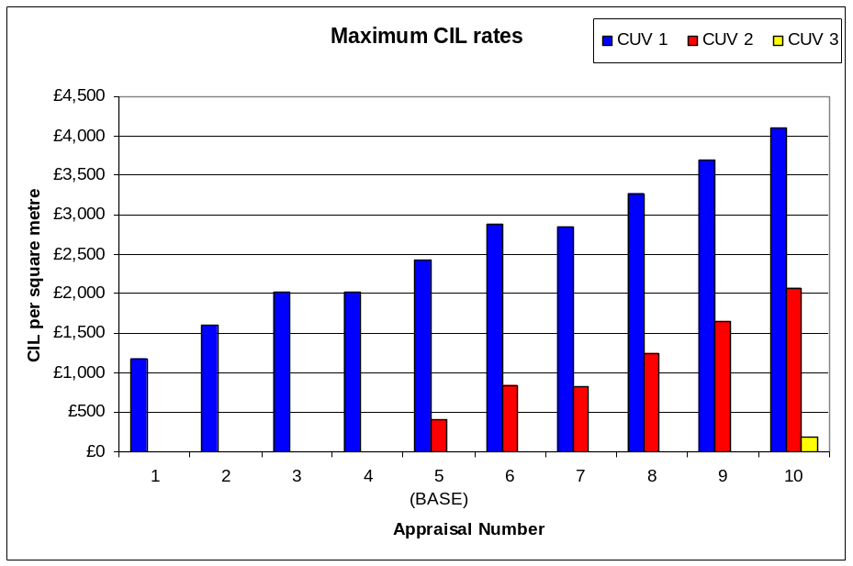

Although the appraisal indicates that a CIL could be absorbed in the ‘base’ scenario, the results are very sensitive to the rent levels and yields. Appraisals 3 and 4 in the Chart incorporate very modest changes to rents and yields, resulting in a very significant shift in the amount of CIL that could be absorbed (see Chart 6.36.1). Furthermore, if the amount of existing floorspace were to increase (which would result in a higher current use value), there would be a similar adverse impact on viability. Consequently, we advise that only a modest rate of CIL should be set on retail development in this area.
Retail development – small towns and larger villages

Lettings of existing and new/refurbished retail floorspace in the smaller towns and larger villages in Kettering (such as Burton Latimer, Desborough, Rushden, Rothwell etc.) indicate that rents are on average £129 per square metre (£12 per sq ft). At this rent level, development is unlikely to generate positive residual land values. Activity is therefore likely to be limited to recycling of existing floorspace, rather than the development of additional space. We therefore recommend a nil rate of CIL in this area.
Retail warehouse/superstore/Retail park

Other charging authorities have considered the differences in viability between small retail and large retail (retail warehousing/retail park/superstores etc.) with the latter two in particular being occupied by operators with greater covenant strength. This greater covenant strength and the likelihood of lower existing use values of sites results in a higher and consequently a potential for a higher CIL rate.

Lettings of existing and new/refurbished retail warehouse/retail park floorspace indicate that rents are on average £161 per square metre (£15 per sq ft). We understand from local agents that yields achieved on units occupied by local tenants are in the region of 7.75%. At this level our appraisals indicate that retail floorspace development is unlikely to generate surplus residual values above the value of current floorspace.

However, small changes to inputs (in particular yields) change the results significantly. Given the covenant strength of the large national retailers better investment values are achieved and therefore lower yields of circa 6.5% to 6.75%. At this level our appraisals show that a maximum CIL ranging from £47 to £291 per square metre could be levied on such retail space, depending on the value of the existing use of the site (see Chart 6.41.1).
Chart 6.41.1: Viable levels of CIL on Retail warehouse/superstore/retail park
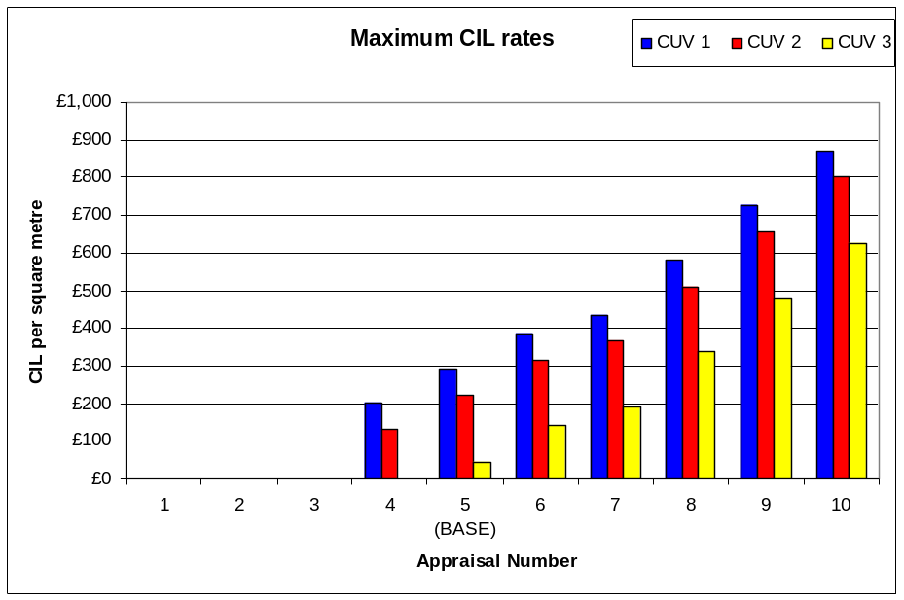

We consider that there is justification for the Council to set different CIL rates for retail based on the viability evidence should they wish to pursue this option, however, the Council would need to establish whether the regulations permit different rates for the same type of development based on size. Sunday trading laws define large units as those above 280 square metres. Therefore this is arguably an appropriate threshold for defining large units. With regard to very large retail developments, the NPPF prescribes a default threshold of 2,500 square metres, at which point retail impact assessments are required. This captures the largest developments, which are likely to have the most significant impacts. Subject to acceptability in terms of the regulations, this could be considered an appropriate threshold. It is expected that very few schemes would be above this threshold.
Industrial and warehouse development (B2/B8)

Our appraisals of industrial and warehouse development indicate that residual values are likely to be too low to absorb any level of CIL. A considerable increase in new build industrial rents would be required before any CIL could be absorbed.

D1 and D2 floorspace development

D1 and D2 floorspace typically includes uses that do not accommodate revenue generating operations, such as schools, health centres, museums and places of worship. Other uses that do generate an income stream (such as swimming pools) have operating costs that are far higher than the income and require public subsidy. Many D1 uses will be infrastructure themselves, which CIL will help to provide. It is therefore unlikely that D1 and D2 uses will be capable of generating any contribution towards CIL.

Conclusions and recommendations

The results of our analysis indicate a degree of variation in viability of development in terms of different uses. In light of these variations, two options are available to the Council under the CIL regulations. Firstly, the Council could set a single CIL rate across the Borough, having regard to the least viable types of development and least viable locations. This option would suggest the adoption of the ‘lowest common denominator’, with sites that could have provided a greater contribution towards infrastructure requirements not doing so. In other words, the Council could be securing the benefit of simplicity at the expense of potential income foregone that could otherwise have funded infrastructure. Secondly, the Council has the option of setting different rates for different types of development and different areas. The results of our study point firmly towards the second option as our recommended route, particularly for residential development.

We have also referred to the results of development appraisals as being highly dependent upon the inputs, which will vary significantly between individual developments. In the main, the imposition of CIL is not the critical factor in determining whether a scheme is viable or not (with the relationship between scheme value, costs and land value benchmarks being far more important). This is evidenced by the very marginal differences between the ‘pre’ and ‘post’ CIL residential appraisals shown in the charts in Section 6. This point is also illustrated in Chart 7.2.1 below, which compares the impact on the residual value of a scheme of a 10% increase and decrease in sales values and a 10% increase and decrease in build costs to a £100 per sq metre change in CIL.

Chart 7.2.1: Impact of changing levels of CIL in context of other factors
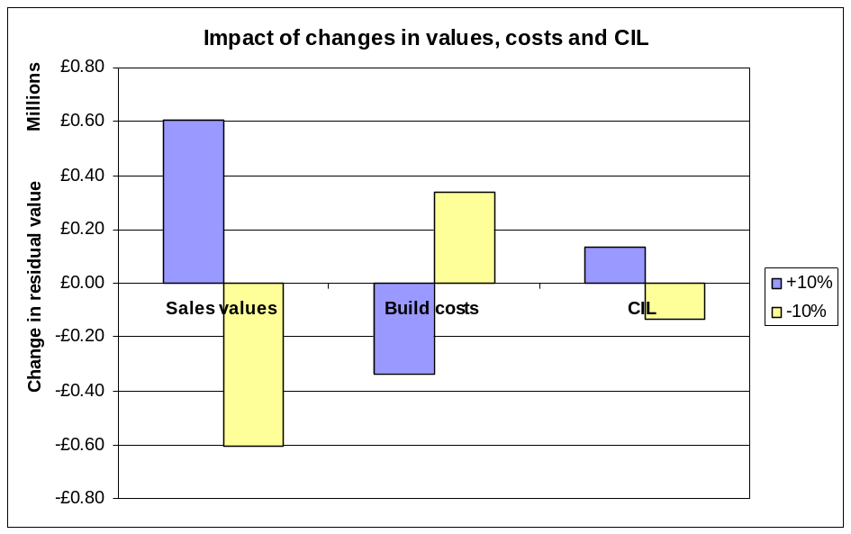

Given CIL’s nature as a fixed tariff, it is important that the Council selects rates that are not on the limit of viability. This is particularly important for commercial floorspace, where the Council does not have the ability to ‘flex’ other planning obligations to absorb site-specific viability issues. In contrast, the Council could in principle set higher rates for residential schemes as the level of affordable housing could be adjusted in the case of marginally viable schemes. However, this approach runs the risk of frustrating one of the Council’s other key objectives of delivering affordable housing. Consequently, sensitive CIL rate setting for residential schemes is also vital.

Our recommendations on levels of CIL are therefore summarised as follows:
- The results of this study are reflective of current market conditions, which are likely to improve over the medium term. It is therefore important that the Council keeps the viability situation under review so that levels of CIL can be adjusted to reflect any future changes.
- The ability of residential schemes to make CIL contributions varies depending on area and the current use of the site. Taking a broad view across our appraisals, the maximum rates suggested are as follows:
  - High Value Villages NN14 (Geddington, Grafton Underwood, Newton, Cranford, Loddington), High Value villages East NN16, NN18 (Weekly, Little Oakley, Warkton) and the LE16 Villages (Wilbarston, Stoke Albany, Sutton Bassett, Dingley, Braybrooke, Weston by Welland, Brampton Ash, Thorpe Underwood): £100 per square metre; and
  - Elsewhere: Nominal rate only.

- The Council will need to consider whether the quantum of development that is expected in the high value villages in NN14, NN16, NN18 and the LE 16 Villages areas justifies adopting a differential rate. If very little development is expected in these areas, the Council may wish to set a nominal rate on all residential developments across the Borough.
- As developments elsewhere are unviable in many circumstances, a nominal CIL rate should be set so that the impact on viability (and deliverability) is modest. We suggest a nominal rate of between £30 to £50 per square metre could be accommodated through a very modest additional increase in sales values.
- The Council has already granted outline planning permission for the Sustainable Urban Extension to the east of Kettering and as such contributions towards infrastructure requirements have been secured through Section 106 agreements. However, it is important that a CIL is set for the areas covering the SUEs (whether consented or not) to address situations where purchasing developers submit new planning applications for parcels of land. If the Urban Extensions are broken up in this way, it would be difficult for the Council to secure pooled Section 106 contributions from individual developers.
- Care homes, Extra Care housing and other residential institutions are unlikely to be sufficiently viable to absorb any CIL contributions.
- At current rent levels, Office development across the Borough is unlikely to come forward in the short to medium term as the capital values generated are insufficient to cover development costs. We therefore recommend that the Council sets a nil rate for office development.
- Residual values generated by Retail developments in Kettering Town Centre are shown to be viable, although surplus residual values are vulnerable to small changes in rents and yields. However, to a degree retail development will involve the re-use of existing retail space, so the differential in value between current and newly developed space is modest in areas where rents are low. We consider that developments would, however, be able to accommodate a CIL charge of circa £60 per square metre without a significant impact on viability.

- Retail development in the small towns and larger villages is clearly unviable in the current market as rents are so low that a scheme would not generate a positive residual value. We therefore suggest a nil rate on retail outside of Kettering town centre.
- Retail warehouse/superstores/retail parks (which for the purposes of CIL could be defined using the Sunday Trading law threshold of 280 square metres) are likely to be viable across the Borough with a maximum CIL rate of £211 per square metre. After allowing a buffer, which we consider to be appropriate to deal with site specific issues, the Council might consider setting a CIL of £125 per square metre. We consider that there is sufficient justification for the Council to set different CIL rates for retail based on the viability evidence and consider 280 square metres to be an appropriate threshold, however, the Council would need to satisfy itself that the current CIL regulations permit differential rates for the same use class.
- Alternatively should the Council wish to adopt a simpler approach to their charging schedule, they would be able to apply a rate of £60 per square metre on such space, inline with that applied to Kettering Town Centre.
- Our appraisals of developments of industrial and warehousing floorspace (B2/B8) indicate that these uses are unlikely to generate positive residual land values. We therefore recommend a zero rate for industrial floorspace.
- D1 and D2 uses often do not generate sufficient income streams to cover their costs. Consequently, they require some form of subsidy to operate. This type of facility is very unlikely to be built by the private sector. We therefore suggest that a nil rate of CIL be set for D1 uses.

For residential schemes, the application of CIL of up to £50 per square metre is unlikely to be an overriding factor in determining whether or not a scheme is viable. When considered in context of total scheme costs, a CIL of £50 per square metre is a very modest amount, accounting for circa 2% of total gross development values. Some schemes would be unviable even if a zero CIL were adopted. We therefore recommend that the Council pays limited regard to these sites.

Private residential sales values

Average Private Sales Values

Area | 2 Bed House | Ave Price  per sq m | 3 Bed House | Ave Price  per sq m | 4 Bed House | Ave Price  per sq m
Kettering | £100,000 | £1,333 | £145,000 | £1,526 | £220,000 | £1,913
Rothwell and Desborough | £100,000 | £1,333 | £135,000 | £1,421 | £205,000 | £1,783
Burton Latimer and Barton Seagrave | £115,000 | £1,533 | £155,000 | £1,632 | £220,000 | £1,913
LE 16 Villages (Wilbarston, Stoke Albany, Sutton Bassett, Dingley, Braybrooke, Weston by Welland, Brampton Ash, Thorpe Underwood) | £175,000 | £2,333 | £215,000 | £2,263 | £250,000 | £2,174
Low Value Villages NN14 East (Broughton, Mawsley, Pytchley, Rushton, Thorpe Malsor, Cransley) | £115,000 | £1,533 | £160,000 | £1,684 | £220,000 | £1,913
High Value Villages NN14 (Geddington, Grafton Underwood, Newton, Cranford, Loddington ) | £165,000 | £2,200 | £200,000 | £2,105 | £250,000 | £2,174
High Value villages East NN16, NN18 (Weekly, Little Oakley, Warkton) | £165,000 | £2,200 | £200,000 | £2,105 | £250,000 | £2,174

Weighted Sales Values Applied to Appraisals

Typology 1
Area | Ave Price  per sq m
Kettering | £1,913
Rothwell and Desborough | £1,783
Burton Latimer and Barton Seagrave | £1,913
LE 16 Villages | £2,174
Low Value Villages NN14 East | £1,913
High Value Villages NN14 | £2,174
High Value villages East NN16, NN18 | £2,174

Typology 2
Area | Ave Price  per sq m
Kettering | £1,472
Rothwell and Desborough | £1,396
Burton Latimer and Barton Seagrave | £1,604
LE 16 Villages | £2,283
Low Value Villages NN14 East | £1,642
High Value Villages NN14 | £2,132
High Value villages East NN16, NN18 | £2,132

Typology 3, 4, 5, 6 and 7
Area | Ave Price  per sq m
Kettering | £1,621
Rothwell and Desborough | £1,532
Burton Latimer and Barton Seagrave | £1,711
LE 16 Villages | £2,247
Low Value Villages NN14 East | £1,732
High Value Villages NN14 | £2,153
High Value villages East NN16, NN18 | £2,153

Residential appraisal results

Commercial appraisal results

This was challenged by Sainsbury’s at Borough of Poole’s CIL examination. Notwithstanding viability evidence of the differences between general retail and supermarkets, Sainsbury’s argued that the regulations simply do not permit differential rates on the same type of development. We suggest that the Council may wish to seek clarification from CLG on this point.
Savills Research: Residential Property Focus, April 2012
This group was led by the Homes and Communities Agency and comprises representatives from the National Home Builders Federation, the Royal Town Planning Institute, local authorities and valuers (including BNP Paribas Real Estate).
The gross area is the whole internal area of the building, measured from wall to wall. It includes common areas, such as stair cores. The net area is the ‘saleable’ area inside each flat. The gross to net ratio is the internal area expressed as a percentage of the gross area. For houses, the whole internal area is measured as ‘saleable’ floorspace.
For the larger developments i.e. typologies 6 and 7 it is assumed that there is more than one developer on site or that the development is being undertaken in phases which run conterminously.
This approach is therefore consistent with the National Planning Policy Framework, which indicates that development should provide “competitive returns” to landowners. A 20% return above current use value is a competitive return when compared to other forms of investment.
Poorer quality office floorspace that attracts low rents and thus coming to the end (or has indeed reached) the end of its economic life, resulting in pressure to redevelop.
Poorer quality industrial floorspace that attracts low rents and thus coming to the end (or has indeed reached) the end of its economic life, resulting in pressure to redevelop.
Para 32: “the price paid for development land may be reduced…. a reduction in development land value is an inherent part of the CIL concept…. in some instances it may be possible for contracts and options to be re-negotiated in the light of the changed circumstances arising from the imposition of CIL charges.”
Existing buildings must be occupied for their lawful use for at least six months out of the twelve prior to grant of planning permission to qualify as existing floorspace for the purposes of calculating CIL liability. Many buildings in the Borough that come forward for redevelopment are derelict and clearly not occupied.
However, as shown by the sensitivity analyses (which reduce affordable housing to 20%, 10% and 0%) even a reduction in affordable housing does not always remedy viability issues. In these situations, it is not the presence or absence of planning obligations that is the primary viability driver – it is simply that the value generated by residential development is lower than some existing use values. In these situations, sites would remain in their existing use.
NV = Site is not viable before CIL is applied. These results are disregarded for the purpose of recommended CIL rates, as the sites would remain in their current use, unless other (non-CIL related) factors were to change.
Sainsburys recently challenged Borough of Poole’s proposed rate of CIL on superstores on the basis that – in their view – the regulations do not permit such variations, as it is not possible to distinguish supermarkets as different ‘types’ of development. The Council may wish to raise this point with CLG before proceeding.
This was challenged by Sainsbury’s at Borough of Poole’s CIL examination. Notwithstanding viability evidence of the differences between general retail and supermarkets, Sainsbury’s argued that the regulations simply do not permit differential rates on the same type of development. We suggest that the Council may wish to seek clarification from CLG on this point.

