- PURPOSE OF REPORT

  - To provide an update on:
    - progress with the market place restaurants
    - the next phase of public realm works (phase 4)
    - the acquisition of a Big Screen for the Borough
    - progress in national awards

b. To record the success of this years’ summer celebrations

2. BACKGROUND INFORMATION

2.1 Kettering Borough lies within the South East Midlands, which is predominantly a growth area, and is expected to facilitate growth of some 13,100 homes and 16,200 new jobs by 2021.

2.2 Members have made their priorities for infrastructure and jobs-led growth clear – these are the prerequisites of growth. Members have indicated they wish to use the growth agenda to leverage three key and interrelated ambitions for the borough; namely:-

- A better offer for our town centres
- A better education and training offer
- A better employment offer – high grade, higher density jobs

  - The mutually supportive role of these three aspirations cannot be over-stated. The town centres and the skills base will be persuasive to inward investors. Similarly, high grade employment supports vibrant town centres.

  - Despite the torrential rain of June and the early part of July, Kettering Market Place has hosted another successful summer of celebrations, which started with the arrival of the Olympic Torch on the 2nd July and was followed by four weeks of the ever-popular Kettering by the Sea, complete with helter-skelter, the London Science Museum’s hands-on experiments, dance troops and beach volleyball, and a fleeting appearance from a big TV screen during the second week of the Olympics.

  - However, the fun does not stop there; plans are already being put in place for a similarly jam-packed Christmas schedule, and of course there is the opening of Prezzo to look forward to.
3. UPDATES

Prezzo

  - Prezzo started work on the fit-out of Unit 2 of the Market Place Restaurants on 6th August and are expecting to open in the Autumn. The coming weeks will see the shell of Unit 2 transformed into a bespoke restaurant design which will accommodate up to 120 diners (easting inside and out) at any one time. The new restaurant is expected to create 15-20 jobs.

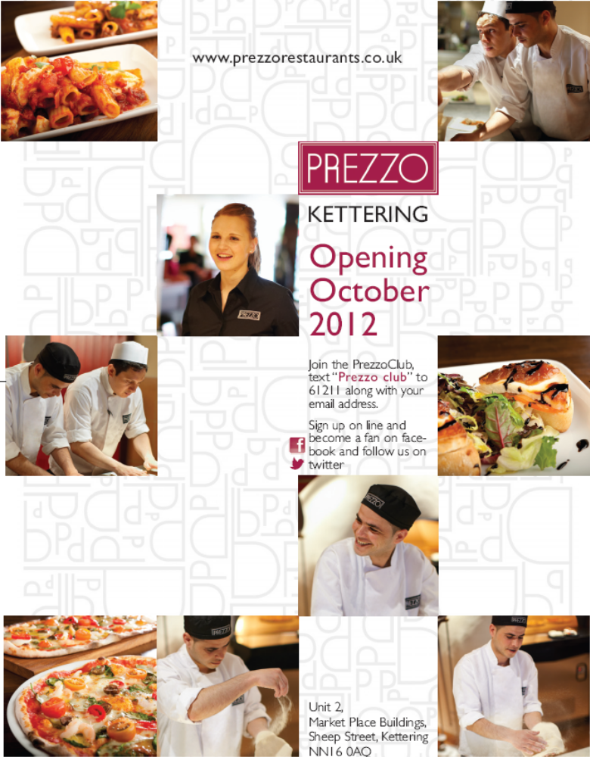

  - With Prezzo now on site in Unit 2, the marketing of Unit 1 will recommence in early September. Although news of Prezzo’s arrival in Kettering has been circulating for some months, our agents had advised us that the physical presence of Prezzo in Unit 2 was a key aspect of their marketing strategy for Unit 1. And whilst work on site started in early August, the commercial letting industry is quite slow during the summer; hence the September date for re-marketing the unit.

  - Our agents have informed us that they have already taken calls from prospective tenants of Unit 1. We hope that this bodes well for securing a second tenant for the Market Place Restaurants.

  - In order to assist with the letting process, we will be submitting our own application for a drinks licence for Unit 1. The process to determine the drinks licence can take up to 6 weeks and although not an issue with the Prezzo Unit, is, ordinarily, one of the few ‘unknowns’ in the contract process. Once unit 1 has been let, the licence can be transferred to the new tenants.

Public Realm Phase 4

  - At the June meeting of the Executive, approval was given for a one-off capital budget of £190,000 to carry out the design works for the next phase of Public Realm Works (Phase 4).

  - Since June, we have been working alongside MGWSP and the County Council on the first stages of the agreed programme which includes a review of Public Realm 2&3; engagement with town centre businesses and first thoughts on the concept design for High Street and Gold Street.

  - With regards to the review of the most recent public realm project, good progress has been made with the County Council in agreeing a new approach to the use of road markings and signage within the scheme. Recent guidance has removed the need to provide double yellow lines and the lining of cycle routes by creating a ‘Restricted Zone’ along Sheep Street, Market Place and Market Street. In order to do this, signage will need to be provided at the entrances to – and exits from - the new zone, and some ‘reminder’ signage will need to be installed at intervals within the new zone. Every effort will be made to affix this new signage to existing poles.

  - Practically speaking, those areas which have been carefully designed not to look like a highway (in other words the shared-surface areas of Market Street and Market Place) will no longer be marked by double yellow lines (primarily on the Market Place and at the junction of Market Street and High Street), and cycle route markings (also at the junction of Market Street ad High Street).

  - We are also working with the County Council and MGWSP to come up with a solution whereby the parking and loading bays of Market Street do not have to be ‘lined’. This may require some small changes to the block paving in those areas.

  - The timeline for carrying out these works is around 12 weeks and will include the specification for the signage being drawn up and then production of the signage. Finally, the signs will be erected and lines removed. It is anticipated that the new Restricted Zone will be up and running in the new year.

A Big Screen for the Borough

  - Following the approval of a budget to acquire a Big Screen for the Borough at June’s meeting of the Executive, a trial took place on the Market Place for two consecutive days in August. The trial ran alongside Kettering by the Sea, with Olympic sports being shown on the screen between 10 and 4 pm on both days.

  - The main aim of the trial was to test whether a strong television signal could be obtained, whether power could be sourced properly to avoid use of the onboard generator which is fairly noisy and gives off fumes, and to test the public reaction to the screen. The equipment was also tested by Community Services staff to ensure that they could operate it should the Council own the equipment.

  - The signal and power test worked well, although there is still some work to be done to secure permanent feeds. The equipment itself was found to be relatively easy to set up and use.

  - Public reaction, although not surveyed, was good. Plenty of people were watching the big screen and positive comments were received through the Market Place’s Twitter feed.

  - The next stage is to scope out the exact equipment requirements and embark on a procurement exercise. The intention at this stage, subject to procurement considerations, is to purchase the screen for use in the 2013 events season.

Kettering Markets shortlisted for National Award

  - Kettering Market has been shortlisted as a finalist in the Regeneration and Renewal Awards 2012 in the category of Boosting High Street Vitality.

  - The entry revolved around four key new approaches that had been put in place since the market was taken ‘in house’:

- A unique "one team" approach of market management - utilising the skills of three complimentary service areas
- Working closely with Tresham college in the re-branding of the market and their participation in a new enterprise stall
- Combining specialist stalls with events
- The proposed development of a flea market to compliment the two new cafes (Costa Coffee and Bewiched)

  - There will be a site visit on 21st September with winners being announced at an awards ceremony in London in November.

4. ANOTHER SUCCESSFUL SUMMER OF EVENTS IN KETTERING

Olympic Torch

4.1 The Olympic Torch had lunch in Kettering on the 2nd July as thousands of residents lined the streets to welcome it on its journey to the Market Place.

4.2 Estimates are that the Olympic Torch event was enjoyed by over 40,000 people in the town centre alone. 13 Torch Bearers brought the flame through the town and we received excellent coverage through all media outlets. At one point, Kettering was reportedly ‘trending’ globally on twitter.

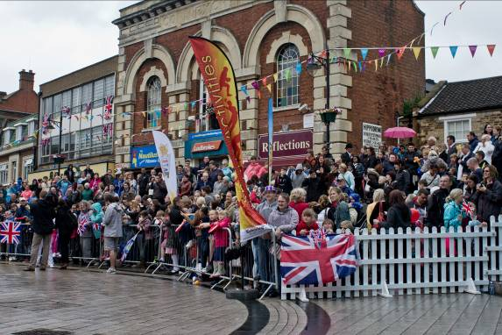 | 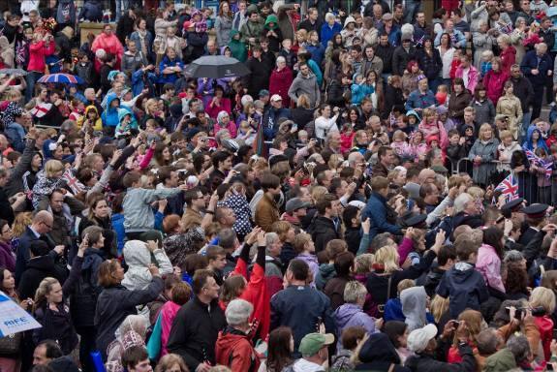
 | 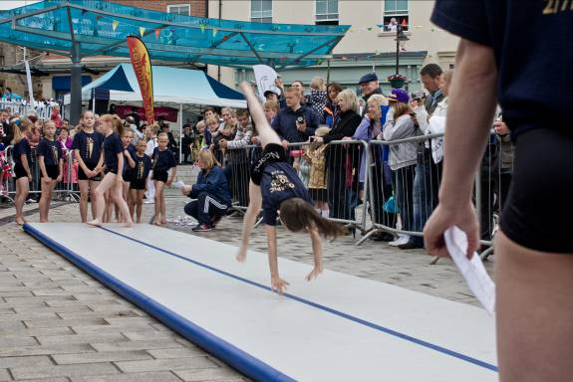
 | 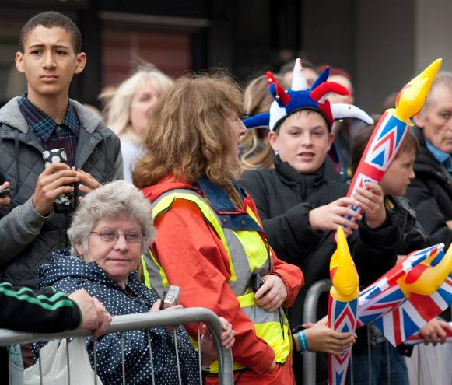

Kettering by the Sea

4.3 This summer, the Market Place hosted the largest ever Kettering by the Sea. Along with the giant sand pit and splash fountains there was also a packed program of activities and entertainment, including:

Punch and Judy, beach volleyball, pantomimes, Olympic games and competitions, arts and crafts, interactive experiments from the London Science Museum, National Space Centre Star Dome, Traditional Helter-Skelter, West Lodge Farm, live music, zumba, hoop dance and speciality markets.

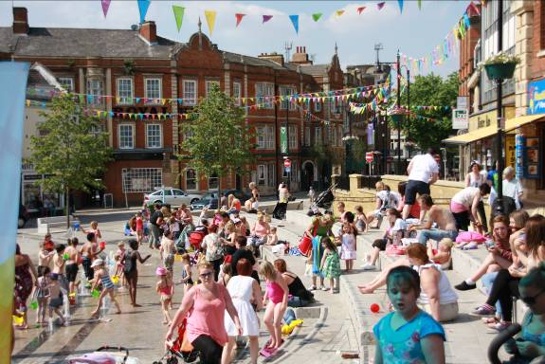 | 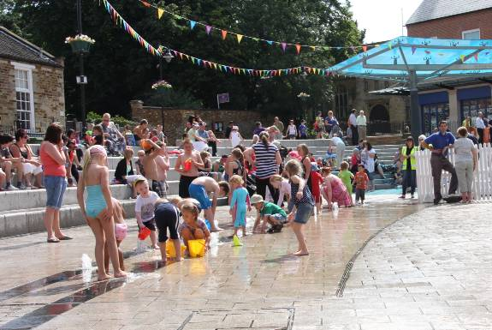
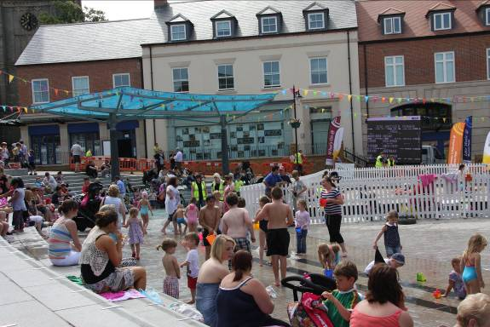 | 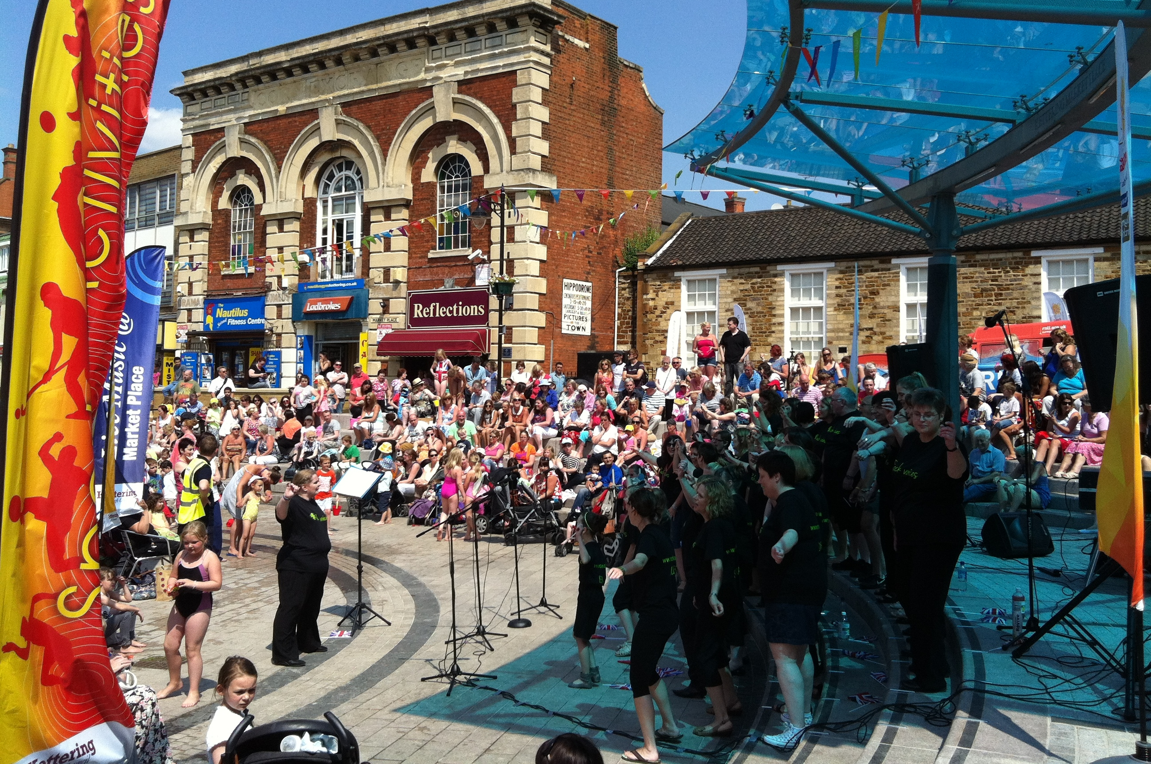
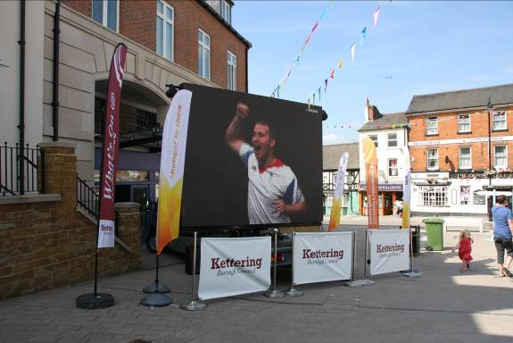

4.4 Kettering by the Sea ran from Saturday 21st on July to 18th August and attracted in excess of 5,000 people over the 4-week event.

Beach Volleyball

4.5 The beach volleyball event was held on the 28th July and attracted about 200 people across the day to come and watch. The day was also supported by Kettering Premier Judo Club and Kettering Cheerleading Academy who put on displays to showcase their clubs. The feedback we had was that it was a good day and a very good idea. Hopefully we will look to do it again next year.

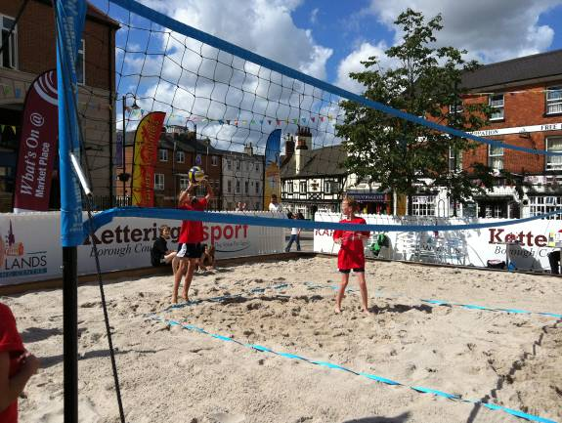 | 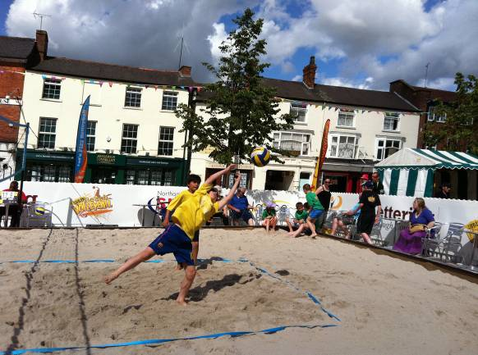

5. FINANCIAL AND POLICY IMPLICATIONS

5.1 The Executive has previously approved one-of capital budgets for Public Realm Phase 4 and for the acquisition of a big screen for the Borough.

6. RECOMMENDATIONS

That the Executive Committee:

  - Recognises the good progress Prezzo are making in fitting-out Unit 2 and the recommencement of marketing for Unit 1 of the Market Place restaurants.
  - Notes that Kettering Town Centre businesses are already in the process of being engaged as part of the first part of consultation on Public Realm Phase 4
  - Notes the proposed timeline for the implementation of a new ‘Restricted Zone’ on Market Street, Sheep Street and Market Place.
  - Notes the success of the trial of a Big Screen on Kettering Market Place and the next steps that are required to secure a Big Screen on a permanent basis.
  - Recognises the success of the rebranded and reinvigorated Kettering Markets, particularly with regard to its shortlisting for a national award.
  - Applauds the success of 2012’s summer celebrations and thanks those who took the time to support it.

