1. PURPOSE OF REPORT

To inform Members of a proposed County Strategy for future planning and investment decisions in the county, and to request endorsement of the officers’ response to the County Council on the document.

2. INFORMATION

Background

2.1 The Northamptonshire Arc is a strategy developed by Northamptonshire County Council (NCC) in the form of a Background Report, as a framework for future planning and investment in the County. A copy of the Northamptonshire Arc Background Report is attached at Appendix 1. It was in the public arena for consultation until the 16th July; however, it has been agreed with NCC that the Borough Council’s response will be accepted if sent following the meeting of this Committee.

2.2 The Arc, so called because it encompasses the county growth areas to the North-East and West of Northampton (fig 1 below), is the County’s attempt to provide a unifying concept for planning, transport and economic development for the county. The Strategic Priorities identified in the document have been extracted and are attached as Appendix 2. The document aims to promote the county and its growth potential, and has the following three thematic outcomes underpinning it:

- Transformed connectivity
- Leadership on climate change & biodiversity
- A stronger and greener economy

2.3 The document sees its role as being an overarching advocacy document for external investment in Northamptonshire, and does this with due regard for the need for low carbon development and protection of biodiversity. Northampton is seen as the focus of the Arc, and the development of its central area to be a thriving regional centre commercially and culturally. Connectivity investment within the Arc is focused on a new Northamptonshire Arc Mass Transit network (NAT).

Figure 1: The Northamptonshire Arc
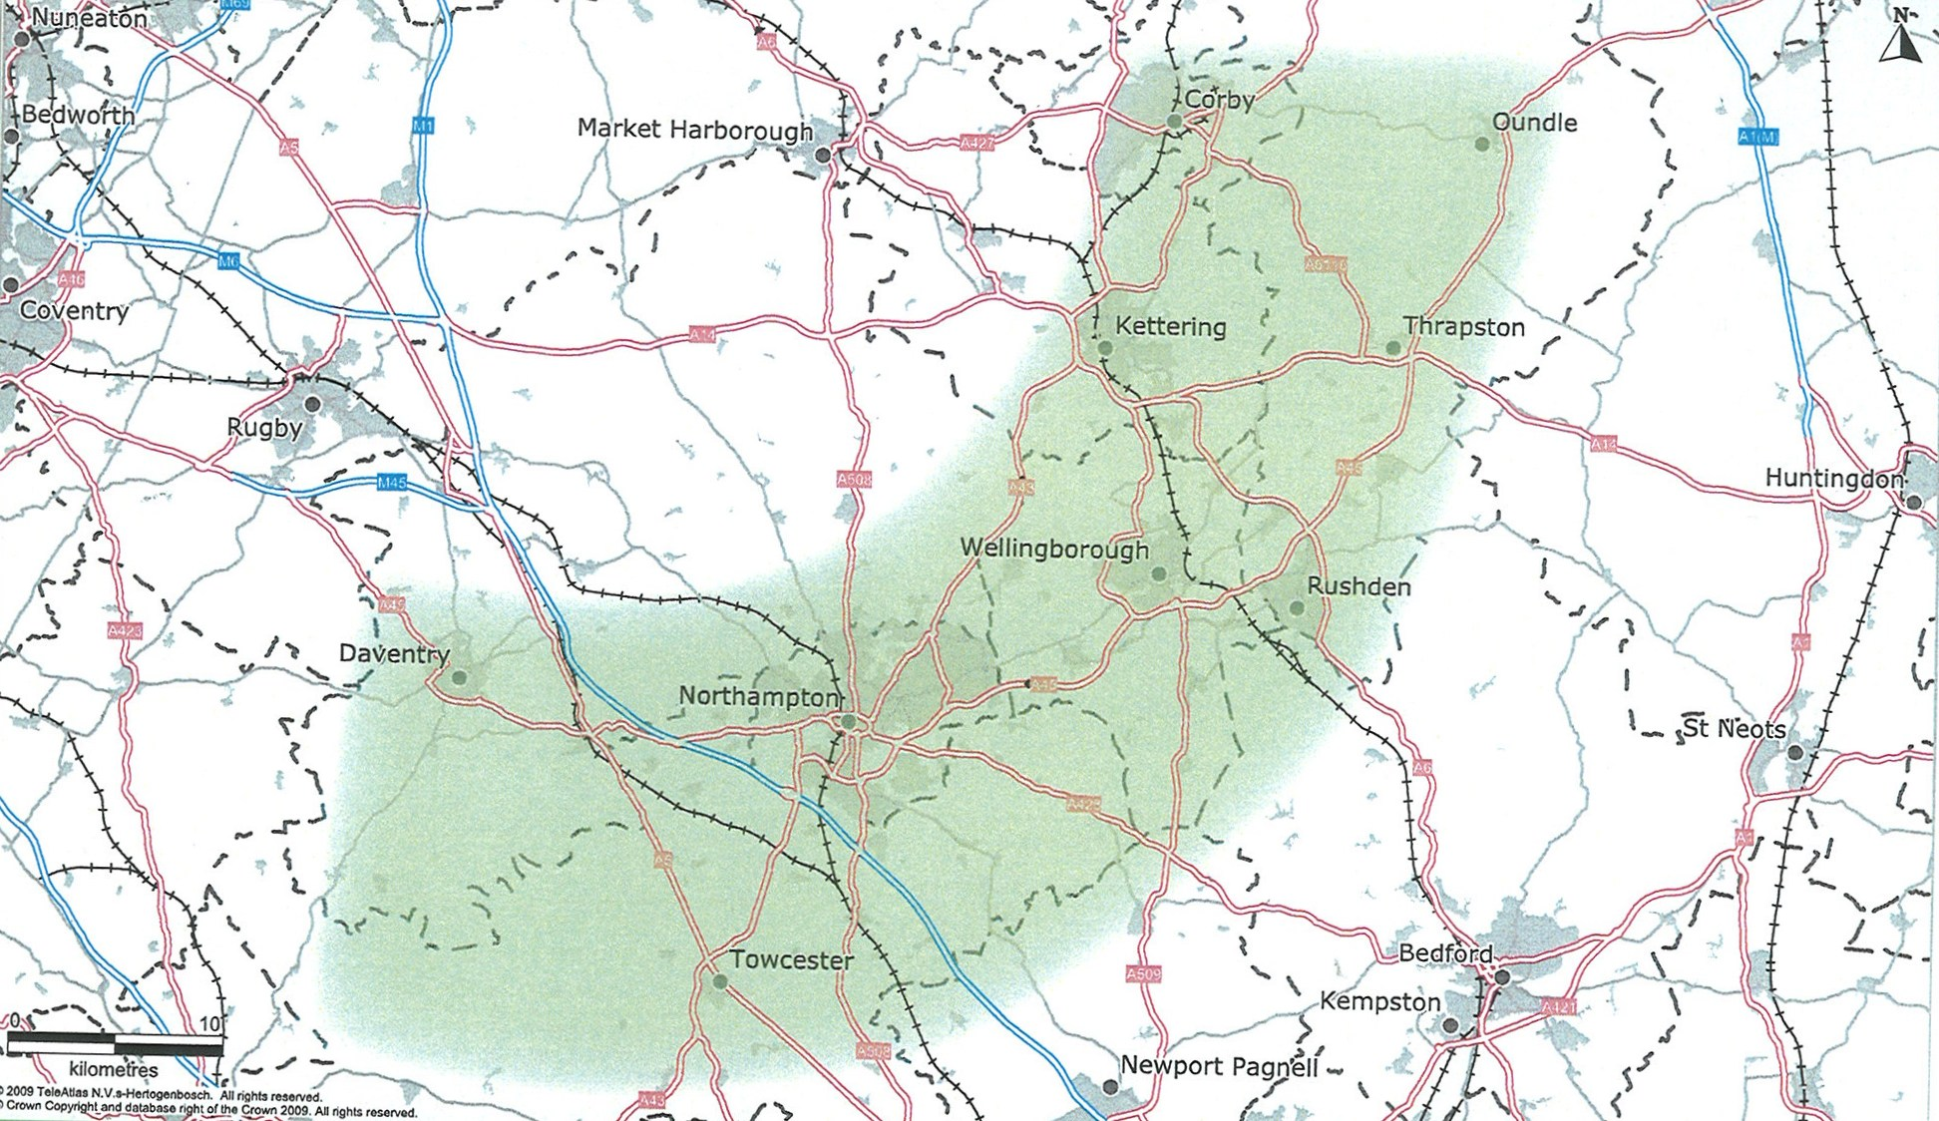

Officers’ comments on the Arc Background Report

2.4 The County are inviting Planning Authorities in Northamptonshire to consider adopting the Northamptonshire Arc as part of their policy frameworks. However as no policy to date has been developed with the Arc strategy and any supporting evidence considered, that is not considered appropriate at this stage. We understand that the on-going review of the North Northamptonshire Core Spatial Strategy will include a consideration of these proposals as one of its options, and support that decision. To avoid confusion, the document should be clearer that strategic spatial planning is primarily set out in the Core Strategies of the West and North areas of the County, and developed by the respective Joint Planning Units, of which the County is, of course, a key member. The Arc is County Council policy, not strategic planning policy.

2.5 For the Arc concept to be taken forward into the Local Development Framework there will need to be greater clarity about what it entails and the evidence base on which it is founded. For example the reference to ‘iconic and transformational infrastructure proposals’ appears to centre on the ‘Northamptonshire Arc Transit (NAT) idea, which is not fleshed out in any detail and is not supported by further detail on modal shift mechanisms. More information will be needed on the nature of the proposals, their impacts, costs and potential funding sources. This detail should arise from ongoing technical work including an Inter-Urban Transport Study funded through Growth Funding. The Joint Planning Unit has agreed it will work with County Council officers and their consultants to ensure, as far as possible, that this work meshes with work on options for the review of the Joint Core Strategy.

2.6 The Arc concept appears to be focused primarily on linking up the main settlements within Northamptonshire and in reinforcing the role of Northampton as a regional centre. The Council supports the aspirations for growth and regeneration of Northampton but considers that the Arc concept should reflect wider relationships to places outside Northamptonshire (such as Milton Keynes, Peterborough, Leicester and London) and to the importance of transport corridors such as the A14, which do not fit the geography of the Arc. Strategic Priority 3 could usefully make reference to improving rail services North on the Midland Mainline.

2.7 Investment and economic proposals, including the promotion of the County externally are to be welcomed. Strategic Priority 17 is welcomed, as it promotes bringing communities in the Arc up to, and then above, the Digital Britain targets for connectivity, with the expansion of fibre optic networks particularly in new developments. Note of economic specialisms in North Northamptonshire could usefully mention the developing financial sector.

2.8 The connectivity proposals in the document are missing key out of area road connections for North Northamptonshire, such as Peterborough and Leicester. The aspirations for the extension of the Corby rail link line to Melton Mowbray and on to Leicester is also missing.

2.9 Traditionally the County has been seen as lacking good East/West connections, particularly in the public transport system. While the proposed Northamptonshire Arc Mass Transit network (NAT) system linking all conurbations in the Arc would go some way to remedy this, a much cheaper option would be to look at linking the two good north-south rail links in the County. This could be done with a new mass-transit system between Northampton and Wellingborough, connecting the Midland Mainline with the Northampton branch of the West Coast Mainline and providing better public transport links between the main urban areas of North Northamptonshire and the County town.

2.10 The high level of growth allocated to Corby, Kettering and Wellingborough (originating from the original Milton Keynes and South Midlands Study) reflects their position on the Midland Mainline corridor and the regeneration needs of Corby in particular. The adopted Core Strategy is to strengthen the role of the Growth Towns and the smaller towns in North Northamptonshire to meet more of the needs of local residents (including those in rural areas). The Arc concept can potentially support this strategy through better connectivity but will not do so if it directs investment decisions in a way that results in the majority of jobs and higher order facilities being located in Northampton; or in infrastructure investment being diverted from priorities established in the Core Strategy and North Northamptonshire Programme of Development.

2.11 Opportunities and policy for the rural areas outside of the identified Arc could be worked up more in the document. At present it does not discuss this area in any depth, apart from it offering a pleasant environmental backdrop to future development.

3. CONSULTATION AND CUSTOMER IMPACT

3.1 Kettering Borough Council is a consultee, and has not had a significant input into the production of this Strategy. The proposed economic investment would benefit local residents, although as discussed above, further policy and proposal development is needed for maximum benefit.

4. POLICY IMPLICATIONS

4.1 The Arc proposal is currently planned to be debated and tested as an option in the forthcoming North Northamptonshire Core Spatial Strategy (CSS) Review. It will be more difficult to do this for the West Northamptonshire CSS, due to the different stage of this document.

5. USE OF RESOURCES

5.1 The document has no immediate resource implications for Kettering, although it does discuss Section 106 pooled contributions for transport, and so could affect future allocations of this funding if the NAT proposals are progressed.

6. RECOMMENDATION

That Members note the contents of the Northamptonshire Arc Background Report, and endorse the comments provided by officers in response to the consultation.

Background Papers:
Title of Document: Northamptonshire Arc: Background Report
Accessed at:http://www.northamptonshire.gov.uk/en/councilservices/Environ/bigidea/
Documents/PDF%20Documents/N.%20Arc%20Background%20Report.pdf

Date: July 2010

Contact Officer: Liz Beth

