Direct Line: (01536) 534398
Email: anneireson@kettering.gov.uk
Our Ref: AI
Your Ref:
Date: 19th July 2004

Dear Councillor

You are summoned to a meeting of Kettering Borough Council to be held in the Council Chamber, Municipal Offices, Bowling Green Road, Kettering on Wednesday, 28th July 2004 at 7.00 pm.

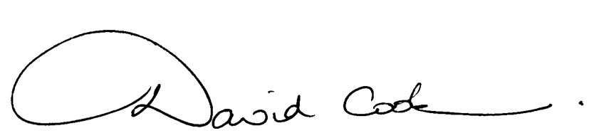Yours faithfully

D Cook
Chief Executive

A G E N D A

1. Apologies.

2. Minutes of the meeting of the Council held on 30th June 2004 to be approved as a correct record and signed by the Mayor.

3. Declarations of Interest.

4. To receive any announcements from the Mayor and/or the Leader of the Council.

5. Reports of the Chief Executive.

6. The Mayor to ask members of the public present if they want to speak on any item on the agenda.
7. Appointment of Town Council Member to the Standards Committee

- Councillor Margaret Talbot of Rothwell Town Council was been nominated at the meeting of the A6 Towns Forum held on 23rd June 2004.

8. To receive the following report from the Chief Finance Officer:-

- Statement of Accounts 2003/04 (The report is attached. The Statement of Accounts will follow.)

9. To receive reports from the Council's Executive and Committees, and receive questions and answers on any of those reports:-

- Joint Planning Committee for North Northamptonshire - Appointment of Members (report attached).

10. To receive any questions on matters for which the Borough Council has responsibility or which affect the Borough.

11. To consider any motions received in accordance with Council Procedure Rule 16:-

Motion proposed by Councillor Christopher Groome and seconded by Councillor Ruth Groome:

“That, mindful of the views of the current majority party when in opposition and their manifesto commitment at the election in May last year, the Overview Committee be asked to examine two changes to the Council's constitution which would enhance democratic accountability without the need for expensive public consultation:

(a) the Executive Committee to be politically proportional, and
(b) Council to appoint the members rather than the Leader”.

Motion proposed by Councillor James Hakewill and seconded by Councillor Alan Pote:

"This Council recognises the economic prosperity that the British Grand Prix held at Silverstone brings to our county, districts and boroughs. Our Council wants to see the British Grand Prix remain at Silverstone. We support the efforts being made by Sir Jackie Stewart and others to ensure that the circuit remains on the annual Formula One calendar in the future."

12. Any matters of urgency that the Mayor decides should be considered.

19.7.04
Fire Alarm

All meetings shall be adjourned immediately on the sounding of the fire alarm. The alarm is a continuous two-tone siren. On hearing the alarm please leave the building by the nearest emergency exit. There are emergency exits at both ends of the corridor outside the meeting rooms. On leaving the building please cross the car park and assemble on the grassed area by the church. Do not attempt to drive out of the car park as this may impede the arrival of emergency vehicles. Please do not return to the building until you are told it is safe to do so by a Council employee.

Toilets and Baby Changing Facilities

There are toilets and baby changing facilities in the corridor off the main entrance to the building you came through to get to the meeting room. The Council actively supports breastfeeding mothers. If you wish to use a private area please ask a member of staff.

Access for Disabled People

There are allocated parking bays outside the main entrance to the Municipal Offices for disabled people. The meeting rooms are located on the ground floor and access is gained for wheelchair users via the main entrance. If you require assistance, please ask the attendant on duty in the reception area.

No Smoking

Smoking is not permitted in the Municipal Offices.

