BOROUGH OF KETTERING

Committee | Full Planning Committee - 11/10/2011 | Item No: 5.5
Report Originator | Alex Jelley  Development Officer | Application No:  KET/2011/0409
Wards Affected | All Saints
Location | 74a Regent Street, Kettering
Proposal | Full Application: Change of use of first floor from retail to 2 no. flats
Applicant | Mr S Walker Tingdene Properties Ltd,

1. PURPOSE OF REPORT

  - To describe the above proposals
  - To identify and report on the issues arising from it
  - To state a recommendation on the application

2. RECOMMENDATION

THE DEVELOPMENT CONTROL MANAGER RECOMMENDS that this application be APPROVED subject to the following Condition(s):-

1. The development hereby permitted shall be begun before the expiration of 3 years from the date of this planning permission.
REASON: To comply with Section 91 of the Town and Country Planning Act 1990 (as amended) and to prevent an accumulation of unimplemented planning permissions.

2. The materials to be used in the construction of the external surfaces of the development hereby permitted shall match, in type, colour and texture those on the existing building.
REASON: In the interests of visual amenity in accordance with policy 13 of the North Northamptonshire Core Spatial Strategy.

3. The windows at first floor level on the west elevation shall be glazed with obscured glass in accordance with details which shall have been submitted to and approved in writing by the Local Planning Authority and any portion of the window that is within 1.7m of the floor of the room where the window is installed shall be non openable. The window shall thereafter be maintained in that form.
REASON: To protect the privacy of the adjoining property and to prevent overlooking in accordance with Policy 13 of the North Northamptonshire Core Spatial Strategy.

4. The development hereby permitted shall not be carried out other than in accordance with the amended plan:
REASON: To ensure that the development accords with the Development Plan, particularly Policy 13 of the North Northamptonshire Core Spatial Strategy.

Notes (if any) :-
- NONE

Justification for Granting Planning Permission

The proposal is in accordance with national and local policies as set out in Planning Policy Statements/Guidance Notes 1, 3, 13 and 23, Policies 2, 3, 39 and 46 of The East Midlands Regional Plan, Policies 1, 9, 10, 13 and 14 of the North Northamptonshire Core Spatial Strategy, and Policy 35 of the Local Plan for Kettering Borough. The proposal is also in accordance with adopted Supplementary Planning Document Sustainable Design. There are no material considerations that indicate against the proposal.

Officers Report

3.0 | Information

Relevant Planning History
None

Site Description
Officer's site inspection was carried out on 26.09.2011

The application site consists of No. 74a Regent Street, which is the first floor unit above an A1 retail shop on the corner of Regent Street and Wellington Street. Indeed, part of the unit appears to be 129 Wellington Street. Both properties are typical of this part of Kettering in that they are Victorian/Edwardian terraced properties constructed of facing bricks and concrete roof tiles. There is a large degree of detailing within the brickwork that is to the benefit of the site, and the wider street scene.

There are a number of retail units with residential units above them within the immediate vicinity, as well as a few factory buildings which have either remained in industrial use or been converted into a variety of different uses. The site is located within walking distance of the town centre and local bus routes.

Proposed Development
This application seeks permission for the change of use of first floor from A1 retail to 2 no. flats (C3). Further detail is contained within Section 7.0 of this report.

Any Constraints Affecting the Site
None

4.0 | Consultation and Customer Impact

Highway Authority
No objection.

Campaign to Protect Rural England
Support.

Environmental Health
No objection.

Neighbours
One letter of objection was received. It raised concerns relating to:
- parking
- highway safety
These issues are material planning considerations and are addressed in full within Section 7.0 of this report.

5.0 | Planning Policy

National Policies
PPS1. Delivering Sustainable Development
PPS3: Housing
PPG13. Transport
PPS23. Planning and Pollution Control

East Midlands Regional Plan
Policy 2. Promoting Better Design
Policy 3. Distribution of New Development
Policy 39. Regional Priorities for Energy Reduction and Efficiency
Policy 46. A Regional Approach to Behavioural Change

North Northamptonshire Core Spatial Strategy
Policy 1. Strengthening the Network of Settlements
Policy 9. Distribution & Location of Development
Policy 10. Distribution of Housing
Policy 13. General Sustainable Development Principles
Policy 14: Energy Efficiency and Sustainable Construction

Local Plan
Policy 35. Housing: Within Towns

SPDs
Sustainable Design

6.0 | Financial/Resource Implications
 | None
7.0 | Planning Considerations
The key issues for consideration in this application are:-
- Principle of Development
- Design and Character
- Residential Amenity
- Highways

A. Principle of Development
Section 38(6) of the Planning and Compulsory Purchase Act 2004 requires local planning authorities to determine planning applications in accordance with the Development Plan unless material planning considerations indicate otherwise.

National policy guidance in the form of PPS1, PPS3 and PPG13 promote sustainable development for residential purposes on previously developed land within town boundaries.

Policies 1 and 9 of the North Northamptonshire Core Spatial Strategy (CSS) indicate that Kettering is a ‘Growth Town’ and therefore should provide a primary focal point for development, and that the priority for this development is that it will be within urban areas. Policy 10 of the CSS establishes that substantial growth should occur within Kettering. Policy 3 of the East Midlands Regional Plan supports this, stating that significant growth with be provided within Kettering.

Policy 13 of the CSS provides for changes of use to residential units subject to specific criteria being satisfied. The criteria relevant in this instance relate to matters of design and character, residential amenity and highways. These issues will be addressed in full within the sub-sections below. Policy 2 of the EMRP highlights the importance of ensuring that new development takes account of local character trends.

It is considered that the proposals are acceptable in principle, subject to the detailed matters discussed below.

B. Design and Character
The proposed development would involve only very minor external changes. The boarded up windows on Regent Street and Wellington Street would be reinstated. The precise details are not included within the application, though it does refer to the use of uPVC. As the site is not within a conservation are, this is not considered to be an issue – though a condition requiring that all external materials match the existing building is necessary to ensure that any additions are appropriate. The character of the surrounding area is defined by the long Victorian terraces and assorted factory buildings. It is a vibrant, bustling part of Kettering – with plenty of traffic generated by the business uses along Regent Street and the surrounding streets, as well as by the residential properties within the area. The introduction of a residential element at first floor in place of an A1 retail use is therefore considered to be in accordance with the presiding character of the area. The relationship between the A1 unit downstairs and C3 units upstairs is also a common arrangement within Kettering.

As a result of the above, it is considered that the proposed development would accord with Policy 13 (h) and (i) of the CSS, as well as Policy 2 of the EMRP and PPS1 with regards to matters of design and character.

C. Residential Amenity
The amended plans submitted were brought about, in part, as a result of concerns expressed by officers regarding a potential detrimental impact on privacy. The reworked internal arrangements that have seen one of the flats go from two bed to one bed enables the window at first floor on the west elevation to be obscure glazed. None of the other windows caused any concern, as the majority face onto the highway, while the other window at first floor level on the west elevation is onto a bathroom and could therefore be conditioned to be obscure glazed.

Concerns raised by Environmental Health with regards to bin storage have also been met via the amended drawings, which now provide a space within the building for the storage of waste.

As the proposals do not involve any addition to the mass of the building, there are no concerns with regards to loss of light or overbearance.

As a result of the above it is considered that the proposals accord with Policy 13 (l) of the CSS.

D. Highways
The proposal would involve the addition of 2 no. flats in place of 112m2 of internal retail space. One of the flats would be 2 bed, the other would be 1 bed. The location of the site is such that local bus routes are within easy walking distance, and the town centre is also within walking distance. Both Regent Street and Wellington Street benefit from informal on street parking, and the future occupiers of the two units would be able to make use of this. The impact of the proposals in terms of traffic movement is considered to be negligible, considering the number of residential properties in the surrounding area as well as business uses that operate from both Regent Street and Wellington Street. The Highways Authority was consulted on the application and has no objection to the scheme. It is considered that the proposals would result in a form of development that retains a satisfactory relationship with the highway network, and promotes a modal shift away from private car usage due to its sustainable location. The application therefore accords with Policy 13 (d), (e) and (n), as well as Policy 46 of the EMRP and PPG13.

Conclusion

The application is in accordance with the Development Plan, and there are no material planning considerations that would indicate against approval.

Background Papers |  | Previous Reports/Minutes
Title of Document: |  | Ref:
Date: |  | Date:
Contact Officer: | Alex Jelley, Development Officer on 01536 534316

SITE LOCATION PLAN

74a Regent Street, Kettering
Application No.: KET/2011/0409

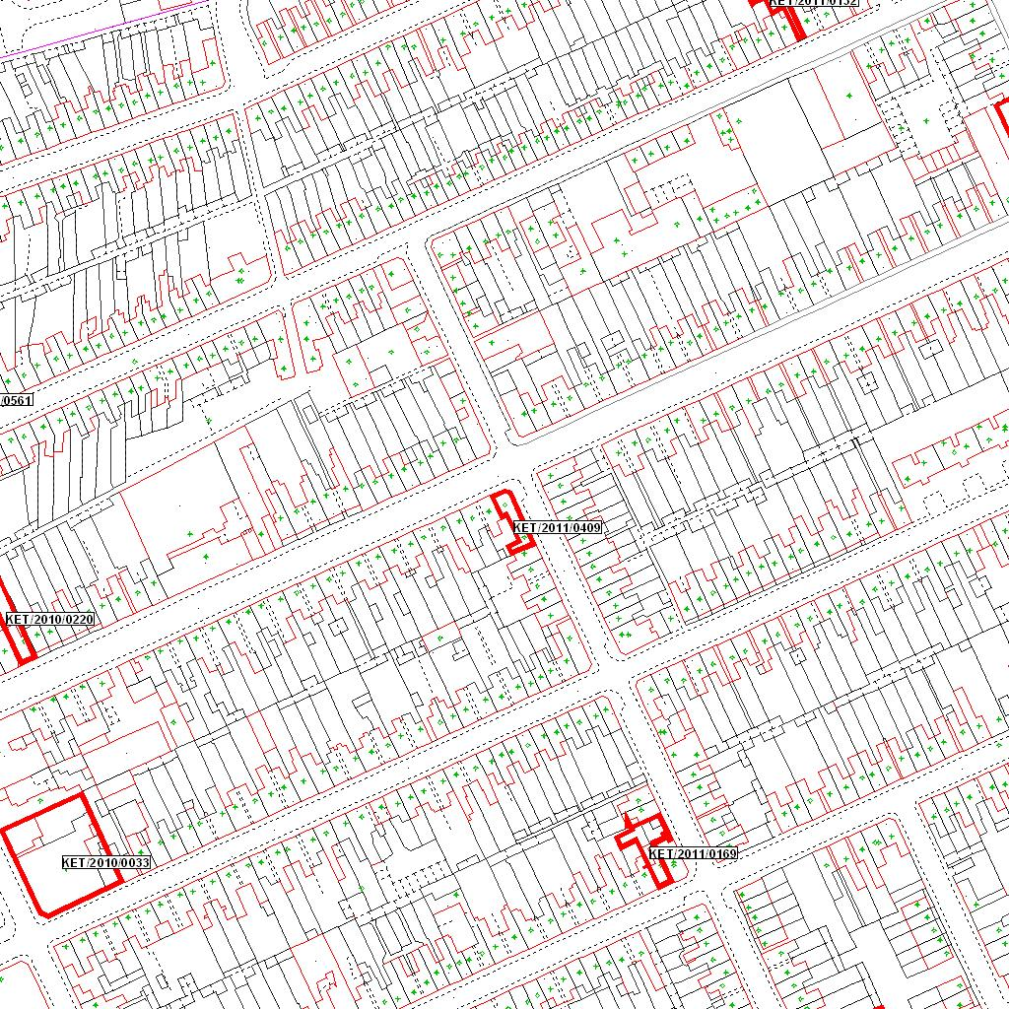

Reproduced from the Ordnance Survey mapping with the permission of the Controller of Her Majesty’s Stationery Office © Crown copyright. Unauthorised reproduction infringes Crown copyright and may lead to prosecution or civil proceedings.  LA078344 |  | N
Date: 06/07/2011 Do not scale from this map. For illustrative purposes only.

