1. PURPOSE OF REPORT

The purpose of the report is to:

- Remind members of the Guiding Principles that underpin the Council’s Financial Strategy;

- Remind members of the agreed policy position for the delivery of the 2012/13 budget and the agreed enhanced monitoring arrangements;
- Provide members with an update on the latest budget position by reference to the following;

  - The draft outturn figures for last financial year (2010/11)
  - An update on the delivery of savings for the current year (2011/12)
  - An update on the delivery of savings for future years

2. BACKGROUND

2.1 The ‘maintaining a durable budget’ report is now a standing report to every meeting of the Executive Committee.

  - The Council’s financial strategy and associated budgets were approved at February’s meeting of Full Council. The key messages in relation to the General Fund budget were;

- Council Tax remains below the national average (around £3 per week);
- The Council has maintained its balanced budget without cutting front line services or using one-off reserves;
- The budget is of course only a paper exercise and the challenge of delivering the £2m of savings during 2011/12 must not be underestimated. The Council’s focus will remain on maintaining the delivery of high quality front-line services however with the level of changes necessary some transition turbulence is inevitable.

- A further £1m of savings is estimated to be needed to balance the budget for 2012/13. This will increase to 1¼ million if a 0% council tax is sought. Work on the budget delivery framework will continue to ensure savings are identified.

- The financial outlook past 2012/13 is difficult to predict with a new government grant regime likely to be introduced. The Council will need to maintain its focus on big ticket items and continue with its successful lobbying strategy;

- Recent attendees at the LGA Conference received some reassurance that the Councils forecasting and modelling are “ahead of the curve.”
  - The Council’s approach to budget setting and monitoring has been developed to cope with the very significant cuts in Government funding both in year (HPDG) and through the grant settlement (15.2% cut in core grant). The Council had the advantage of starting from a 'strong financial platform' with no reliance on reserves or structural budget deficit. It developed its own budget delivery framework to ensure that the Council had a robust mechanism on which to base its financial strategy.
  - The foundations of the Medium Term Financial strategy are the 'guiding principles,' 'modelling for recovery’ principles and newly approved ‘budget containment strategy.’ which are set out below: -
Guiding principles:

- Revenue balances should not fall below £1m and overall revenue reserves should not fall below 10% of net revenue expenditure;

- In setting the Council Tax, members should consider the medium term to ensure that a sustainable budgetary position is preserved (with due regard being given to any penalties that might apply);

- The level of household Council Tax to increase each year in line with inflation at least, where the budget is in deficit, to ensure resources remain consistent with budgeted costs;

- When setting the Capital Programme, consideration is given to allocating capital resources to schemes that are beneficial to the Council’s overall revenue budget position;

- To maximise the resources available to the Authority, the Council will actively lobby the Government on relevant issues (e.g., grant distribution/ planning fees).

  - The guiding principles have been instrumental in helping the Council deliver a balanced budget The principles discourage the use of one-off reserves to balance the budget in favour of more sustainable methods like proactive budget management, ongoing efficiency savings and attracting external funding.
  - The Council has recognised that as a major economic engine in the Borough it has an important role as a stimulus for the economy and as support to other local businesses. The Council endorsed a set of counter cyclical 'modelling for recovery' principles. The principles were designed to help the Council continue to invest in both infrastructure and services and to help achieve its major objectives of higher grade higher density jobs, better town centres and a better education offer.
Modelling for recovery principles

- Wherever possible, continue with all planned investments and programmes, to protect the local economy and lever in other investments;

- Given that we currently have no long-term debt, we should be prepared to consider debt-funding as a means of programme delivery or stimulus – if this can be shown to be sustainable and have a wider economic benefit;

- Organise our fiscal structures and business models to attract and retain the maximum amount of revenue within the local economy;

- To ensure all possible avenues are used within procurement rules to source locally;

- Protect the performance of Council services which come under particular strain;

- Work closely with partners in the voluntary, public and private sectors, to ensure optimum efficiency.
2.7 During the budget cycle 2011/12 the Council approved a further set of principles for managing the impact of changes made externally and outside the control of the Council – these were termed the ‘budget containment strategy’.

Budget Containment Strategy:

- Where a specific grant which funds a specific service is withdrawn, the service stops;

- Where grant funding reduces, which Kettering Borough Council passports through to another organisation, the reduced sum continues to be passported, providing the end recipient organisation feels it can still provide a value-added service at that funding point.
- Where a function is transferred to another provider, the Council leaves all service-provision discussions, including any top-up funding, with the new provider;

- The Council would ordinarily neither seek to buffer nor profit from tax changes;

- The Council should not substitute itself as the provider / funder of services when another public provider cuts such a service.

  - Whilst these principles provide a robust framework to work within the Council’s success comes from an ability to deliver. The Budget Delivery Framework has provided the operational mechanism for delivering the savings required to balance the budget for 2011/12 and this will continue for maintaining a durable budget into the medium term.
  - The following statement is repeated from previous durable budget reports to this committee and remains important advice – ‘the budget is of course only a paper exercise and the challenge of delivering the £2m of savings during 2011/12 must not be underestimated. The Council’s focus will remain on maintaining the delivery of high quality front-line services however with the level of changes necessary some transition turbulence is inevitable’.

- POLICY POSITION
  - As previously reported to members, during 2010 the Council agreed a unique budget delivery framework from which to help deliver its ambitious financial strategy. The framework consisted of eight workstreams – this is illustrated below for ease of reference;


Capital
Review
Service Plans
Fees and
Charges
Review
Prioritisation
Innovation
Group
Staff
Suggestions
Partnership
Working
Lobbying
Budget
Delivery
Framework

  - As reported in the June 2011 durable budget report to this committee, the strategy has to date proved extremely successful and helped provide additional flexiblities from which to address the national funding challenges that face all local authorities.

  - This overall strategy provides the cornerstone on which the Council's long-standing success in both setting a ‘balanced budget’ and delivering within budget are founded. The Council's established policy position has been key in providing a stable point of reference – this was recognised at the meeting of the Executive Committee on 6th April 2011 when the following resolution was approved;

“the same methodology be applied to the formulation of the 2012/13 budget as it applied to the 2011/12 budget, with particular reliance on:-

- the existing guiding principles
- the existing modelling for recovery principles
- the existing budget containment strategy
- the existing eight workstreams”

  - At the previous meeting of this committee members also agreed that a more detailed budget monitoring template be adopted for future reports to this committee – consequently the information in section 5 of this report has been refined and developed further.

  - The following section looks at the out-turn position for last financial year. Members are reminded of advice contained in the March 2011 durable budget report in relation to the closedown process – ‘Experience from previous years has shown that the closedown process will identify a number of favourable and unfavourable variances at operational budget level. Following the closedown process, should there be an overall favourable budget variance it would be advisable to consider this as a source of funding to help stimulate and secure future savings’.

- OUTTURN 2010/11
  - This section provides members with a summary of the outturn figures for last financial year (2010/11).

  - The analysis covers the Council’s three main accounts (plus an update on Treasury Management) and is split as follows;

- General Fund
- Housing Revenue Account
- Capital Programme
- Treasury Management

  - The following was reported to the June 2011 meeting of this committee – ‘The Council is currently busy on the detailed process of closing the accounts for 2010/11. This is a very technical process that requires much care and attention and is being completed against a new statutory timescale this year – the draft accounts must be compiled by the end of June so that they can be submitted for external audit validation. Once audited they are then reported to members for information. The process of closing the accounts is on track and will be complete in accordance with the statutory timescales. The outturn figures will be reported to this committee as part of next month’s durable budget report – significant work is still ongoing to ensure that the correct figures are validated for big money items such as benefits subsidy and internal cost allocations prior to a technical assessment of provisions such as debt provisions. Early indications are encouraging in that there are some items of a ‘one-off’ nature that the Council have benefitted from towards the end of the year. It is also expected that a number of the on-going framework savings that are required to balance the budget in 2011/12 have started to be delivered early during the 2010/11 financial year. These are currently being analysed and will be reported further in the July report.

  - The closedown process for the 2010/11 accounts is now complete subject to external audit validation, which will take place between July and September 2011. Once audited the accounts will be formally reported to members in accordance with the statutory requirements.
General Fund Revenue Account
  - Members are reminded that the General Fund account is the account that contains the majority of the Councils everyday service expenditure (excluding spending on council housing). The following diagram is taken from the members financial handbook to provide a little more background;

General Fund Account
Covers: Day to day expenditure and income on services other than Council Housing
Funding sources: Fees & Charges /
Govt Grant / Council Tax

Budget: £49.0m



  - The gross annual budget for the General Fund is just below £50m.

  - As previously mentioned in section 4.3, the early indications were ‘encouraging’ in relation to the potential out-turn position for the general fund. As the closedown process progressed it was clear that the council had benefitted from a number of one-off budget savings / additional income at the same time as making progress by getting ‘ahead of the curve’ through embedding the early delivery of the savings that were required for the following year (2011/12).

  - Members will recall that the Council required £1,906,000 of budget savings / income to balance its budget for 2011/12. If the organisation was to be successful in delivering these it was vital that early progress was made to implement savings as soon as possible so that the full year benefit could be enjoyed for 2011/12 – we are very pleased to report that the progress made has exceeded our initial expectations and that approximately £650,000 ‘cash’ budget savings were made early in last year. When these are translated into a full year, this means that approximately £1,040,000 of the savings that were required for the current year have been secured ahead of schedule. This is very encouraging and has justified the faith that members have shown in the Councils unique budget delivery framework to deliver the savings required.

  - Table 2 (page 11) summarises these savings against the relevant workstreams (please note – the figures contained in the table are the part-year cash savings for 2010/11);

  - A direct consequence of this early delivery of savings for 2011/12 is that the Council has some additional one-off resources to help provide additional flexibility and protection for the future. As previously reported to members, the advice contained in section 3.5 will be acted upon i.e. to be used as a ‘source of funding to help stimulate and secure future savings’.

  - In addition to the early delivery of savings for future years, the Council has also benefitted from a few high value budget savings that are very much of a one-off nature. As such, they can also be used to supplement the policy outlined in section 3.5 especially given that they will not have an ongoing impact on the Councils base budget. Table 3 (page 11) summarises these and highlights that a further £736,000 of additional income has been secured through this route during the latter part of the 2010/11 financial year;

  - However it is prudent to consider at this juncture any additional one-off cost that may fall on the Council and make full and adequate provision for this.
  - Overall, the outturn for the General Fund is very encouraging for the following reasons;

- Early implementation of identified savings;
- The budget delivery framework has successfully engaged staff at all levels;
- The early delivery of the savings required for 2011/12 allows attention to be turned to savings for future years;
- Additional flexibility and resources have been secured to help pump prime delivery of future years’ savings and protect against possible future burdens.
  - The early delivery of savings (£650,000) and the additional one-off items (£736,000) has resulted in the Council being in a better position from which to move forward. The key issue for members to be aware of is the implications that this has for the Councils medium term financial strategy and budget projections. In summary, the early delivery of savings has meant that the Council has made a very good start whilst at the same time benefitting from some additional one-off resources that can be put aside to help provide some earmarked resources to assist in actually delivering future ongoing budget reductions – very much in the style of the ‘invest to save’ initiatives of previous years. At the same time, some of the one-off resources need to be earmarked to help protect the Council against specific business risks / threats – something that has not been possible previously but is increasingly required in the current economic conditions. Table 4 (page 11) highlights the movement in our ‘smoothing reserves’ as a result of the out-turn position and the factors mentioned herein. A full list of the Councils reserves will be included in the Statement of Accounts 2010/11.

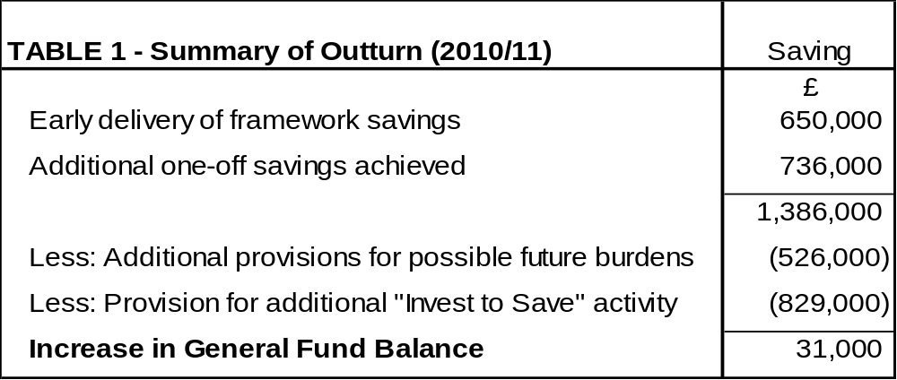
  - Three new reserves have been set up, which are designed to either drive revenue savings or to help protect the Council against a specific business risk or threat. These are:

- Invest to Save – This reserve can be used to support initiatives that have an ongoing revenue benefit and assist with achieving framework savings.
- Interest and VAT de-minimis – This reserve has been set up from the savings achieved through Fleming claims and will be used to offset revenue implications of an increase in interest rates or should the Council breach its VAT de-minimis level.

- Welfare Reform – This reserve has been set up from the savings made in Housing Benefits and will be used to offset any revenue costs associated with the new welfare reform regulations to be introduced from 2013/14.

  - After taking account of contributions to reserves and balances the Council’s General Fund working balance increased by £31,000 to £1.415m – this is still in line with the Council’s Medium Term Financial Strategy ‘guiding principles’.

  - The savings made give confidence that the Council remains “ahead of the curve” in delivering the Medium Term Financial Strategy. Section 4 provides more detail on the savings for 2011/12 however members are reminded of the levels of uncertainty after 2012/13.

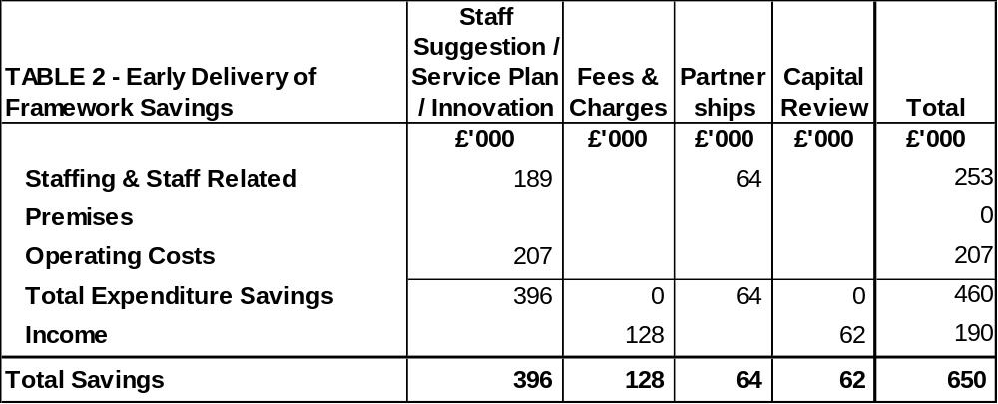
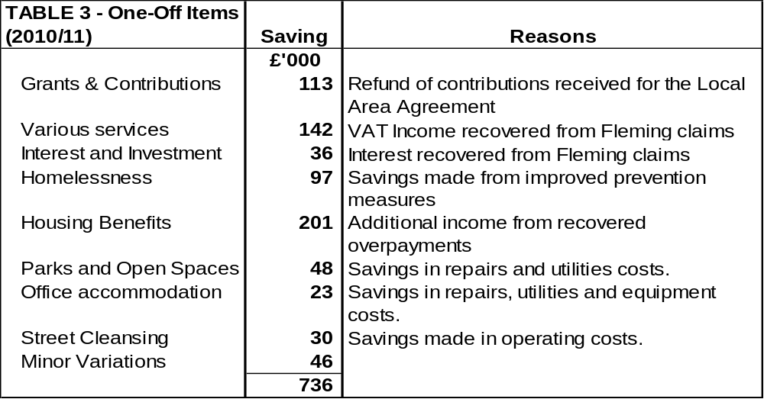
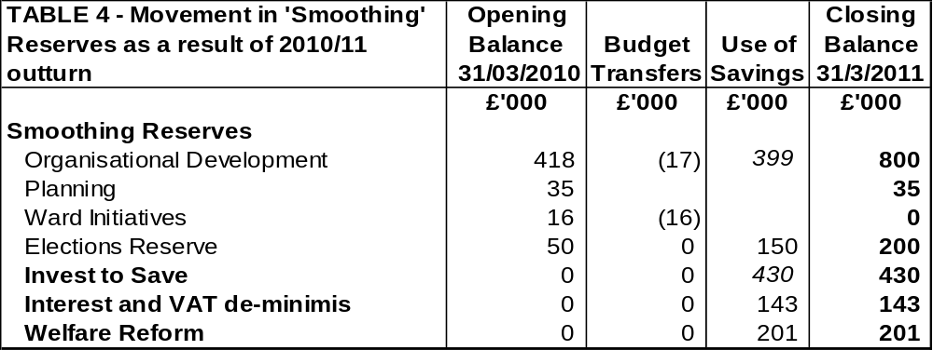
Housing Revenue Account

  - Members are reminded that the Housing Revenue Account is a ring-fenced account for day to day income and expenditure relating to the Councils role as a Housing Landlord.

Housing Revenue Account

Covers: Day to day expenditure and income relating to being a Council Housing landlord

Budget: £13.5m

Funding sources: Council House
Rents

  - The outturn for the Housing Revenue Account reflects a similar position to the General Fund. Savings of £182,000 have been achieved against the Revised Budget. The major reasons for variances are shown in the table below.
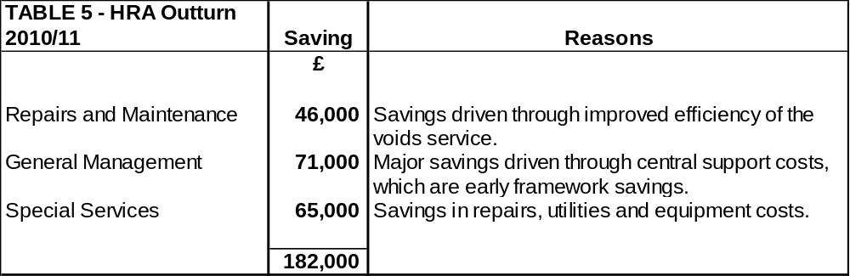
  - A total of £258,000 has been added to the Housing Revenue Account balance which is now £563,000. This is in line with the Council’s Medium Term Financial Strategy, which states “the account must operate in a surplus position and this is achieved by adopting the principle that an agreed minimum balance of £300,000 should be the primary strategic aim over the medium to long term.”

  - The strengthening of the Housing Revenue Account and the HRA balance has been an aspiration leading into a period of significant change. The next two years will see a fundamental change to the operation of the Housing Revenue Account under the Government self financing regime.

  - Self financing will undoubtedly provide a real challenge both in terms of set up and preparation before 1st April 2012; and also operationally with an unprecedented debt burden for the Council. This is likely to be in the region of £70m and although the Council will retain all of its rents it will not the level that rents are set at and nor will it retain all of the capital receipts from the sale of any council houses.

  - There are however likely to be opportunities, within the new system, for those Councils that are innovative and able to grasp the initiative. The Council finds itself in a good position having strengthened its financial position and with its stock in comparatively good condition it should be well placed to take advantage of any opportunities that present themselves.

Capital Programme

  - Members are reminded that the Capital Programme is used for the acquisition, improvement and enhancement of the Council’s assets.

Capital Programme
Covers: Expenditure on acquiring, maintaining, enhancing assets
Budget: £8.1m
Funding sources: Govt Grant / borrowing / capital receipts / external contributions
  - Overall, the expenditure during 2010/11 was £7.985m compared to the revised budget of £9.242m (i.e. 86% of the approved programme was actually spent). The major variations are outlined in the table below and Appendix A sets out budgets to be carried forward to 2011/12, which will need the Executive to approve.
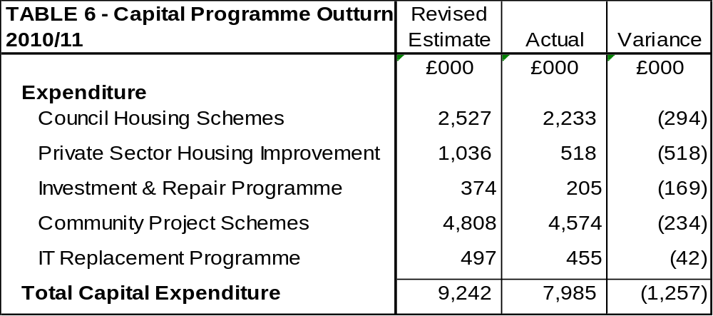
  - The Capital Programme variance will also be within 1% of the net budget taking account of carry forwards to 2011/12.
  - The outturn for the capital programme represent significant delivery and in particular the two Suite 16 projects, which are nearing completion. The Market Place buildings will ensure the Councils vision for a restaurant quarter can turn into a reality and the Public Realm scheme will not only complement and enhance the works already completed on the Market Place but also better connect the area to the Shopping Quarter, Yards and Horsemarket.

  - The Capital Programme funding is outlined in the table below. Once again the Council has attracted significant external funding to support its capital programme. Whilst future opportunities will undoubtedly become more limited the Council will continue to search out the funding streams that remain.
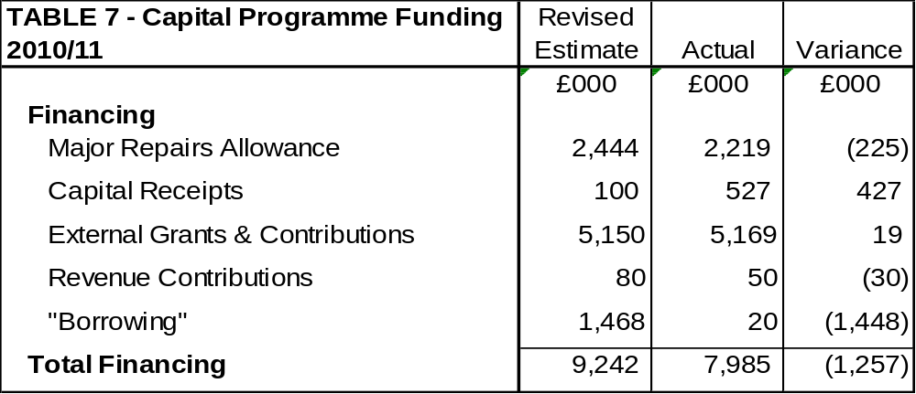

Treasury Management – Current Position

  - The Council’s debt and investment position at the beginning and the end of the year was as follows:
 | 31st March 2011 |  | 31st March 2010
 | Principal | Rate/ Return | Principal | Rate/ Return
Total Investments | £1.235m | 0.77% | £0m | n/a
Total Debt | £7.00m | 0.68% | £7.00m | 0.50%

 | Rate of Return
Council Portfolio | 0.77%
Benchmark – 3 Month LIBID | 1.00%

  - The £6.00m represents temporary borrowing for cashflow smoothing, (in line with the Council’s Treasury Management Strategy) not long term external debt of which the Council has none.
  - Although the Council has no long term debt it does effectively use its cash reserves to finance to avoid having to borrow money externally. Reserves are therefore not cash-backed and the Council would need to borrow if it wanted to use a significant proportion of its reserves.
  - Members are reminded of their “modelling for recovery” principle 2. which states “Given that we currently have no long-term debt, we should be prepared to consider debt-funding as a means of programme delivery or stimulus – if this can be shown to be sustainable and have a wider economic benefit;
Compliance with Treasury Limits and Prudential Indicators

  - During the financial year the Council operated within its treasury limits and Prudential Indicators set out in the Council’s Treasury Policy Statement and Annual Treasury Strategy Statement. The outturn for the Prudential Indicators is shown in Appendix B.

- BUDGET MONITORING

2011/12
  - The early delivery of savings outlined in section 4 has also had a positive impact on the budgeted framework savings for 2011/12. The table below shows the full-year effect of the £650,000 savings achieved in 2010/11 and the confidence levels for the delivery of the remainder of the Framework savings:
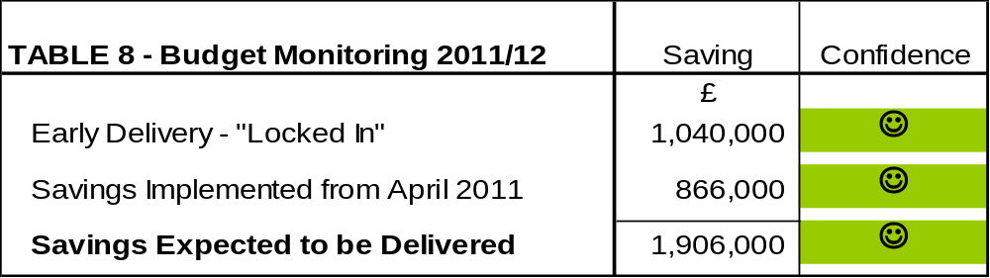
  - The vast majority of framework savings for 2011/12 are being successfully delivered. There are two minor variations where an additional £22,000 is expected from the New Homes Bonus and £22,000 less is expected in Highways income from the County Council.
  - The chart below also shows achievement against the framework year to date.
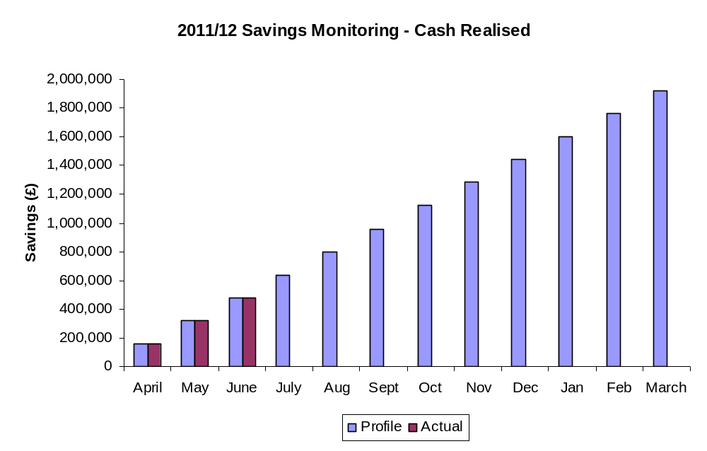

2012/13
  - As well as monitoring framework savings identified for 2011/12 work continues on identifying savings for 2012/13. Members are reminded of the current Medium Term Financial Forecast which requires an additional £1,043,000 of savings to balance the budget in 2012/13. The table below shows framework savings that have already been “locked in”. Further details of other savings that have been identified (but not yet secured) will be provided in future report.
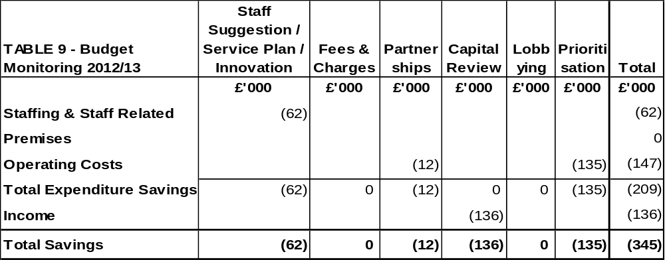
  - The following chart identifies framework savings that have already been identified for 2012/13. The savings are plotted in the month they are identified and the comparator is the £1,043,000 identified above. It is particularly encouraging that in July 2011 we have identified around one third of the savings needed for 2012/13 i.e. to July 2012.
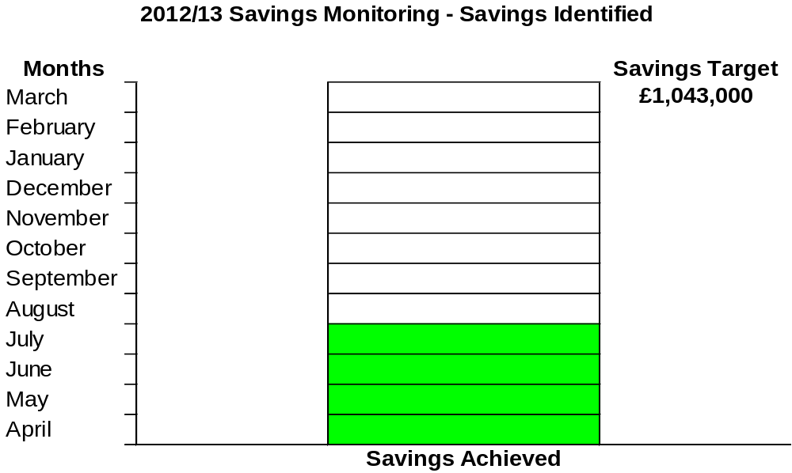
  - The above chart includes the ‘early win’ that the Council has already secured against the savings target for 2012/13 due to the cancellation of the public conveniences contract. As previously agreed by the Executive, the contract notice has been served (12 months) and will take effect early 2012/13.

- CONSULTATION AND CUSTOMER IMPACT

  - None as a direct consequence of this report however members are reminded that the formal budget consultation period is from 18th January 2012 to 22nd February 2012 when the Council sets its Council Tax for 2012/13. Comments from the consultation process will be reported to the Executive for consideration at it’s meeting on 15th February 2012.

- POLICY IMPLICATIONS

  - There are no direct policy implications as a result of this report.

- USE OF RESOURCES
  - The implications on the Council’s resources will be considered through out the durable budget reports.

9. RECOMMENDATION

The Executive Committee is recommended to

  - Note the out-turn position for 2010/11 for the General Fund, Housing Revenue Account and Capital Programme.
  - Endorse the capital carry forwards outlined in Appendix A.

  - Recognise the early delivery of savings for 2011/12

  - Note the budget monitoring information (as contained in section 5) and the significant progress that is being made.

Background Papers: Previous Reports/Minutes:
Title of Document: Estimate Working Papers Monthly Durable Budget Reports
Contact Officers: P Sutton (April 2010 to date)

