BOROUGH OF KETTERING

Committee | Full Planning Committee - 26/04/2011 | Item No: 5.4
Report Originator | Fjola Stevens  Development Officer | Application No:  KET/2011/0169
Wards Affected | All Saints
Location | 67 Princes Street & 103 Wellington StreetKettering
Proposal | Full Application: Conversion of dwelling to 2 no. flats with additional windows to south west elevation, and change of use of outbuildings to dwelling with two storey extension, roof lights and alterations
Applicant | Mr N Hassan

1. PURPOSE OF REPORT

  - To describe the above proposals
  - To identify and report on the issues arising from it
  - To state a recommendation on the application

2. RECOMMENDATION

THE DEVELOPMENT CONTROL MANAGER RECOMMENDS that this application be APPROVED subject to the following Condition(s):-

1. The development hereby permitted shall be begun before the expiration of 3 years from the date of this planning permission.
REASON: To comply with Section 91 of the Town and Country Planning Act 1990 (as amended) and to prevent an accumulation of unimplemented planning permissions.

2. The materials to be used in the construction of the external surfaces of the development hereby permitted shall match, in type, colour and texture those on the existing building.
REASON: In the interests of visual amenity in accordance with policy 13 of the North Northamptonshire Core Spatial Strategy.

3. The roof lights hereby permitted shall be conservation type rooflights which shall sit flush with the roofslope.
REASON: In the interests of visual amenity in accordance with policy 13 of the North Northamptonshire Core Spatial Strategy.

4. Prior to the first occupation of the dwellinghouse hereby permitted the bedroom and landing windows and the glass blocks on the south east elevation shall be non-opening and glazed with obscured glass in accordance with details and samples which shall have been submitted to and approved in writing by the Local Planning Authority prior to installation and thereafter shall be permanently retained in that form.
REASON: To protect the privacy of the adjoining property and to prevent overlooking in accordance with policy 13 of the North Northamptonshire Core Spatial Strategy.

5. Prior to installation full details of the proposed materials and finishing of the sliding garage doors hereby permitted shall be submitted and and approved in writing by the Local Planning Authority.
REASON: In the interests of visual amenity in accordance with policy 13 of the North Northamptonshire Core Spatial Strategy.

6. Notwithstanding the provisions of Article 3 of the Town and Country Planning (General Permitted Development) Order 1995 (or any Order revoking and re-enacting that Order with or without modification) no building, structure or other alteration permitted by Classes A, B, C, D or E of Part 1 of Schedule 2 of the Order shall be erected, constructed or made on the application site.
REASON: In the interests of the proper planning of the area and in the interests of amenity in accordance with policy 13 of the North Northamptonshire Core Spatial Strategy.

7. The development hereby permitted shall not be carried out other than in accordance with the Sustainable Design and Energy Statements submitted with the application.
REASON: In the interests of sustainability in accordance with policy 14 of the North Northamptonshire Core Spatial Strategy.

8. The development hereby permitted shall not be carried out other than in accordance with the approved plans.
REASON: In the interests of amenity in accordance with policy 13 of the North Northamptonshire Core Spatial Strategy.

Notes (if any) :-
- The applicants should be aware that should the hard paved areas of the site be changed then there may be a risk from naturally occuring contaminants and an investigation may be required.
The application should be aware that the acoustic insulation between new dwellings must conform to the requirements of approved document E 'Resistance to the passage of sound'.

Justification for Granting Planning Permission

The proposal is in accordance with national and local policies as set out in Planning Policy Statements/Guidance Notes 1, 3 and 13, Policies 1, 2, 3 and 11 of The East Midlands Regional Plan, Policies 1, 9, 10, 13 and 14 of the North Northamptonshire Core Spatial Strategy, and Policy 35 of the Local Plan for Kettering Borough. The proposal is also in accordance with adopted Supplementary Planning Document Sustainable Design. There are no material considerations that indicate against the proposal.

Officers Report

3.0 | Information

Relevant Planning History
KET/2010/0746 Conversion of dwelling to 2 no. flats with additional windows to south west elevation, and change of use of outbuildings to dwelling with two storey extension, roof lights and alterations WITHDRAWN 12/01/11

KET/2007/1029 2 storey extension and conversion of derelict outbuildings and garden to 2 no. dwellings REFUSED 09/01/2008

Site Description
Officer's site inspection was carried out on 25th March 2011.

The application site incorporates the existing dwelling at 67 Princes Street, which lies on the northern side of Princes Street, and an outbuilding currently associated with 103 Wellington Street and this sits behind the dwellings on the western side of Wellington Street. The existing buildings are both brick built 19th century buildings in keeping with the predominant high density, linear form of development in the locality.

The outbuilding sits within a rear yard screened by a high brick wall with a small garage in front built up to the back of the pavements. The outbuilding is functional and utilitarian in design, and having once most probably been a work shop associated with industry in the town it now serves no useful purpose to the associated dwelling due to its large size.

Proposed Development
This application seeks planning permission to convert an existing mid-terraced dwelling (67 Princes Street) into 2 no. 2 bed flats and to convert an existing outbuilding associated with the adjoining dwelling (103 Wellington Street) to provide a 2 bedroom dwelling.

Any Constraints Affecting The Site
None

4.0 | Consultation and Customer Impact

Environmental Health
No objection

Neighbours
3 letters of objection received:
- objection to development being attached to private wall
- development will cause structural damage
- lack of on-street parking
- proposal will cause noise and disturbance
- loss of privacy
- add to strain on local resources such as bin storage
- does not create a living space that fits with the local community
- traffic flow is bad and this application will increase traffic problems

5.0 | Planning Policy
National:
PPS1 Delivering sustainable development
PPS3 Housing
PPG13 Transport

Local:
East Midlands Regional Plan policies (EMRP):
P. 1 Regional core objectives
P. 2 Promoting better design
P. 3 Distribution of new development
P. 11 Development in the southern sub-area

Saved Local Plan policies (LP):
P. 35 Housing: Within towns

Core Strategy policies (CSS):
P. 1 Strengthening the network of settlements
P. 9 Distribution & location of development
P. 10 Distribution of housing
P. 13 General sustainable development principles
P. 14 Energy efficiency and sustainable construction

Supplementary Planning Guidance:
Sustainable Design SPD

6.0 | Financial/Resource Implications
 | None
7.0 | Planning Considerations
The key issues for consideration in this application are:-

1. Principle of development
2. Design and visual impact
3. Impact upon neighbours
4. Sustainable construction and design
5. Highway safety

1. Principle of development

PPS1, PPS3, Policies 1, 3 and 11 of the EMRP and Policies 1, 9 and 13 of the CSS require new development to be focused within existing built up areas in order to ensure new developments are located in sustainable locations. In addition policy 35 of the LP states that application for residential development within towns is likely to acceptable provided the development accords with other policies in the plan.

The application site lies within the existing built up area of Kettering relatively close to the town centre and the application site is therefore located in a sustainable location. Therefore the principle of converting an existing dwelling and an outbuilding to create 2 flats and a detached dwelling accords with planning policy and is acceptable in principle.

2. Design and visual impact
PPS1 states that good design is indivisible from good planning, whilst Policy 2 of the EMRP promotes high quality design, Policy 13(h) of the CSS states that new development should be high quality in design and it should respect and enhance the character of its surroundings.

The proposal would result in only minor changes to fenestration of the existing dwelling which, due to their location at the rear of the property, would not have a significant impact upon the appearance of the surrounding area.

The proposed changes to the existing outbuilding, which include a first floor extension to incorporate the garage with the outbuilding and a dormer window to the front of the building, are more significant and will have an impact upon the street scene. However, because the extensions to the front of the building would be set back from both neighbouring properties and would be lower in height than the neighbouring properties the development would not detract from the appearance of the host building or the street scene. The small dormer and new lead roof proposed to the rear of the main roofslope would not be particularly visible from the surrounding area and therefore would not harm the appearance of the locality.

A number of changes to the fenestration of the outbuilding are proposed, and these include;
North east elevation - Replacing the garage door with sliding timber/glass doors, replacing an existing door with a window at ground floor level and creating 2 new windows at first floor level;
South east elevation – creation of front door and hall window at ground floor level, provision of obscure glass blocks at a high level to serve ground floor living space, insertion of an obscure glazed window and rooflight to serve the landing and 2 rooflights to serve bedroom at first floor level, 1 lower rooflight to provide natural light to covered parking area, and 3 further rooflights to provide light to the ground floor living space at the rear of the building. The 2 existing windows will be retained, with the small window serving bedroom 2 being changed to obscure glass;
South west elevation – No change
North west elevation – insertion of 1 rooflight to serve landing

Although the proposed alterations would result in a mix of window types and sizes, many of these windows would not be highly visible due to their location and the screening of the building and in any event the existing windows are different scales and designs and the proposal has considered the heritage of the building and retained the existing openings where possible.

It is considered that due to the siting and scale of the proposed changes of the fenestration of the existing dwelling, and the scale and design of the proposed extensions and alterations to the outbuilding and its siting set back from the street and well screened by surrounding properties to the north, south and west the proposed development would respect and enhance the character of the surrounding area. The proposal therefore accords with PPS1, policy 2 of the EMRP and policy 13(h) of the CSS.

3. Impact upon neighbours
Policy 13(l) of the CSS states that new development should not have an unacceptable impact upon neighbours by reason of overlooking or loss of light among other factors.

The changes to the fenestration on the existing dwelling would include replacing a window with a door on the rear elevation at ground floor level, creating 2 new windows on the south west side elevation to serve a kitchen and bathroom. The first floor fenestration would be retained as existing. Due to the scale of the proposed alterations to the existing dwelling it is considered that these works would not have a detrimental impact upon neighbours.

In terms of the alterations to the existing outbuilding, the creation of a 2 storey living space within the rear part of the building ensures that the existing and proposed windows and rooflights would not overlook the adjoining properties. In addition the use of obscure glazing in the south east facing window to bedroom 2 would prevent adjacent properties from being overlooked.

In terms of the amenities of future occupiers the Environmental Health Officer has advised that it is important that adequate noise insulation is provided between the proposed flats and within the new dwelling. The Sustainable Construction and Energy Statement confirm that this will be carried out and in any case this would be controlled by building regulations. It is therefore considered that the proposal would also not harm the amenities of future occupiers.

The proposal would therefore accord with policy 13 of the CSS with respect to the impact upon neighbours.

4. Sustainable construction & design
Policy 14 of the CSS requires new developments to meet the highest viable standards of resource and energy efficiency standards. The application is accompanied by a sustainable design and energy statement for both aspects of the development which demonstrate that sustainable construction methods such as using double glazing, good insulation, thermal bridging and re-use of materials where possible to minimise waste will be incorporated. The statements also demonstrate that water efficient systems and electrical appliances e.g. washing machines/dishwashers will be installed, space will be provided for bin storage including recycling bins, and low energy lighting will be used.

Sustainable Design SPD checklists have also been submitted for both aspects of the development, and these outline how the character of the existing buildings will be retained, note that sustainable transport options are available close-by, and refers to the water conservation measures and waste reduction/recycling measures proposed.

It is considered that sufficient information has been submitted with the application to ensure that the proposed development incorporates adequate sustainable construction and energy efficiency measures in accordance with policy 14 of the CSS.

5. Highway Safety
Policy 13(n) of the CSS states that new development should not have an adverse impact upon the highway network or prejudice highway safety. The proposed covered space is currently used as a garage and it is understood that this would remain the case, although it is noted that its size does not meet the Highways Authority standards and therefore its use would be dependent upon the size of the vehicle. It is however considered that due to the location of the site and the small size of the dwellings, which are in a sustainable location and unlikely to result in a great demand for on-street parking, the lack of off-street parking provision would not have a significant impact upon highway safety. The proposal therefore accords with policy 13(n) of the CSS.

Comments on other points raised by proposal
Two objections have been received that relate to party wall or structure issues. These are private matters between the developer and the owners of adjoining land or buildings and are not material planning considerations which would warrant a reason for refusal.

Conclusion
The proposed development would result in the provision of 3 small dwellings within an existing built up area close to the town and it would make use of 2 existing buildings. The development therefore constitutes sustainable development which would be in-keeping with the predominantly residential character of the surrounding area. In addition, due to the siting, scale, design and appearance of the proposed alterations the proposal would not harm the amenities of neighbours or the visual amenity and character of the locality. The proposal therefore accords with PPS1, PPS3 and PPG13, Policies 1, 2, 3 and 11 of the East Midlands Regional Plan, Policies 1, 9, 10, 13 and 14 of the North Northamptonshire Core Spatial Strategy, Policy 35 of the Local Plan for Kettering Borough and the Sustainable Design Supplementary Planning Document.
Background Papers |  |  | Previous Reports/Minutes
Title of Document: |  |  | Ref:
Date: |  |  | Date:
Contact Officer: |  | Fjola Stevens, Development Officer on 01536 534316

SITE LOCATION PLAN

67 Princes Street & 103 Wellington Street, Kettering
Application No.: KET/2011/0169

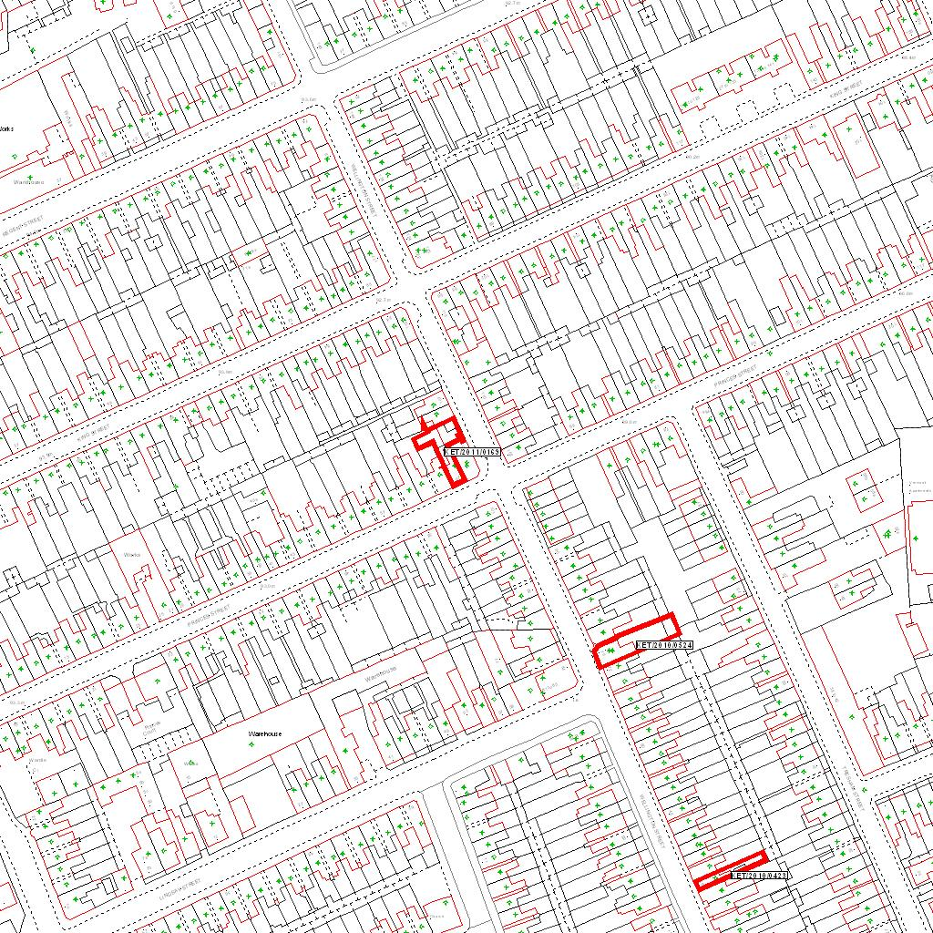

Reproduced from the Ordnance Survey mapping with the permission of the Controller of Her Majesty’s Stationery Office © Crown copyright. Unauthorised reproduction infringes Crown copyright and may lead to prosecution or civil proceedings.  LA078344 |  | N
Date: 21/03/2011 Do not scale from this map. For illustrative purposes only.

