BOROUGH OF KETTERING

Committee | Full Planning Committee - 29/03/2011 | Item No: 5.4
Report Originator | Fjola Stevens  Development Officer | Application No:  KET/2011/0051
Wards Affected | Rothwell
Location | McDonalds Restaurants Ltd, A14 Eastbound, Kettering
Proposal | Full Application: Refurbishment of restaurant and patio area, including extensions, changes to elevations, reconfiguration of car park layout, installation of customer order display, canopy and new height restrictor
Applicant | McDonald's Restaurant Ltd

1. PURPOSE OF REPORT

  - To describe the above proposals
  - To identify and report on the issues arising from it
  - To state a recommendation on the application

2. RECOMMENDATION

THE DEVELOPMENT CONTROL MANAGER RECOMMENDS that this application be APPROVED subject to the following Condition(s):-

1. The development hereby permitted shall be begun before the expiration of 3 years from the date of this planning permission.
REASON: To comply with Section 91 of the Town and Country Planning Act 1990 (as amended) and to prevent an accumulation of unimplemented planning permissions.

2. No development shall commence on site until details of the types and colours of all external facing and roofing materials to be used, together with samples, have been submitted to and approved in writing by the Local Planning Authority. The development shall not be carried out other than in accordance with the approved details.
REASON: In the interests of the visual amenities of the area in accordance with policy 13 of the North Northamptonshire Core Spatial Strategy.

3. Prior to the commencement of development samples of the proposed colour and finish of the fenestration, piers, soffits and booths shall be submitted to and approved in writing by the Local Planning Authority.
REASON: In the interests of amenity in accordance with policy 13 of the North Northamptonshire Core Spatial Strategy.

Notes (if any) :-
- The applicant is reminded that this planning permission does not give any indication of any consent necessary under the Town and Country Planning (Control of Advertisements) (England) Regulations 2007 which may or may not be required nor any indication that such consent will be forthcoming. The applicant is advised to contact Development Services in this regard.

Justification for Granting Planning Permission

The proposal is in accordance with national and local policies as set out in Planning Policy Statements 1 and 4, Policies 1, 2, 3 and 11of The East Midlands Regional Plan and Policies 1, 9, 13 and 14 of the North Northamptonshire Core Spatial Strategy. There are no material considerations that indicate against the proposal.

Officers Report

3.0 | Information
KET/2011/0052 – 7 no. illuminated and 1 no. non-illuminated signs UNDER CONSIDERATION

KET/2011/0053 – 4 no. internally illuminated roof signs and 1 no. order display unit UNDER CONSIDERATION

KET/2011/0063 – 2 no. appendage signs on existing totem sign UNDER CONSIDERATION

KET/2006/0101 – Replace existing menu boards and add a new board illuminated and non illuminated APPROVED 27/03/06

KET/1997/0685 – Extension to restaurant building to create additional space for crew room and refuse areas APPROVED 05/01/98

KET/1997/0478 – Proposed one bay extension and crew room APPROVED 31/03/98

KET/1995/0506 – Illuminated 70/50 pole sign (on 10m pole) REFUSED 17/10/95

KET/1995/0485 – Illuminated mansard roof sigh APPROVED 06/11/95

KET/1995/0484 – Illuminated series 2000 signs/traffic signs/gantry sign APPROVED 17/10/95

KET/1995/0483 – Illuminated 70/25 pole sign (on 6m pole) APPROVED 17/10/95

KET/1995/0482 – 2 No. illuminated flag poles REFUSED 17/10/95

KET/1995/0157 – McDonalds Drive Thru Restaurant APPROVED 13/11/95

Site Description
Officer's site inspection was carried out on 4th March 2011.

The application site lies on the northern side of the A14 trunk road to the south east of Rothwell. The site forms part of a service station and is occupied by a single storey fast food restaurant with ‘drive thru’. The site is accessed via a slip road from the eastbound A14 with car parking to the north of the building.

Proposed Development
This application seeks planning permission for extensions and alterations to the existing building, reconfiguration of the patio, vehicular routes and car parking, new customer order display unit, and new height restrictor.

Any Constraints Affecting The Site
Trunk Road
Outside settlement framework

4.0 | Consultation and Customer Impact
Town Council
No objection

Environmental Health
No objection

Highways Agency
No objection

Highways Authority
No objection

5.0 | Planning Policy

National Policies
PPS1 Delivering sustainable development
PPS4 Planning for sustained economic growth

Development Plan Policies

East Midlands Regional Plan
P. 1 Regional core objectives
P. 2 Promoting better design
P. 3 Distribution of new development
P. 11 Development in the southern sub-area

North Northamptonshire Core Spatial Strategy
P. 1 Strengthening the network of settlements
P. 9 Distribution and location of development
P. 13 General sustainable development principles
P. 14 Energy and sustainable construction

SPGs
Sustainable design SPD

6.0 | Financial/Resource Implications
 | None
7.0 | Planning Considerations
The key issues for consideration in this application are:-

- Principle of development
- Impact upon visual amenity of surrounding area
- Impact upon highway safety
- Impact upon trees
- Impact upon amenity
- Sustainability

1. Principle of development
PPS1, policies 1 and 3 of the EMRP and policies 1, 9 and 13 of the CSS encourage new development within existing built up areas to ensure that it is sited in sustainable locations accessible via sustainable modes of transport. The application site lies within the defined rural area, however the proposal relates to relatively small scale alterations to an existing development and the proposal would not result in encroachment into the open countryside, thereby ensuring that the development relates to previously developed land.

Furthermore PPS4 states that Local Planning Authorities (LPA’s) should adopt a constructive approach to planning applications for economic development subject to considerations about the development’s environmental impact, design, accessibility, impact on economic regeneration and impact upon local employment. Due to the small scale of the development the applicant is not required to complete a sequential assessment and given the existing use of the site and the scale of the additions it is considered that the proposal would not have a significant impact upon the vitality or viability of the nearby towns of Rothwell and Kettering and would not change the level of employment at the site. The other considerations are addressed below, however in principle it is considered that the proposed development accords with the principles of PPS4.

For the reasons set out above it is considered that the principle of the development accords with PPS1 and PPS4.

2. Impact upon visual amenity of surrounding area
PPS1, policy 2 of the EMRP and policy 13(h) of the CSS all encourage high quality design which is appropriate within its context and enhances the character and quality of the surrounding area.

The objective of the proposed works is to upgrade and modernise the existing building in line with the recent rebranding of McDonalds restaurants. At present the brick building is detailed with white plastic piers, soffits, windows and drive through booths. The windows, soffits and piers would all be painted khaki green and the ‘drive thru’ booths would be covered with grey aluminium cladding. The proposed extensions that form part of the development would not significantly increase the floor area of the building, with the extensions totalling approximately 23.2m.

The extensions on the front of the building (west elevation) would include infilling the space beneath the existing eaves overhang and providing a new lobby which would project approximately. 1.5m out from the current eaves. The existing windows would be reused where possible, however they would be painted khaki green and the proposed lobby would be fully glazed with flat roof hidden by a parapet also painted green. It is considered that these alterations would contribute to improving the overall appearance of the building and due to their scale and design they would not harm the appearance of the locality.

At the rear of the building (east elevation) there is currently a small extension with mono-pitched roof which is used as a cold store and a service area screened by diagonal timber fencing. The proposal would increase the size of the existing extension to the south and east to enlarge the existing cold store and servery areas. However these additional would be well screened by a new timber fence which would enclose the extensions and the existing service area. The proposed extensions and alterations at the rear of the building simplify its existing appearance and therefore they would not have a detrimental impact upon the appearance of the surrounding area.

It is also considered that the reconfiguration of the patio areas, car park and access would not have a significant impact upon the visual amenity of the locality because all of the alterations would take place within the existing car park and access areas, most of which is the rear of the building. Although one of the patios at the far western edge of the site would be replaced with car parking it is considered that this would not have a significant visual impact because the green open space to the south of the building would be retained. A new footpath would be created from the foot/cycle way that runs alongside the A14, however due to the scale of this alteration it would not detract from the amenity of the surrounding area.

The proposed height restrictor and the order display unit have also been considered under and application for advertisement control (KET/2010/0052), and it is recommended that due to the siting of these structures they would not detract from the amenity of the surrounding area.

Therefore, for the reasons set out above the proposed development would not have an adverse impact upon the visual amenity or character of the surrounding area and as such the proposal accords with policy 13(h) of the CSS.

3. Highway safety
Policy 13(n) of the CSS states that new development should not have an adverse impact upon the highway network or prejudice highway safety. The proposed development would not have any direct impact upon the existing highway network and it is considered that due to the scale of the extensions the proposal would not have any significant impacts upon the capacity of the highway network. In addition the proposed works, which include the reconfiguration of the car park and a new pedestrian access, have been designed to create a safer environment for users within the site. It is therefore considered that the proposed development accords with policy 13(n) of the CSS.

4. Impact upon trees
The proposed works to reconfigure the car park and access would result in the loss of some early to mid mature trees however there are of little or no consequence other than as localised landscape value to the immediate users of the restaurant. The replacement trees will adequately compensate for their loss and therefore it is considered that that the proposal is acceptable in this regard.

5. Impact upon amenity
Policy 13(l) of the CSS states that new development should not have an unacceptable impact upon the amenity of neighbouring properties or the wider area by reason of noise, smell, light or other pollution, loss of light or overlooking.

The application site lies alongside a petrol station with shop and to the south east on the southern side of the A14 lies a waste digestion plant. It is considered that due to the nature and scale of the proposed development it would not have a significant impact upon the neighbouring sites or the wider area. The proposal therefore accords with policy 13(l) of the CSS.

6. Sustainability
Policy 14 of the CSS states that new development should meet the highest viable standards of resource and energy efficiency, incorporating techniques of sustainable construction and energy efficiency, waste reduction/recycling and water reduction/recycling. Due to the scale and nature of the proposed alterations it is not possible to incorporate any significant sustainable construction and energy efficiency measures. However, the proposed extensions to the front of the building will make use of the existing windows and therefore this will reduce the amount of waste generated during the construction phase. It is therefore considered that the proposal accord with policy 14 of the CSS.

Conclusion

S. 37(6) of the Planning and Compulsory Purchase Act 2004 states that applications for planning permission must be determined in accordance with the development plan unless other material considerations indicate otherwise. The proposed development by reason of its siting, scale, design and appearance would not have an unacceptable impact upon visual amenity, highway safety, trees within the site, the amenity of neighbours or the wider area and the proposed development incorporates sustainable construction principles. Therefore the proposal accords with PPS1, Policies 1, 2, 3 and 11 of the East Midlands Regional Plan, and Policies 1, 9, 13 and 14 of the North Northamptonshire Core Spatial Strategy, and there are no material considerations that indicate against the proposal.

Background Papers |  | Previous Reports/Minutes
Title of Document: |  | Ref:
Date: |  | Date:
Contact Officer: | Fjola Stevens, Development Officer on 01536 534316

SITE LOCATION PLAN

McDonalds Restaurants Ltd, A14 Eastbound, Kettering
Application No.: KET/2011/0051

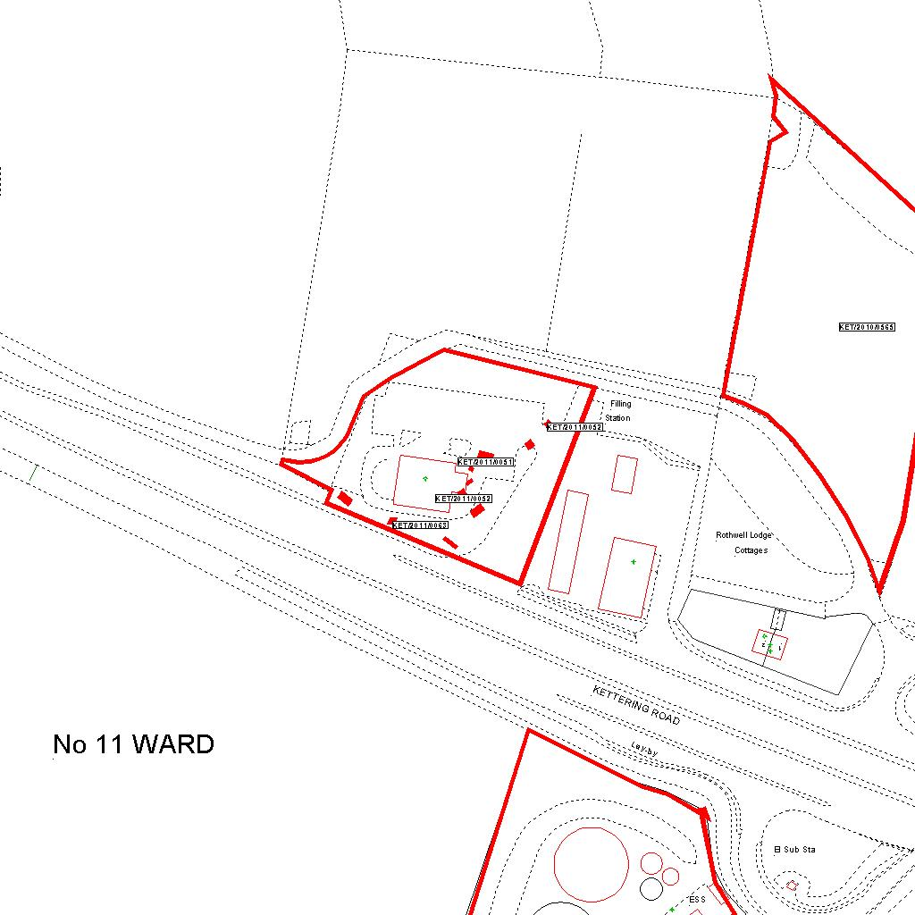

Reproduced from the Ordnance Survey mapping with the permission of the Controller of Her Majesty’s Stationery Office © Crown copyright. Unauthorised reproduction infringes Crown copyright and may lead to prosecution or civil proceedings.  LA078344 |  | N
Date: 03/02/2011 Do not scale from this map. For illustrative purposes only.

