Appendix 1
Item 9
Executive Committee - 8.12.10

More on the Menu in Kettering!

Eagle-eyed readers of the Evening Telegraph may have already noted that Kettering’s new restaurant quarter has already started to take off, with plans to open a new restaurant above Sessions Wine Bar on the Market Place.
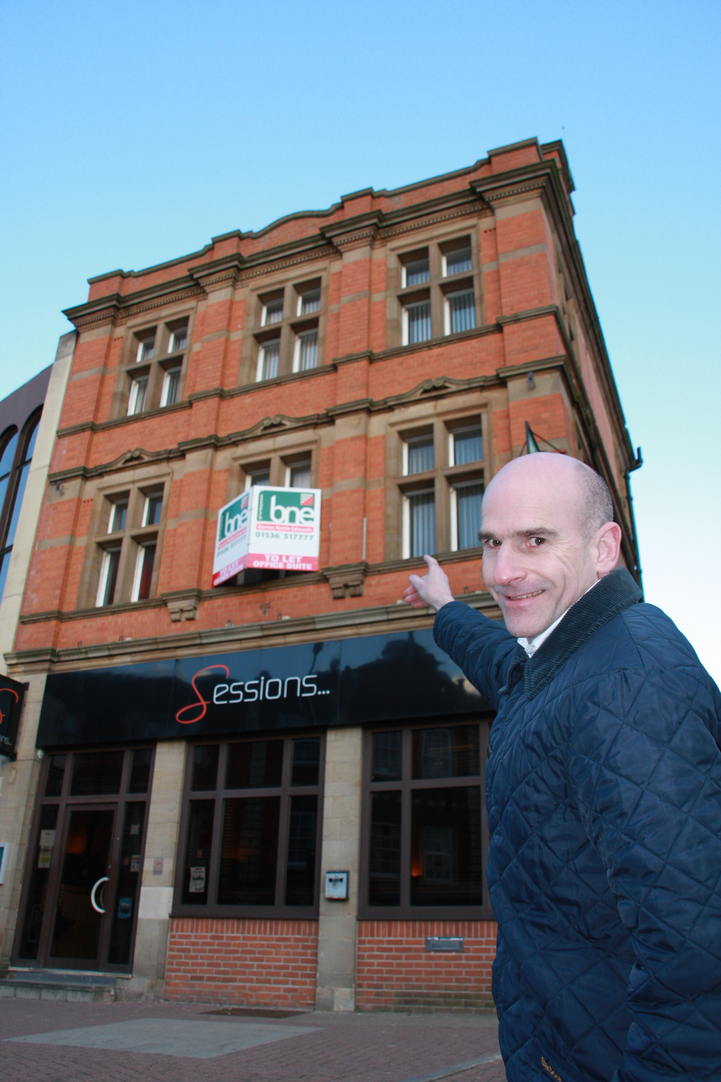
The plans - submitted to Kettering Borough Council planners last week – propose converting the floors above the popular wine bar to more than 2,000 sqft of new restaurant use. Simon Musto (pictured right), the owner of 7a Market Place - and proprietor of Simon Musto Estate Agents on Sheep Street - is looking forward to a successful new venture:

“Ever since the new Market Place opened there has been a real ‘buzz’ in and around the restaurant quarter. The building of the new restaurants is set to be a fantastic addition to the quarter and with the completion of the new public realm I think we will be the envy of many other town centres. The new restaurant above Sessions will have space for up to 100 covers and I am already on the look out for restaurateurs to take up this exciting opportunity”

The new Market Place restaurants currently being constructed on the old Market Place car park are due for completion in the spring and have already attracted interest from top restaurant names.

Councillor Derek Zanger, Portfolio Holder for Market Towns and Villages, cites the Market Place as an exemplar in Town Centre Regeneration:

“The emerging restaurant quarter is a perfect example of the clever use of external money. We have created a fantastic new space for the whole community to enjoy, but not only that we have stimulated the economy by delivering new restaurants to the town. That local entrepreneurs have chosen to follow suit is proof of the successful leadership and vision shown by Kettering Borough Council.”

Investor confidence in Kettering is growing as the recent sales of the Corn Exchange and the Cherry Tree Public House have shown there is a strong demand for property in Kettering.

Programme Manager, Paul Thomas is confident that the Council’s regeneration plans will succeed:

“There are already some fantastic restaurants in and around the Market Place and the sorts of names we are talking about attracting to the town will certainly complement the current offer. We have every reason to be confident that other restaurants will be queuing up to be part of the restaurant quarter”

He added:

“The vision for Kettering is straight forward. In order to thrive in the future, the town needs to be able to offer a unique experience that will make people want to return again and again. Kettering is undergoing a transformation that will see further improvements to shopping, employment, living and visiting experience”.

ends

