


BUSINESS CONTINUITY

Business Impact Analysis

23RD NOVEMBER 2010

Contents

Section |  | Page No.
1. | Executive Summary | 3
2. | Business Impact Analysis - overview | 4
3. | Business Impact Analysis - Key services matrix | 5
4. | Business Impact Analysis - Service Summary Details | 6 - 10
5. | Business Impact Analysis - Threat Identification | 11 to 13
Appendix A | Prioritised list of services | 14



SECTION 1 – EXECUTIVE SUMMARY

The purpose of a Business Impact Analysis (BIA) is to set priorities around which robust business continuity planning can take place. The Business Impact Analysis identified the main services that are critical (Mission Critical Activities) to the Council and the nature of the potential threats against those services.

The table below summarises the highest priority services to be maintained and the Recovery Time Objective (RTO’s). The full list will form the basis of the initial impact assessment following an incident.

Table 1 – Key Mission Critical Services

SERVICE 1:1 CSC/CRC to support essential services (< 24 hours RTO)
SERVICE 3:1 Election Management (< 24 hours RTO)
SERVICE 1:3 Customer Services (Face-to-face, Telephone, Website, IT): (< 24 hours RTO)
SERVICE 2:1 Dangerous Structures (< 24 hours RTO)
SERVICE 8:1 Facilities (Main buildings) (< 24 hours RTO)
SERVICE 8:2 Communications(< 24 hours RTO)

SERVICE 3:2 Electoral Registration August/September (2-3 day RTO)
SERVICE 3:4 Property – lettings – rents collection (2-3 day RTO)
SERVICE 6:3 Crematorium/cemeteries (2-3 day RTO)
SERVICE 7:2 Excavation of graves (2-3 day RTO)
SERVICE 7:3 Housing – Essential Repairs E.g. Utilities failures (2-3 day RTO)
SERVICE 7:7 Refuse and Street Cleansing (2-3 day RTO)
SERVICE 7:11Housing – Essential Repairs / All Priority 1’s (less than 24 Hrs) (2-3 day RTO)
SERVICE 8:3 Cleaning (2-3 day RTO)
SERVICE 9:3 Money (bank/investments) (2-3 day RTO)
SERVICE 10:1 Scheme Managers inc support workers (2-3 day RTO)
SERVICE 10:2 Cleaners (2-3 day RTO)
SERVICE 10:3 Housing Options Team (2-3 day RTO)

Appendix A contains the complete list of prioritised services. It is against this prioritised list that an impact assessment can be undertaken following an incident.

Table 2 – Key Threats to Mission Critical Services

No | Threat | Risk Score
1a | Loss of staff (illness) | High - Critical
1c | Loss of staff (extreme weather) | Significant - critical
2 | Loss of I.T (virus / hacking etc) | Significant – critical
3 | Depot (fire potential) | Significant – critical
4 | Contractor (financial / market conditions) | Significant – critical
5 | Main Office (fire potential) | Low - Catastrophic
Risks highlighted in red are top priority and those in amber are medium priority.

The next fundamental action is to consider in high level terms the current mitigation measures and the broad strategies that should be followed.

SECTION 2 – BUSINESS IMPACT ANALYSIS (BIA) OVERVIEW

The Business Impact Analysis is the foundation to understanding your organisation and developing the Business Continuity Plan(BCP). It allows the identification of your Mission Critical Activities (MCAs) and helps document the potential impact of activity failure. The purpose of this is to focus future BCM work on the council’s key services and the main threats to those services. This in turn means that when an interruption happens the response focuses resources – people, space, time and money – to the services that are most important to the council.

The key outcomes

- identify those activities whose loss would have the greatest impact in the shortest time and which need to be recovered most rapidly (Mission Critical Activities – MCA’s)

- identify potential points of failure, threats and risks to MCAs (Threat analysis)

- agree critical response times (Recovery Time Objective - RTO’s)

SECTION 3: BIA - MISSION CRITICAL SERVICES MATRIX

This section was completed at the Business Impact Analysis workshop with the Management Team on the 16th September 2009. The matrix allows Mission Critical Activities (MCAs) to be prioritised, i.e. the key strategic, operational or support services most important to the Council in discharging its statutory duties and achieving key corporate aims and objectives. The numbers in the matrix refer to the table of services below. The matrix considers the services in terms of consequential loss and the Recovery Time Objective (RTO).

The objective is to plan for service recovery beginning with those less than 24 hour services.

Figure 1: Mission Critical Services Matrix
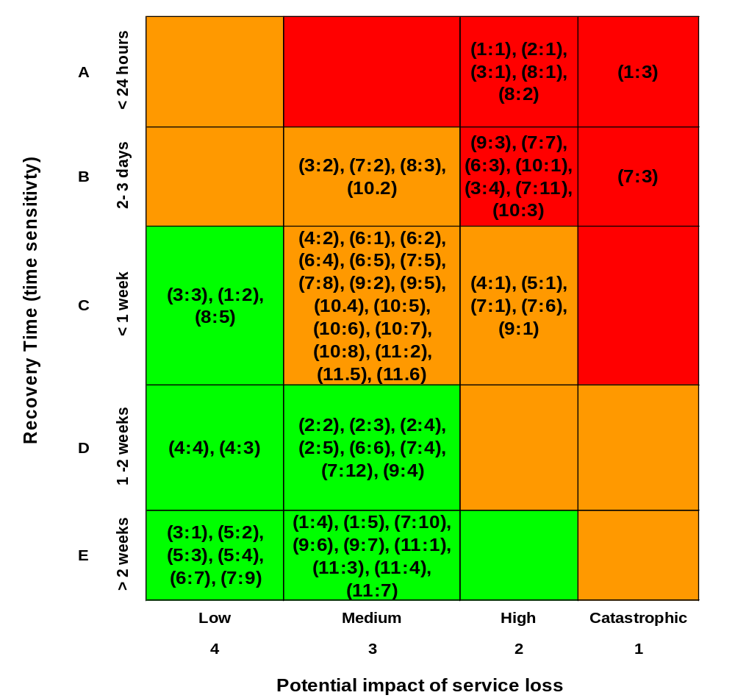

SECTION 4: BIA - CRITICAL SERVICES PRIORITISATION

Service Area | A  Must continue e.g for public health reasons | B  Should continue to maintain customer service and normality | C  Can de deferred or delayed
AREA 1  Customer Services & Information | SERVICE 1:1 CSC/CRC to support essential services (< 24 hours RTO)  SERVICE 1:2 IT for Environmental Health, Environmental Care (3-7 days RTO)  SERVICE 1:3 Customer Services (Face-to-face, Telephone, Website, IT): (< 24 hours RTO) | SERVICE 1:4 FOI’s (> 2 weeks RTO)  SERVICE 1:5 Complaints (> 2 weeks RTO) | - Access to services  - Service excellence programme  - Web development  - IT development  - Performance monitoring
AREA 2  Development Services | SERVICE 2:1 Dangerous Structures (< 24 hours RTO) | SERVICE 2:2 Planning applications (1 – 2 weeks RTO)  SERVICE 2:3 Building Control (1 – 2 weeks RTO)  SERVICE 2:4 Local land charge searches (1 – 2 weeks RTO)  SERVICE 2:5 Planning enforcement (1 – 2 weeks RTO) | - Policy development  - Performance monitoring
AREA 3  Democratic & Legal Services | SERVICE 3:1 Election Management (< 24 hours RTO) | SERVICE 3:1 Committees (> 2 weeks RTO)  SERVICE 3:2 Electoral Registration August/September (2-3 day RTO)  SERVICE 3:3 Legal support to committees (3-7 days RTO)  SERVICE 3:4 Property – lettings – rents collection (2-3 day RTO) | - Legal – delay, defer or outsource (Wellingborough)  - Committees – short term – increase delegation  - Property – sales/purchase
AREA 4  Income & Debt Management | SERVICE 4:1 Benefit Processing (3-7 days RTO)  SERVICE 4:2 Telephone team (3-7 days RTO)  SERVICE 4:3 Reduced Business support (systems) (1 – 2 weeks RTO) | SERVICE 4:4 Council Tax (administration) (1 – 2 weeks RTO) | Benefit take-up  Visiting officers  Non-domestic rates (administration)
AREA 5  Human Resources |  | SERVICE 5:1 Payroll input and running (3-7 days RTO)  SERVICE 5:2 Recruitment (> 2 weeks RTO)  SERVICE 5:3 Liaison with OCC (> 2 weeks RTO)  SERVICE 5:4 Health/absence management (> 2 weeks RTO) | Training activity  KBT
AREA 6  Environmental Health | SERVICE 6:1 Dog control (3-7 days RTO)  SERVICE 6:2 Pest control (3-7 days RTO)  SERVICE 6:3 Crematorium/cemeteries (2-3 day RTO)  SERVICE 6:4 Reactive services eg. Accident investigation, food poisoning, noise, taxi licensing etc. LA 2003+ others (3-7 days RTO) | SERVICE 6:5 Inspections – food, H&S, IPPC (3-7 days RTO)  SERVICE 6:6 Car park inspection and enforcement (1 – 2 weeks RTO)  SERVICE 6:7 Litter enforcement (> 2 weeks RTO) | Advice  Heartbeat Scheme
AREA 7  Environmental Care | SERVICE 7:1 Grounds Maintenance – Play Area Cleansing & Inspections (3-7 days RTO)  SERVICE 7:2 Excavation of graves (2-3 day RTO)  SERVICE 7:3 Housing – Essential Repairs E.g. Utilities failures (2-3 day RTO)  SERVICE 7:4 Street Cleansing – Emptying Dog & Litter Bins (1 – 2 weeks RTO)  SERVICE 7:5 Public Toilet (Cleansing and / or Closure (3-7 days RTO)  SERVICE 7:6 Clinical Waste Collections (3-7 days RTO)  SERVICE 7:7 Refuse and Street Cleansing (2-3 day RTO) | SERVICE 7:8 Administration –Time sheets & responding to the Public (3-7 days RTO)  SERVICE 7:9 General - Statutory returns & Partnership / Joint working (> 2 weeks RTO)  SERVICE 7:10 Grounds Maintenance – Reduced Scheduled Grass Cutting & Tree Maintenance (> 2 weeks RTO)  SERVICE 7:11Housing – Essential Repairs / All Priority Ones (less than 24 Hrs) (2-3 day RTO)  SERVICE 7:12 Street Cleansing – Scheduled Street cleansing & Hazardous Fly-Tipping (1 – 2 weeks RTO) | Grounds Maintenance – Non Scheduled Grass Cutting, Tree Maintenance & Play Area Repairs  Housing – Anything not Priority Ones (over 24 Hrs)  Street Cleansing – Non Scheduled Street cleansing (Non Urban Roads) & Inert Fly – Tipping
AREA 8  Corporate Development | SERVICE 8:1 Facilities (Main buildings) (< 24 hours RTO)  SERVICE 8:2 Communications(< 24 hours RTO) | SERVICE 8:3 Cleaning (2-3 day RTO)  SERVICE 8:5 Print Room | - Performance management  - Print Room (depends on need for printed information for public re: Swine Flu
AREA 9  Finance | SERVICE 9:1 Payments (credits/payroll) (3-7 days RTO)  SERVICE 9:2 Insurance (3-7 days RTO)  SERVICE 9:3 Money (bank/investments) (2-3 day RTO) | SERVICE 9:4 Financial management/monitoring (1 – 2 weeks RTO)  SERVICE 9:5 Systems (3-7 days RTO)  SERVICE 9:6 Statutory returns (> 2 weeks RTO)  SERVICE 9:7 Risk Management (> 2 weeks RTO) | - Systems work  - Internal audit
AREA 10  Housing | SERVICE 10:1 Scheme Managers inc support workers (2-3 day RTO)  SERVICE 10:2 Cleaners (2-3 day RTO)  SERVICE 10:3 Housing Options Team (2-3 day RTO) | SERVICE 10:4 Housing Managers (3-7 days RTO)  SERVICE 10:5 Housing Manager (ASB) (3-7 days RTO)  SERVICE 10:6 Supported Housing Manager (3-7 days RTO)  SERVICE 10:7 Housing Options Manager (3-7 days RTO)  SERVICE 10:8 Housing Renewal team (3-7 days RTO) | - Communications Officer  - House Move Advisor  - H.O.Neighbourhoods  - Business Support Officers  - Home Ownership Officer  - Modern Apprentice  - Service Development Manager  - Housing Strategy Officers  - Trainee Housing Manager  - HOD Officer  - Lettings Officers  - Surveyors  - Rent Team  - Life Plan Advisor
AREA 11  Community Services | None | SERVICE 11:1 Keep all leisure centres, Museum, TIC & Art Gallery open (> 2 weeks RTO)  SERVICE 11:2 Maintain continuity in summer Playschemes (3-7 days RTO)  SERVICE 11:3 Maintain all health-related programmes and project e.g. Keep Healthy @ Kettering, MEND Scheme (> 2 weeks RTO)  SERVICE 11:4 Keep all sports activities going, e.g. fun run(> 2 weeks RTO)  SERVICE 11:5 Delivery of time-critical projects within the Capital Programme e.g. Desborough Leisure Centre improvements (3-7 days RTO)  SERVICE 11:6 Maintain concessionary travel (3-7 days RTO)  SERVICE 11:7 Maintain leisure pass(> 2 weeks RTO) | - All other activities

Note: This table is reproduced as Appendix A in Recovery Time Objective (RTO) order.
SECTION 5: RISK IDENTIFICATION & ANALYSIS

A major part of Business Continuity Management is to ensure that the likelihood of MCAs being affected by an incident is minimised, and adequate controls are implemented and appropriately managed. To enable this, an organisation needs to understand the main threats.

The purpose of the Risk Assessment is to identify those threats / risks to an organisation Mission Critical Activities. The strategies developed for the red threats in particular will enable a degree of pre planning to take place. It is also likely that these strategies would increase resilience generally and would cover for wider incidents.

Key to likelihood (incident potentially in the next / or every …….)
A = Very High (1 year);
B = High (5 years);
C = Significant (10 years);
D = Low (25 years);
E = Very Low (50 years);
F = Negligible (100 years)

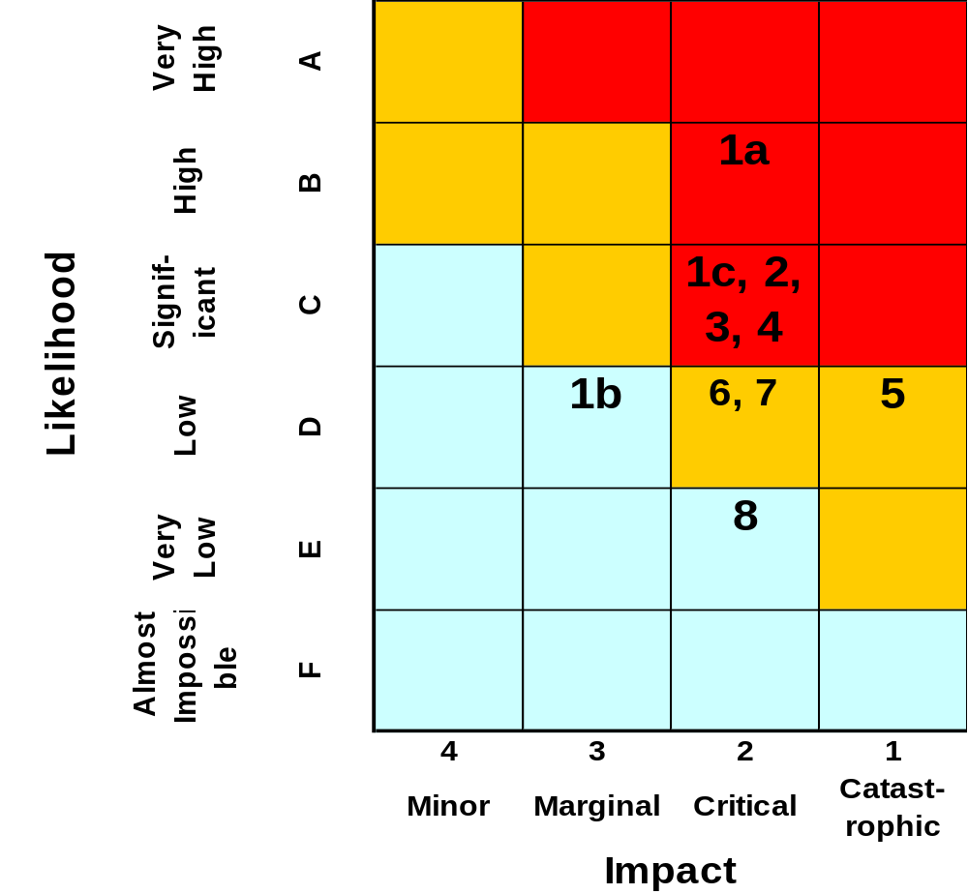
Table: Main Business Continuity Threats (Sorted by Priority)

No | Plan? | Key Threats | Potential Triggers of the Risk | Risk Width (MCAs that will be affected) | Likelihood & Impact
1a |  Plan required | Staffing loss | Illness (potential pandemic) | Could be a period of months.  All services | High - Critical
1b |  Plan required | Staffing loss | Strike action | Shorter time period and more selective. | Low and marginal
1c |  Plan required | Staffing loss | Extreme weather conditions | All MCAs | Significant and critical
2 |  Plan required | Loss of IT | Virus  Hacking  damage to infrastructure caused by property damage | All MCA’s | Significant - Critical
3 |  Plan required | Loss of property – Depot | Fire  Explosion on fuel island  Vandalism  Extreme weather event  Consequences  Loss of fleet  Loss of employees  Loss of office accommodation | - Many external services e.g. refuse collection  - Winter gritting  - Highways emergency response  - Street Cleansing | Significant - Critical
4 |  Plan required | Loss of key partner or contractor | Triggers  Loss of their property  Bankruptcy  Change of market conditions | Failure would be limited to those particular services | Significant - Critical
5 |  Plan required | Loss of property – BGR  (delivers most services) | Flooding  Fire  Terrorism  Extreme weather event | - I.T impact  - Customer services | Low - Catastophic
6 |  Plan required | Loss of property – Crematorium | Flooding  Fire  Equipment failure  Extreme weather |  | Low - Critical
7 |  | Loss of critical suppliers - fuel | Could be disrupted by an international event or industrial action | All services reliant on fuel for transport such as waste collection/disposal and cleansing, and property maintenance | Low - Critical
8 |  | Loss of utility  Primarily Electricity  Short term (2 -3 days) | Supply failure  Storm  Sabotage  Connection issues to offices | Normally half a day maximum  Inconvience.  All services | Very Low - Critical
9 |  | Loss of telecommunications | New equipment  Main supplier failure  Main switch fault  Cable into office  Potential threat through inability to access the office | All services directly | NOT RANKED
10 |  | Loss of utility – gas (Crematorium) | Failure of equipment  Failure of supply | Inability to deliver service
11 |  | Loss of utility - water | Failure of supply  Contamination within Council or externally | All services (no toilets, drinking water, heating)

Appendix A – Activities sorted into priority order
SERVICE 1:1 CSC/CRC to support essential services (< 24 hours RTO)
SERVICE 3:1 Election Management (< 24 hours RTO)
SERVICE 1:3 Customer Services (Face-to-face, Telephone, Website, IT): (< 24 hours RTO)
SERVICE 2:1 Dangerous Structures (< 24 hours RTO)
SERVICE 8:1 Facilities (Main buildings) (< 24 hours RTO)
SERVICE 8:2 Communications(< 24 hours RTO)

SERVICE 3:2 Electoral Registration August/September (2-3 day RTO)
SERVICE 3:4 Property – lettings – rents collection (2-3 day RTO)
SERVICE 6:3 Crematorium/cemeteries (2-3 day RTO)
SERVICE 7:2 Excavation of graves (2-3 day RTO)
SERVICE 7:3 Housing – Essential Repairs E.g. Utilities failures (2-3 day RTO)
SERVICE 7:7 Refuse and Street Cleansing (2-3 day RTO)
SERVICE 7:11Housing – Essential Repairs / All Priority Ones (less than 24 Hrs) (2-3 day RTO)
SERVICE 8:3 Cleaning (2-3 day RTO)
SERVICE 9:3 Money (bank/investments) (2-3 day RTO)
SERVICE 10:1 Scheme Managers inc support workers (2-3 day RTO)
SERVICE 10:2 Cleaners (2-3 day RTO)
SERVICE 10:3 Housing Options Team (2-3 day RTO)

SERVICE 1:2 IT for Environmental Health, Environmental Care (3-7 days RTO)
SERVICE 3:3 Legal support to committees (3-7 days RTO)
SERVICE 4:1 Benefit Processing (3-7 days RTO)
SERVICE 4:2 Telephone team (3-7 days RTO)
SERVICE 5:1 Payroll input and running (3-7 days RTO)
SERVICE 6:1 Dog control (3-7 days RTO)
SERVICE 6:2 Pest control (3-7 days RTO)
SERVICE 6:4 Reactive services eg. Accident investigation, food poisoning, noise, taxi licensing etc. (3-7 days RTO)
SERVICE 6:5 Inspections – food, H&S, IPPC (3-7 days RTO)
SERVICE 7:1 Grounds Maintenance – Play Area Cleansing & Inspections (3-7 days RTO)
SERVICE 7:5 Public Toilet (Cleansing and / or Closure (3-7 days RTO)
SERVICE 7:6 Clinical Waste Collections (3-7 days RTO)
SERVICE 7:8 Administration –Time sheets & responding to the Public (3-7 days RTO)
SERVICE 8:5 Print Room
SERVICE 9:1 Payments (credits/payroll) (3-7 days RTO)
SERVICE 9:2 Insurance (3-7 days RTO)
SERVICE 9:5 Systems (3-7 days RTO)
SERVICE 10:4 Housing Managers (3-7 days RTO)
SERVICE 10:5 Housing Manager (ASB) (3-7 days RTO)
SERVICE 10:6 Supported Housing Manager (3-7 days RTO)
SERVICE 10:7 Housing Options Manager (3-7 days RTO)
SERVICE 10:8 Housing Renewal team (3-7 days RTO)
SERVICE 11:2 Maintain continuity in summer Playschemes (3-7 days RTO)
SERVICE 11:5 Delivery of time-critical projects within the Capital Programme e.g. Desborough Leisure Centre improvements (3-7 days RTO)
SERVICE 11:6 Maintain concessionary travel (3-7 days RTO)

SERVICE 2:2 Planning applications (1 – 2 weeks RTO)
SERVICE 2:3 Building Control (1 – 2 weeks RTO)
SERVICE 2:4 Local land charge searches (1 – 2 weeks RTO)
SERVICE 2:5 Planning enforcement (1 – 2 weeks RTO)
SERVICE 4:3 Reduced Business support (systems) (1 – 2 weeks RTO)
SERVICE 4:4 Council Tax (administration) (1 – 2 weeks RTO)
SERVICE 6:6 Car park inspection and enforcement (1 – 2 weeks RTO)
SERVICE 7:4 Street Cleansing – Emptying Dog & Litter Bins (1 – 2 weeks RTO)
SERVICE 7:12 Street Cleansing – Scheduled Street cleansing & Hazardous Fly-Tipping (1 – 2 weeks RTO)
SERVICE 9:4 Financial management/monitoring (1 – 2 weeks RTO)
SERVICE 3:1 Committees (long term) (> 2 weeks RTO)
SERVICE 1:4 FOI’s (> 2 weeks RTO)
SERVICE 1:5 Complaints (> 2 weeks RTO)
SERVICE 5:2 Recruitment (> 2 weeks RTO)
SERVICE 5:3 Liaison with OCC (> 2 weeks RTO)
SERVICE 5:4 Health/absence management (> 2 weeks RTO)
SERVICE 6:7 Litter enforcement (> 2 weeks RTO)
SERVICE 7:9 General - Statutory returns & Partnership / Joint working (> 2 weeks RTO)
SERVICE 7:10 Grounds Maintenance – Reduced Scheduled Grass Cutting & Tree Maintenance (> 2 weeks RTO)
SERVICE 9:6 Statutory returns (> 2 weeks RTO)
SERVICE 9:7 Risk Management (> 2 weeks RTO)
SERVICE 11:1 Keep all leisure centres, Museum, TIC & Art Gallery open (> 2 weeks RTO)
SERVICE 11:3 Health-related programmes and project e.g. Keep Healthy @ Kettering, MEND Scheme (> 2 weeks RTO)
SERVICE 11:4 Keep all sports activities going, e.g. fun run(> 2 weeks RTO)
SERVICE 11:7 Maintain leisure pass(> 2 weeks RTO)

See Section 5: Risk Identification & Analysis

