BOROUGH OF KETTERING

Committee | Full Planning Committee - 12/10/2010 | Item No: 5.2
Report Originator | Fjola Stevens  Development Officer | Application No:  KET/2010/0494
Wards Affected | Welland
Location | Three Bears Cottage, Pipewell Hall Grounds, Pipewell
Proposal | Full Application: Single storey side extension and erection of garage, carport and workshop
Applicant | Mr R Kilduff

1. PURPOSE OF REPORT

  - To describe the above proposals
  - To identify and report on the issues arising from it
  - To state a recommendation on the application

2. RECOMMENDATION

THE DEVELOPMENT CONTROL MANAGER RECOMMENDS that this application be APPROVED subject to the following Condition(s):-

1. The development hereby permitted shall be begun before the expiration of 3 years from the date of this planning permission.
REASON: To comply with Section 91 of the Town and Country Planning Act 1990 (as amended) and to prevent an accumulation of unimplemented planning permissions.

2. The development hereby permitted shall be constructed with the Clipsham Limestone (where stone is proposed), natural slate, hydraulic lime mortar (3.5 parts sharp sand: 1 part lime) and black painted iron rainwater goods to match the samples submitted on the 19th August 2010. The development shall not be carried out other than in accordance with the approved details.
REASON: In the interests of preserving the character and appearance of the conservation area in accordance with policy 13 of the North Northamptonshire Core Spatial Strategy.

3. Prior to the installation of the external windows and doors hereby permitted full details of the proposed windows and doors, including sections at a scale no less than 1:10 and glazing bar details at a scale or no less than 1:1 shall be submitted to and approved in writing by the Local Planning Authority. The windows shall have a tripartite division, structural glazing bars and be cream painted timber, and shall thereafter be retained as approved in perpetuity.
REASON: In the interests of preserving the character and appearance of the conservation area in accordance with policy 13 of the North Northamptonshire Core Spatial Strategy.

4. Prior to construction of the outbuildings hereby permitted full details and samples of the proposed timber cladding and doors to be used in the constuction of the car port and workshop hereby permitted shall be submitted to and approved and writing by the Local Planing Authority. The development shall not be carried out other than in accordance with the approved details and thereafter the buildings shall be retained as approved.
REASON: In the interests of preserving the character and appearance of the conservation area in accordance with policy 13 of the North Northamptonshire Core Spatial Strategy.

Notes (if any) :-
- NONE

Justification for Granting Planning Permission

The proposal is in accordance with The Town and Country Planning (Listed Buildings and Conservation Areas) Act 1990 and the national and local policies as set out in Planning Policy Statements 1 and 5 and Policy 13 of the North Northamptonshire Core Spatial Strategy. There are no material considerations that indicate against the proposal.

Officers Report

3.0 | Information

Relevant Planning History
None

Site Description
Officer's site inspection was carried out on 18th August and 15th September 2010.

The application property is an old estate cottage (now in separate ownership) that lies within the grounds of the Grade II Listed Pipewell Hall. The dwelling lies at the southern edge of the estate adjacent to The Lodge (the gatehouse to the estate) and is therefore close to the main access to Pipewell Hall and visible from Oakley Road and Rushton Road. Due to the siting of the dwelling within the grounds of Pipewell Hall it is a curtilage listed building. In addition the application site lies within the Pipewell Conservation Area.

The dwelling is a detached single storey dwelling with attic and features 3 dormer windows on the front elevation. The building has coursed rubble limestone elevations with dressed stone quoins, white painted timber windows and a slate roof. At present there is a single storey extension to the side and rear elevation (west and north), and a detached garage and shed to the north. These structures are ‘modern’ additions to the property that are of no architectural merit due to their design and are in a poor state of repair with evidence of structural issues when viewed externally.

Proposed Development
This application seeks planning permission for a single storey side extension, and the erection of a car port and workshop.

The proposed side extension would measure 5m (w) x 4m (d) x 4.3m (h). The proposed car port would provide covered parking for 2 vehicles and would measure 5.6m (w) x 5.4m (d) x 4m (h). The proposed work shop would measure 5m (w) x 4m (d) x 4m (h).

In addition to these extensions and outbuildings a number of alterations are proposed to the interior and exterior of the building. These do not constitute development requiring planning permission, however they do require listed building consent. A separate application for listed building consent has been submitted and is also under consideration, see KET/2010/0495 for more details.

Any Constraints Affecting The Site
Listed building curtillage
Setting of Listed building
Pipewell Conservation Area
Mineral Consultation Site Limestone

4.0 | Consultation and Customer Impact

Parish Council
No Objection

Neighbours
No Objection

5.0 | Planning Policy

National Policies
PPS1 Delivering sustainable development
PPS5 Planning for the historic environment

Development Plan Policies

North Northamptonshire Core Spatial Strategy (CSS)
P. 13 General sustainable development principles

6.0 | Financial/Resource Implications
 | None
7.0 | Planning Considerations
This application seeks permission for a domestic extension and outbuildings within the curtilage of an existing dwelling and therefore the principle of the proposal is acceptable in policy terms. The key issues for consideration in this application are therefore:

1. the impact upon the special architectural and historic interest of the host dwelling
2. the impact upon the setting of the listed neighbouring Lodge and Pipewell Hall
3. the impact upon the character and appearance of Pipewell Conservation Area
4. the impact upon the living conditions of the occupiers of the neighbouring dwelling
5. the impact upon the trees within the site

1. Impact upon the special architectural and historic importance of the listed building

The application property is a curtilage listed building sited within the grounds of the Grade II Listed Pipewell Hall. Three Bears Cottage is a modest 2 storey stone built property which had ornamental detailing applied to the south elevation in the mid to late 19th Century to enhance the appearance of the building from the nearby road. There are existing extensions to the east and north of the building and some detached outbuildings to the north believed to date from the 1960’s or 70’s. These appear to be in a poor state of repair and are of little architectural merit as a result of their design typical of their age, and as such do not form part of the historic fabric of the building and do not contribute positively to the architectural or historical importance of the building.

S.66 of the Town and Country (Listed Building & Conservation Areas) Act 1990 (The Act) requires Local Planning Authorities to have special regard to the desirability of preserving the building or its setting or any features of special architectural or historic interest. S72 of the Town and Country (Listed Building & Conservation Areas) Act 1990 there is a requirement for Local Planning Authorities to give special attention to the desirability of preserving or enhancing the character and appearance of the area. In addition, PPS5 states that there should be a presumption in favour of the conservation of heritage assets, and that the significance of a heritage asset can be harmed or lost through alteration or destruction of a heritage asset or development within its setting.

The proposed development would include the demolition of an existing extension and outbuildings which are not sensitive to the character or appearance of the dwelling or the surrounding area and therefore their loss would not harm the special architectural interest of the building or the significance of the building. The proposed extension has been designed to reflect the design and materials used on the main building, and due to its scale it would remain subservient to the main dwelling. Although double glazed windows are considered acceptable in principle on this building a condition requiring full window details is recommended to ensure that the glazing bars are structural and not bulky. This will prevent the windows from appearing heavy or overly modern on the building. It is considered that in principle the proposed extension would not have an adverse impact upon the architectural or historic importance of the listed building. The proposed side extension therefore accords with PPS5 and policy 13 of the CSS.

The proposed car port and workshop would be oak framed structures with slate roofs and timber clad elevations. The outbuildings would be subservient to the main dwelling and would be sited to ensure that they did not obstruct the principle views of the listed building from the south. It is therefore considered that the proposed outbuildings would not cause harm to the setting, the special architectural or historic character or the significance of the host listed building.

2. Impact upon the setting and the special architectural and historic importance of the neighbouring listed buildings
The application property lies approximately 14m to the west of The Lodge a decorative Tudor style mid 19th Century stone building which is Grade II Listed Building, and approximately 115m to the south west of the Grade II Listed Pipewell Hall. The stone built Hall dates from 1675, however it has been altered with time and includes an extension built in 1864.

It is considered that due to the siting, scale and design of the proposed additions to Three Bears Cottage and the distances between the application property and the nearby listed buildings the proposal would not have an adverse impact upon the setting of the adjacent listed buildings and would not harm their special architectural or historic interest. The proposal therefore accords with PPS5 and policy 13 of the CSS.

3. Impact upon the character and amenity of the Conservation Area
The Pipewell Conservation Area extends across the Pipewell Hall estate and to the east and north to encompass most of the village. The application property is sited in a prominent and highly visible location on the southern edge of the Conservation Area. S. 72 of the Town and Country (Listed Building and Conservation Areas) Act 1990 requires Local Planning Authorities to have regard to the desirability of enhancing or preserving designated Conservation Areas. Furthermore PPS5 outlines a presumption in favour of protecting heritage assets and policy 13 of the CSS states that new development should conserve and enhance designated built environmental assets whilst PPS1 states that new development which is not appropriate in its context should not be accepted.

The proposed development would remove an existing insensitive addition to a historic building which does nothing to enhance the Conservation Area and replace it with a development which would respect the character and appearance of the host dwelling and its setting in terms of its siting, scale and design. As such the proposal would preserve the character and appearance of the Conservation Area and therefore accords with PPS1, PPS5 and policy 13 of the CSS.

4. Residential Amenity
The application site is surrounded by the Pipewell Hall estate land to the north and west and to the south lies Oakley Road. There is a dwelling to the south of Oakley Road adjacent to the site however it is in excess of 40m from the application dwelling and therefore the proposals would not have a significant impact upon the occupiers of that dwelling.

The nearest dwelling to the site is ‘The Lodge’, it being approximately 14m to the east of the existing dwelling. The proposed extension would replace an existing part of the dwelling and although the extension would have a greater mass as a result of the pitched roof it is considered that due to the distance between the two properties the proposal would not have an adverse impact upon the neighbours in terms of being overbearing. Furthermore there would be no glazing on the east elevation of the extension therefore the proposal would not result in overlooking.

The proposed car port would sit to the rear of the dwelling in line with the proposed extension. This would replace an existing structure and it is considered that due to its distance from the neighbouring property it too would not have a significant impact upon the occupiers of that property. The proposed workshop would be screened from the neighbouring property by the proposal car port and again would replace an existing structure. As such, this element of the proposal would also not have a significant impact upon the living conditions of the neighbours.

The proposed extension and outbuildings by reason of their siting and design would not have an adverse impact upon the occupiers of the neighbouring dwelling and therefore the proposal accords with policy 13 (l) of the CSS.

5. Impact upon trees
The proposal would result in the loss of 3 small shrub-like trees close to the northern boundary. The trees lie within the application site and their removal is required in order to access the proposed car port. It is considered that due to the position and size of the existing trees to be removed their loss would not result in an adverse impact upon the visual amenity and character of the surrounding area, and the works would not undermine the character and appearance of the Conservation Area. The proposal therefore accords with PPS5 and policy 13 of the CSS.

Conclusion

The proposed developments by virtue of their siting, size, design and appearance would not have an adverse impact upon the historic or architectural importance of the host dwelling or the setting of the nearby listed buildings, and the proposals would preserve the character and appearance of the Pipewell Conservation Area. The proposals would also not have a detrimental impact upon the occupiers of the nearby dwellings due to the scale, siting and design of the proposal. The proposed development accords with PPS1, PPS5 and Policy 13 of the North Northamptonshire Core Spatial Strategy and is therefore considered to be acceptable in accordance with S. 38(6) of the Planning and Compulsory Purchase Act 2004.
Background Papers |  |  | Previous Reports/Minutes
Title of Document: |  |  | Ref:
Date: |  |  | Date:
Contact Officer: |  | Fjola Stevens, Development Officer on 01536 534316

SITE LOCATION PLAN

Three Bears Cottage, Pipewell Hall Grounds, Pipewell
Application No.: KET/2010/0494

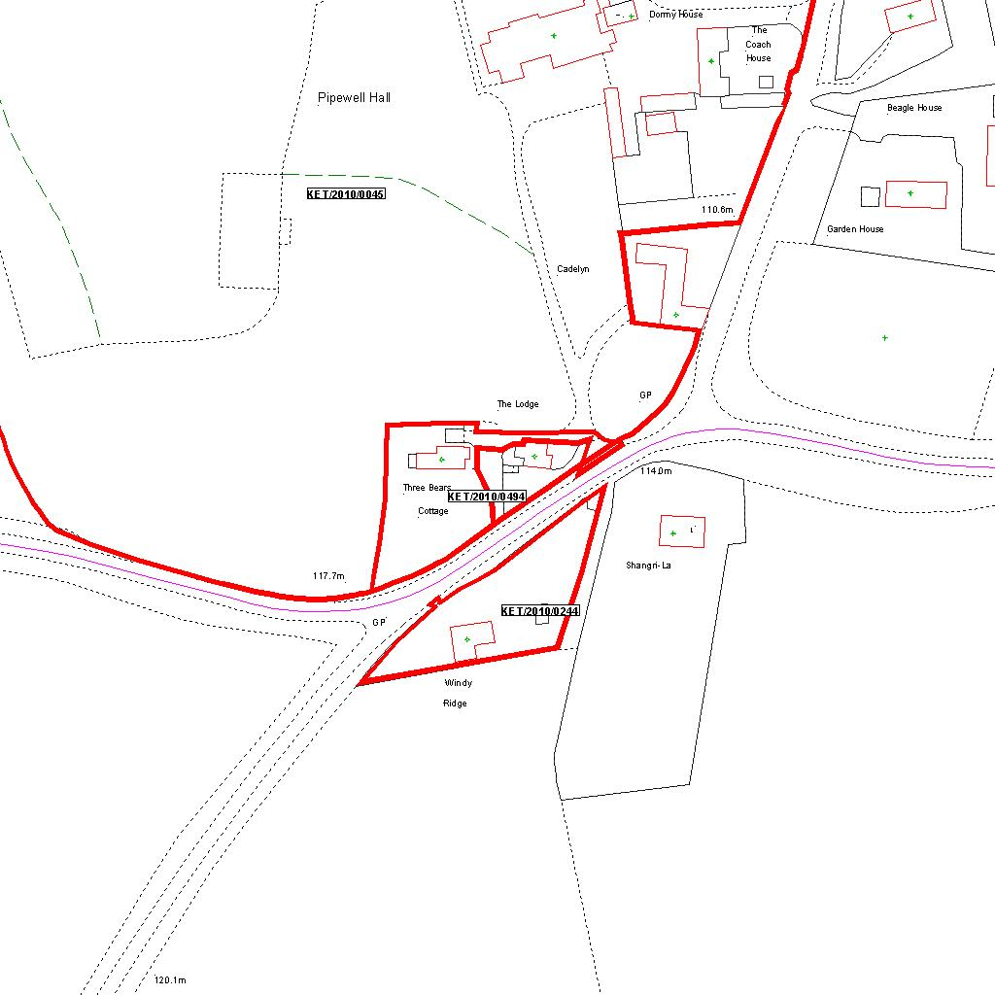

Reproduced from the Ordnance Survey mapping with the permission of the Controller of Her Majesty’s Stationery Office © Crown copyright. Unauthorised reproduction infringes Crown copyright and may lead to prosecution or civil proceedings.  LA078344 |  | N
Date: 12/08/2010 Do not scale from this map. For illustrative purposes only.

