To all Members | Direct Line: (01536) 534398  Email: anneireson@kettering.gov.uk  Our Ref: AI  Your Ref:  Date: 22nd June 2010

Dear Councillor

You are summoned to a meeting of Kettering Borough Council to be held in the Municipal Offices, Bowling Green Road, Kettering on Wednesday, 30th June 2010 at 7.00 pm.

Please note that, prior to commencement of the meeting, a short DVD will be shown containing excerpts of the Halfords Tour Series cycle race from 10th June 2010.

Yours faithfully

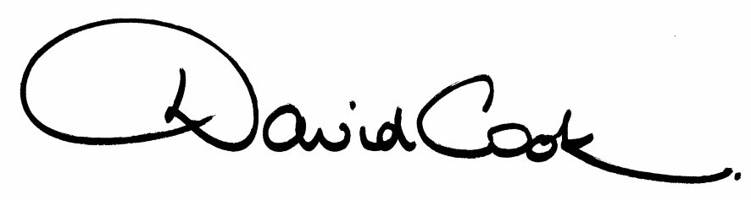

D Cook
Chief Executive

A G E N D A

1. Apologies.

2. Minutes of the Annual Meeting of the Council held on 12th May 2010 to be approved as a correct record and signed by the Mayor

3. Declarations of Interest:-

- Personal
- Prejudicial
4. To receive any announcements from the Mayor or the Leader of the Council.

5. Report of the Chief Executive.

6. The Mayor to ask members of the public present if they want to speak on any item on the agenda

7. Statement of Accounts (report to follow)

8. Annual Report and Improvement Plan

9. Petitions Scheme

10. Consultation on Changes to Executive Arrangements

11. Urgent Items considered by the Executive Committee – March 2010 to June 2010 (in accordance with Council Procedure Rule 16.3)

12. To consider motions received in accordance with Council Procedure Rule 14:-

(i) To be proposed by Councillor James Hakewill and seconded by Councillor David Soans

"That this Council compliments the organisers and sponsors of the Halfords Tour Cycle Race on staging such an exciting event in our Borough. The Council further thanks all the sponsors who made the event possible. Council colleagues, volunteers, local cycling clubs and local people left the visitors we welcomed with positive, warm and friendly memories of our Borough."

(ii) To be proposed by Councillor Linda Adams and seconded by Councillor Paul Corazzo

"We wish to acknowledge the efforts that have been put into recent sporting events at Kettering Market Place and within the Town itself and hope that it continues with increasing imagination and innovative ideas.

Having this in mind and the issues that we have across the Borough with the illegal use of petrol driven machines in inappropriate places, I would like to ask that we send our congratulations to the two neighbouring councils that have chosen to tackle these issues, Wellingborough Council for opening an off road track for motorcycles, and Corby Council for launching a kart track.

We also ask the administration that, within our partnership working with our neighbours, that we gather the information that would enable us to provide an exciting diverse facility for the people of Kettering Borough."

10. To receive questions from members.

11. Any matters of urgency that the Mayor decides should be considered

22.6.10
Fire Alarm

All meetings shall be adjourned immediately on the sounding of the fire alarm. The alarm is a continuous two-tone siren. On hearing the alarm please leave the building by the nearest emergency exit. There are emergency exits at both ends of the corridor outside the meeting rooms. On leaving the building please cross the car park and assemble on the grassed area by the church. Do not attempt to drive out of the car park as this may impede the arrival of emergency vehicles. Please do not return to the building until you are told it is safe to do so by a Council employee.

Toilets

There are toilets in the corridor off the main entrance to the building you came through to get to the meeting room.

Facilities for Babies and Children

If you wish to use a private area to feed your baby please ask a member of staff. There are changing facilities in the corridor off the main entrance adjacent to the toilets.

.Access for Disabled People

There are allocated parking bays outside the main entrance to the Municipal Offices for disabled people. The meeting rooms are located on the ground floor and access is gained for wheelchair users via the main entrance. If you require assistance, please ask the attendant on duty in the reception area.

No Smoking

Smoking is not permitted in the Municipal Offices.

