To all Members | Direct Line: (01536) 534398  Email: anneireson@kettering.gov.uk  Our Ref: AI  Your Ref:  Date: 17th April 2007

Dear Councillor

You are summoned to a meeting of Kettering Borough Council to be held in the Wicksteed Park Pavilion, Wicksteed Park, Barton Road, Kettering Wednesday, 25th April 2007 at 7.00 pm.

Yours faithfully

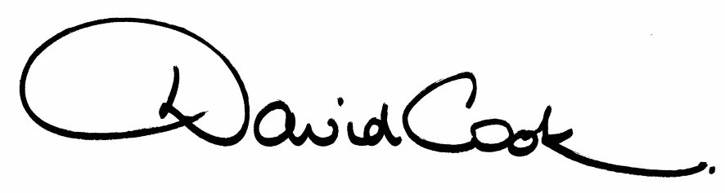

D Cook
Chief Executive

A G E N D A

1. Apologies.

2. Minutes of the meeting of the Council held on 28th February 2007 to be approved as a correct record and signed by the Mayor

3. Declarations of Interest.

4. To receive any announcements from the Mayor or the Leader of the Council.

5. Report of the Chief Executive.

6. The Mayor to ask members of the public present if they want to speak on any item on the agenda.

7. Deputations and Petitions:-

- Race Action Kettering

8. To receive questions from members

9. Town Centre Regeneration (referral from the Executive Committee)

10. Constitutional Change Required for the New Council
(part referral from the Executive Committee)

11. Any matters of urgency that the Mayor decides should be considered.

17.4.07

