- PURPOSE OF REPORT

To facilitate a debate about leisure and sport facilities within the borough with a particular focus on the Council’s play areas.

- INFORMATION

LEISURE, SPORT AND PLAY FACILITIES IN THE BOROUGH

  - A report was considered by Research and Development Committee in December 2014 providing background information relating to sport and leisure facility provision in the Borough of Kettering. Members may find that report provides useful context within which to frame their debate.

THE IMPORTANCE OF LIVING A HEALTHY AND ACTIVE LIFESTYLE

  - The importance of living a healthy and active lifestyle cannot be overstated. Benefits include, but are in no way limited to:

- Helping people live longer, more active lives
- Reducing the demand for health related public services, saving money, for example, reducing levels of heart and respiratory disease reducing levels of obesity and diabetes
- Helping create a general feeling of wellbeing in the community
- Diverting some groups from anti-social behaviour and crime
- They also help improve the look, feel and attractiveness of the area as a place to live

  - Encouraging people to live more active lifestyles through leisure, sport and play are national priorities, not just local ones. Strategies and coordinated activity exist through the tiers of government and across the spectrum of public services such as health, education and local government.

  - The Council, alongside partner organisations, local clubs and sporting organisations play an important role in helping people stay fit and active. It therefore stands to reason that this subject has been a longstanding priority for the Council.

  - Getting people into physical activity as early as possible, such as in childhood can also help with physical and mental development and help establish healthier lifestyles from an early age. At the same time, helping older people get into healthy activities such as walking and gentle exercise can also yield significant health and wellbeing benefits.

BROAD SCOPE OF COUNCIL ACTIVITY

  - The Council is involved in a wide range of activities to help deliver against this important priority area. This activity includes activities such as:-

- Health promotion activity, for example, cooking classes at school, Health Walks, and Walking Football.
- Summer play schemes and sport coaching for children
- Supporting high profile local events and venues such as The Women’s Tour and the National Volleyball Centre for England & Northants Sports Awards
- The provision of safe and stimulating play areas within the borough
- Supporting After School provision
- Football pitches, Track & Pitch, Swimming Pool, Skatepark, leisure and community centres
- Support many local sports clubs with facilities and funding.

PLAY SPACES AND OUTDOOR GYMS WITHIN THE BOROUGH

  - Kettering Borough Council is responsible for around forty play areas within the borough. Most it owns but there are three that are owned by Parish Councils. Details of these play areas have been provided as Appendix one. Information has been included for each play area that shows:

- Approximate age of the play area
- General state of repair
- Quality of the equipment (from the perspective of playability)
- Level of usage of the facility
- Likely cost of maintenance and the life expectancy of the play area (if it is left with no investment)

  - The assessment of the above criteria is not an exact science and is intended to be a guide for future resource planning. The Council will soon be revisiting the criteria to see if can be further enhanced.

  - A growing trend in helping to promote more participation in physical activity has been the installation of free to use outdoor gym equipment. In the last two years, four new Outdoor Gyms have been installed in the borough. These are often sited within close proximity to children’s play equipment to help promote the participation of parents in exercise whilst their children play. Furthermore, following the original inspiration of Charles Wicksteed, the Council seeks to select park based ‘playthings’ (as he called play equipment) that “should give healthy as well as joyous physical exercise”. So we seek to select play equipment for our parks that requires a good deal of physical input from the children. We call this ‘fit-play’. Feedback from users of the outdoor gyms has been very positive.

RECENT PLAY IMPROVEMENTS

  - Since 2012 the Borough has seen a number in significant play area improvement projects, either directly delivered or supported by the council. These include:
- All new play areas at Geddington, Great Cransley, and Mawsley, each delivered by the Parish Council with support from Kettering Borough Council (including grant support)

- Fully refurbished play area at Rockingham Road Pleasure Park including 8 new items of play equipment and an 11 piece Outdoor Gym. Delivered by KBC and 95% grant funded.

- All new Nature Play area for toddlers in the Pleasure Park. Delivered by Kettering Borough Council and funded by local Friends of Park Group.

- New BMX track in the Pleasure Park. Delivered and funded by Kettering Borough Council.

- All new 8 piece Outdoor Gym at Bramblesides Millennium Park delivered by Kettering Borough Council and 100% grant funded.

- All new play area at Grafton Street Park in Kettering including new ‘five a side’ football goals and fitness equipment. Delivered by Kettering Borough Council and 95% grant funded.

- An all new 16 item Outdoor Gym at Dunkirk Avenue Recreation Ground in Desborough. Delivered jointly by Desborough Town Council and Kettering Borough Council.

- All new full concrete Multi Wheeled Sports Facility (‘skatepark’) for Kettering. Delivered by Kettering Borough Council and 100% externally funded.
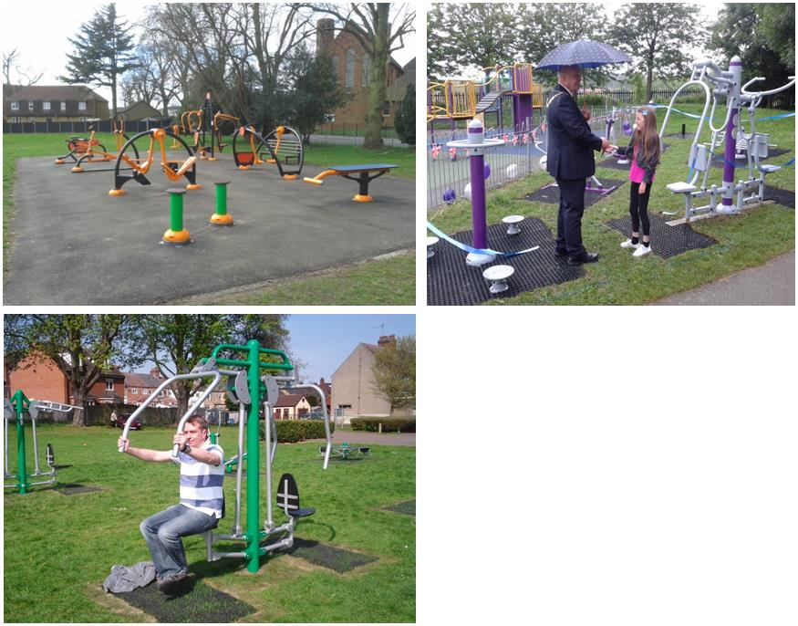

3 new Outdoor Gyms since 2013
Top Left. Rockingham Road Park, Kettering
Top Right. Mayor opening Brambleside Gym, Kettering
Bottom. Huge 16 item Gym. Dunkirk Ave Rec, Desborough.

  - Whilst the safety of play areas is a major focus of the Councils work, both RoSPA and the Health & Safety Executive advise that play areas should be “as safe as necessary, not as safe as possible”, and that one of the key features of an equipped play area is to provide a challenging environment where children can learn the lessons of balancing risk. Nevertheless, ensuring equipment is safe in that it is performing its function properly, is of paramount importance. Regular safety inspections are carried out by the Council’s Grounds Maintenance Team. They consist of a daily visual inspection (Monday – Friday), a weekly physical inspection of equipment and a detailed inspection by a RoSPA accredited member of staff twice a year. The statutory requirement is for this to be carried out once per annum.

AGEING PLAY AREAS AND EQUIPMENT

  - There are items of play equipment at some of the play areas, particularly the older ones, that are starting to look tired. A common issue is the wearing of paint finishes on equipment. Although this has no bearing on the safety of the equipment, it can lead to the perception that the play area is not cared for.

  - Blythe Close play area in Rothwell is a good example of an old and outdated play area. This facility is presently the subject of a development plan. After representations to Rothwell Town Council from local parents with disabled children, the Council is creating plans to redevelop the site as the borough’s first ‘accessible’ play area specifically designed to cater to the needs of physically disabled children to allow them to play alongside their able bodied friends and siblings. This will be subject to securing the required funding. However, the Council has ‘kick started’ the project by the very recent installation of a wheelchair accessible roundabout.

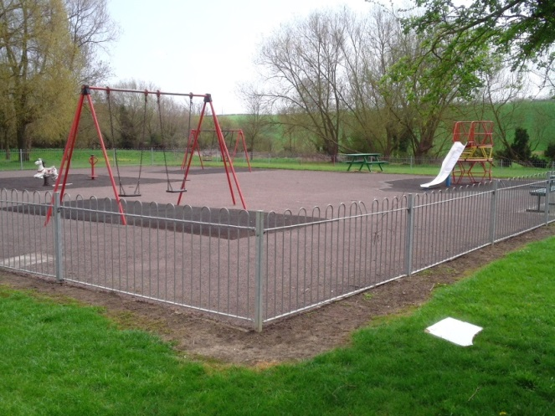
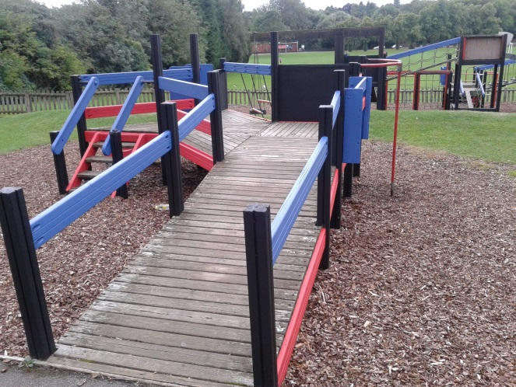
  - The all wooden play equipment at Meadow Road play area in Kettering is also showing its age. Work is currently under way from Probation Service’s Community Payback Team to fully repaint the play area and Kettering Borough Council will supply all materials. This play area is due for replacement.
Above Right: Blyth Close Play Area, Rothwell
Above Left: Meadow Road Play Area, Kettering

  - The Council is presently developing a new Play Strategy aimed at bringing together all of the different approaches and policies under one document. This strategy will be based on up to date play guidance from bodies such as Play England, the Play Safety Forum, and RoSPA. The Strategy will look at the use of fencing around Play Areas and whether it is required in all circumstances or whether play equipment should be more widely incorporated into semi-natural green areas to further enhance the play experience. Furthermore, the strategy will also examine developing approaches questioning the blanket use of safety surfacing, which can form a major cost of a play area, with limited evidence of its universal effectiveness. Caution will be applied with respect to both of these issues as it is understood that public and user perceptions may be in a different place to the latest industry research and guidance on the matter.

  - In addition to the development of Blyth Close as detailed above, there are also other short and medium term projects at the planning stage. For example. The Council is looking at the play facilities at the Ise Valley Parklands area. The present play area is now around 20 years old and outdated. It offers limited play scope and what is there is really aimed at the younger child and the Council have received complaints from residents regarding this play area.

  - In order to take the Ise scheme forward, the Council would initially develop ideas as to the nature of equipment and then seek the views of local residents and service users. It is likely that the Council will recommend more play kit for older children, fitness equipment for teenagers and adults, new five-a-side football goals and additional family seating and picnic benches. Consultation will commence during the latter part of 2015/16. The feasibility of the scheme will be subject to identifying and securing sufficient funding.

  - Vandalism is a constant problem with play areas. A member of the Grounds Maintenance team is a certified and trained play equipment specialist, who undertakes day-to-day servicing and repairs. The Council is has a £20,000 annual maintenance budget to cover replacement of old single play pieces and the restoration and repair of serviceable items. The Council, where possible, will install equipment that is more resistant to vandalism.

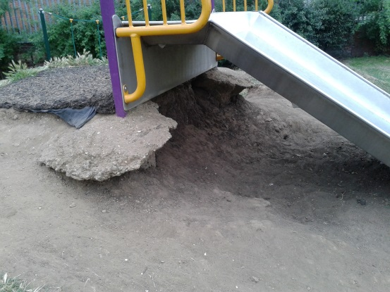
Left: At, Mill Road Park. Earth has been dug out that is the supporting mound around the slide, exposing sharp concrete footings. Slide has to be fenced off until the repair can be completed

THE COUNCIL’S PLAY STRATEGY

  - The last formal play strategy that existed run from 2007 – 2012. This was developed primarily to support a £200,000 funding application in response to the Big Lottery’s Children’s Play Programme. At the time the strategy set out a number of aims:

- Provide a clear policy statement on adventurous children’s play
- Provide high quality play spaces
- Improve children’s access to places to play and socialise
- Sustain play provision over the longer term
  - Currently the Council’s approach to play spaces and outdoor gyms consists of a range of working practices, shaped by best practice guidance, health and safety legislation, other Council policies such as procurement and years of experience in the area. However, the Council is in the process of developing a new strategy, a draft of which will be reported back to Research and Development Committee in due course

- CONSULTATION AND CUSTOMER IMPACT

3.1 Adopting an effective and inclusive approach to communication will be a key objective of the new play strategy. The Council has learned important lessons in relation to how communication has worked well and where it has been less effective and it is important that it adjusts its approach accordingly in the future.

- POLICY IMPLICATIONS

4.1 The play strategy, when developed, will play an important role in directing the future activity of the Council and where possible, its partners.

- HUMAN RESOURCES AND FINANCIAL RESOURCE IMPLICATIONS

5.1 As stated earlier in this report, the Council has limited financial and people resources and therefore has to remain realistic as to its ambitions in relation to the provision of services relating to leisure, culture, sport and play. As a result, it is important that the Council prioritises its resources carefully, ensuring that equipment remains safe and fit for purpose and that external funding is attracted wherever possible to help delivery new schemes and projects in the future.

- LEGAL IMPLICATIONS

6.1 None at this stage. However, the Council’s work on installing and maintaining play areas, outdoor gyms and equipment is guided by the Council’s internal procurement procedures, health and safety legislation and in many cases, the requirements of funders that are set out in contracts.

7. RECOMMENDATION
That the Committee identify areas for future consideration and potential inclusion within the draft play strategy.

Background Papers: Previous Reports/Minutes:

Leisure and Play provision, December 2014

Indoor Sports Facilities Strategy,
2011 - 2021

