- PURPOSE OF REPORT

For the Executive Committee to;
- endorse the development of our current financial strategy to embrace a systematic and measured approach towards developing a balanced portfolio of revenue generating assets, and;
- Executive endorse the need for the governance and professional leadership arrangements to be adapted to appropriately embrace the development and implementation of this strategy.
- BACKGROUND

2.1 For some years now the Council has been successful in delivering a balanced budget with:-

- Zero increases in council tax.
- Zero reductions in frontline services.
- Zero reduction in our overall support to the voluntary sector.

2.2 This committee has had regular reports on the mechanisms which have facilitated this success and at least as importantly the cultural and behavioural success factors.

2.3 Whilst one need not go into great detail, a few critical success factors emerge:-

- Clear guiding principles, golden rules and the like.
- A clear political steer coupled with room to deliver it.
- An energetic, imaginative and engaged workforce.

2.4 It is worth considering the scale of the achievement to date and the context against which it was set.

The Context

2.5 Prior to the recession, Kettering sat in the lower tax; higher performance quadrant, and despite the significant financial challenges is a position that the Council continues to maintain.

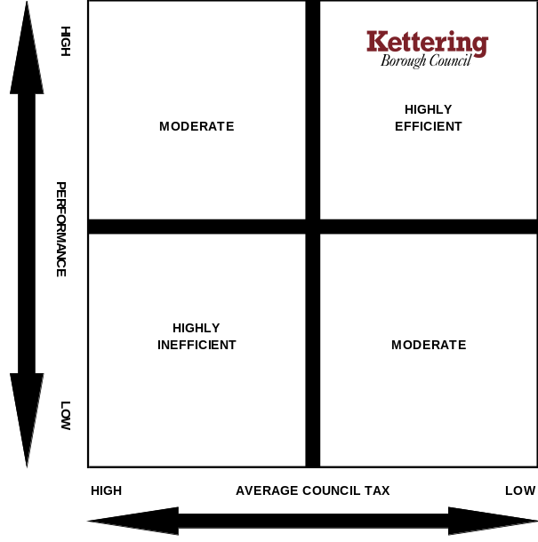

The Scale

2.6 The total quantum of ongoing savings to date is tabulated in Table 1 below:

Table 1 – Efficiency Savings | £000
2010/11 | 1,260
2011/12 | 1,910
2012/13 | 1,330
2013/14 | 950
2014/15 | 1,330
Total (already delivered) | 6,780
2015/16 (planned) | 1,580
Total  % Cash Savings (Net Budget) | 8,360  82%

2.7 As clearly outlined in the recent budget report considered by Full Council, the best estimates of the ongoing savings targets going forward are at least of a similar scale to those already met, the following chart shows:
- Savings of £6.780m have been identified and delivered between 2010/11 – 2014/15;
- Savings of £1.580m have been identified but need to be delivered in 2015/16;
- Savings of around £5m need to be identified and delivered over the next four years (2016/17 – 2019/20).

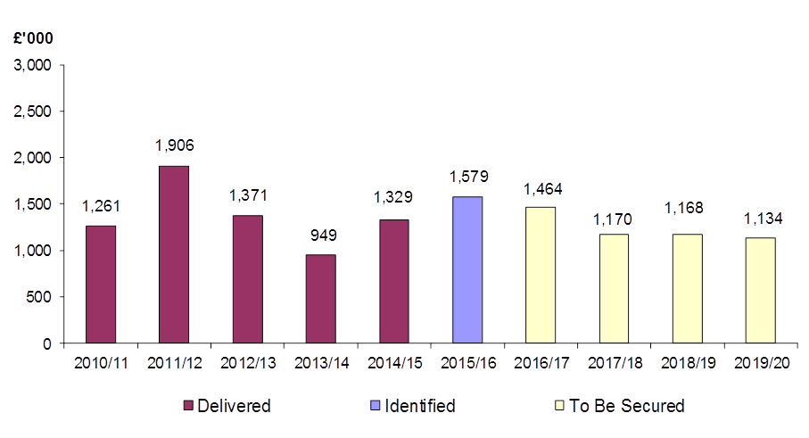
Efficiency Savings

- DEVELOPING A LONG TERM STRATEGY

3.1 An analysis of the source of savings shows the last year of savings (2015/16) have come from very different sources compared with an average over the previous years.
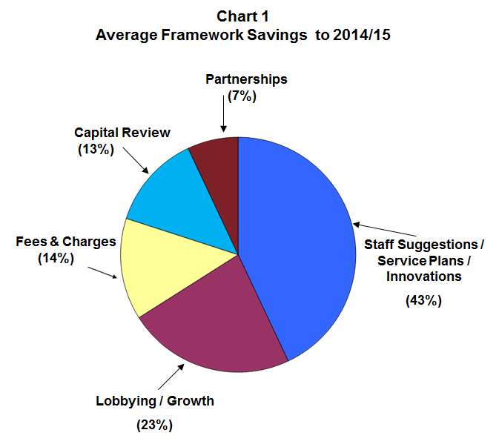

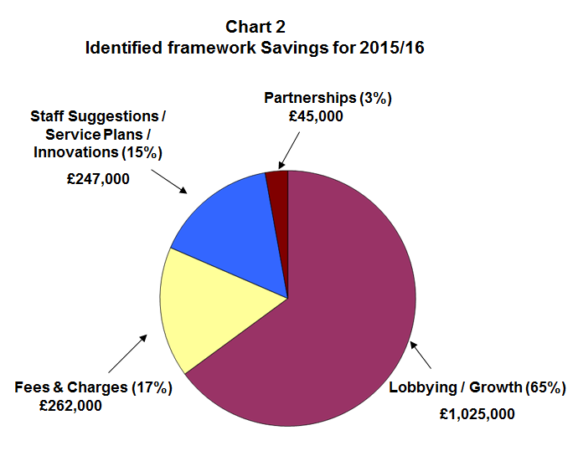
  - It was previously been reported to the Executive that savings of this magnitude are becoming increasingly difficult to maintain. Around 65% of the savings identified for 2015/16 have been generated through the lobbying / growth framework. It is going to become increasingly important to consider further frameworks in future years as the reality of being able to deliver a balanced budget in the Medium Term (2016/17 – 2019/20) is looking increasingly fragile – the consideration of investment opportunities will become a key element and this report looks at the requirements and arrangements for such a strategy.

  - The current phase of the economic cycle continues to be particularly challenging – reductions in external funding are expected to continue to decline coupled with increases in demand for front-line services.

  - The challenges going forward are no less significant and whilst there is no diminution of enthusiasm or determination, it is difficult to see how the exceptional performance referred to above can possibly be maintained at such levels into the future. The table in 2.7 sets out around £5m of savings need to be identified over the next four budget years (2016/17 – 2019/20). Additionally it is worth noting that these estimates are set against a particularly volatile national funding landscape given our point in the national political cycle.

  - It is consequently wise to work toward a place where less reliance is placed on external government grant and more emphasis is placed on harvesting returns from investments and assets. The following example is an excellent case study, of how revenue yields can be generated from capital investment.

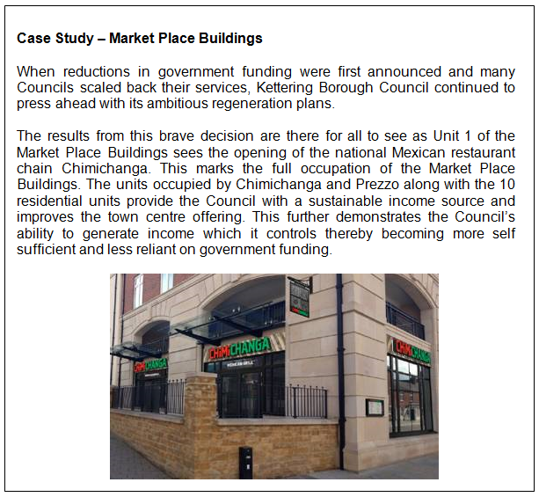

  - However, if there is an ambition to do much more of this type of commercial investment and return (which is commended), then a number of things must be in place:-

(i) Firstly, the organisation must be equipped with, and have access to, excellent professional commercial skills and acumen.

(ii) Secondly, the arrangements – including political decision making, must:-

(a) Reflect that priority
(b) Be organised to deliver those expectations
(c) Be robust in governance terms
(d) Be able to transparently demonstrate risk and return has been appropriately considered.
  - It is important to emphasise what is not proposed is asset disposal, quite the contrary. There is scope for the acquisition and / or development of assets that are held, in trust as it were, for the benefit of generating revenue returns for tax payers.

  - It is equally important to emphasise that developing a strategy for self-sustainability is no golden bullet. It will take time to develop and deliver a more self-sufficient asset base. Risks must be carefully assessed. Proper governance arrangements and structures need to be put in place.

  - If the Council is to consider a financial strategy which proactively seeks out investment opportunities as a mechanism of assisting with fiscal suitability then it is important that those assets which are required are managed in a business like, long term way for the benefit of optimising the yield for the Council.

  - It would be inappropriate for very significant multi million pound investments to be made which becomes the subject of political expedience. It is to all members’ credit that informal discussions with all groups have recognised the importance of the appropriate governance structure around assets with political choice being exercised through the way in which returns are used in the community.

  - If Councillors conclude that it is important to develop this type of approach, then it will have implications for our professional leadership arrangements, as well as our political governance arrangements. It would not be appropriate of this committee to deal with all of those matters now. The purpose of this report is to get a clear steer from the Executive as to whether it seeks in principle to develop a more self-sufficient model with appropriate acquisition of a balanced portfolio of revenue generating assets. The implications in staffing terms can then be considered by the appropriate committee with perhaps the entire package coming together as a coherent whole for Council to consider including any new, more robust governance arrangements.

  - Whilst it is clear that this notion of self-sufficiency has been an emerging thread of thought for some time, it is nonetheless appropriate to now make some formal, in principle, decisions as it is becoming clearer that the financial landscape in the future remains very challenging and there is an appetite amongst members of all groups for strategic investments.

  - One example of our recent general direction of travel in this area is the initiative taken within the Council’s treasury management strategy, to ensure the borough could benefit from initiatives such as the local authority bond agency - in the eventuality it might prove a useful financial instrument in the future.

- CONSULTATION AND CUSTOMER IMPACT

  - Individual investment decisions will be taken on their own merits with reports being presented to committee for consideration.

  - Any associated changes for the professional leadership will be subject to separate consultations.

  - Any associated changes to governance arrangements will be subject to a separate report.

- POLICY IMPLICATIONS

5.1 If the recommendations in this report are approved, it will lead to our current financial strategy being supplemented.

- FINANCIAL RESOURCE IMPLICATIONS

6.1 None as a direct result of this report however the development of a revised financial strategy (as outlined in this report) may have significant financial implications in the medium term.

- RECOMMENDATIONS

That the Executive Committee;

  - Note the scale of what has been achieved to date; the scale of the challenge; and the need to develop new strands to meet the anticipated future financial challenges;

  - Endorse the adaption of our current financial strategy to embrace a systematic and measured approach towards developing a balanced portfolio of revenue generating assets;

  - Endorse the need for both the governance and professional leadership arrangements to be adapted to appropriately embrace the development and implementation of this strategy.

  - Endorse the need for separate reports on the governance and staffing arrangements to be considered by appropriate committees.

Background Papers: Previous Reports/Minutes:

Title of Document: Estimate Working Papers Monthly Durable Budget Reports
Contact Officers: M Dickenson (April 2010 to date)

