1. PURPOSE OF REPORT

This is the first of three reports which focus on the strategic aims of the new Housing Strategy. Specifically, this report focuses on increasing housing supply across all tenures, as follows:

- the current position on affordable housing supply and the contribution that affordable housing supply makes to the overall supply of new housing in the Borough;

- the alternative ways that the Council can deliver new affordable housing including the consideration of providing new council housing.

2. BACKGROUND INFORMATION

2.1 A key strategic aim of our draft Housing Strategy 2015-20 will be to increase housing supply across all tenures.

2.2 Within this, our objectives are to:

- Ensure an increasing supply of good quality new homes of all tenures to support growth.
- Increase the supply of affordable homes, including a proportion of smaller one and two bedroom homes, to meet the needs of current and future communities
- Unlock the potential of empty homes.
- Make best use of the existing social housing stock.

2.3 As the local population expands as a result of both natural growth and people moving into the Borough, we need to increase housing supply to provide a choice of housing for people at all stages of their lives at prices they can afford.

2.4 The number of households in the Borough is expected to increase to 45,000 by 2021 (a 13% increase on 2011 levels). We are experiencing a significant increase in the number of smaller households (single person and childless couples) coupled with an increasingly ageing population.

3. ACHIEVEMENTS TO DATE

3.1 Kettering Borough Council has been a leader in delivering new affordable housing for a considerable period of time. We have consistently delivered one of the highest levels of new affordable homes in the County and over the past five years, a total of 732 new affordable homes have been completed.

3.2 We have had a successful working relationship with our partners, delivering high quality and award winning schemes. One of our partner schemes on previously council owned land was the first scheme in the north of County to achieve level 5 of the Code for Sustainable Homes, illustrating how affordable housing can lead the way in design and energy efficiency.

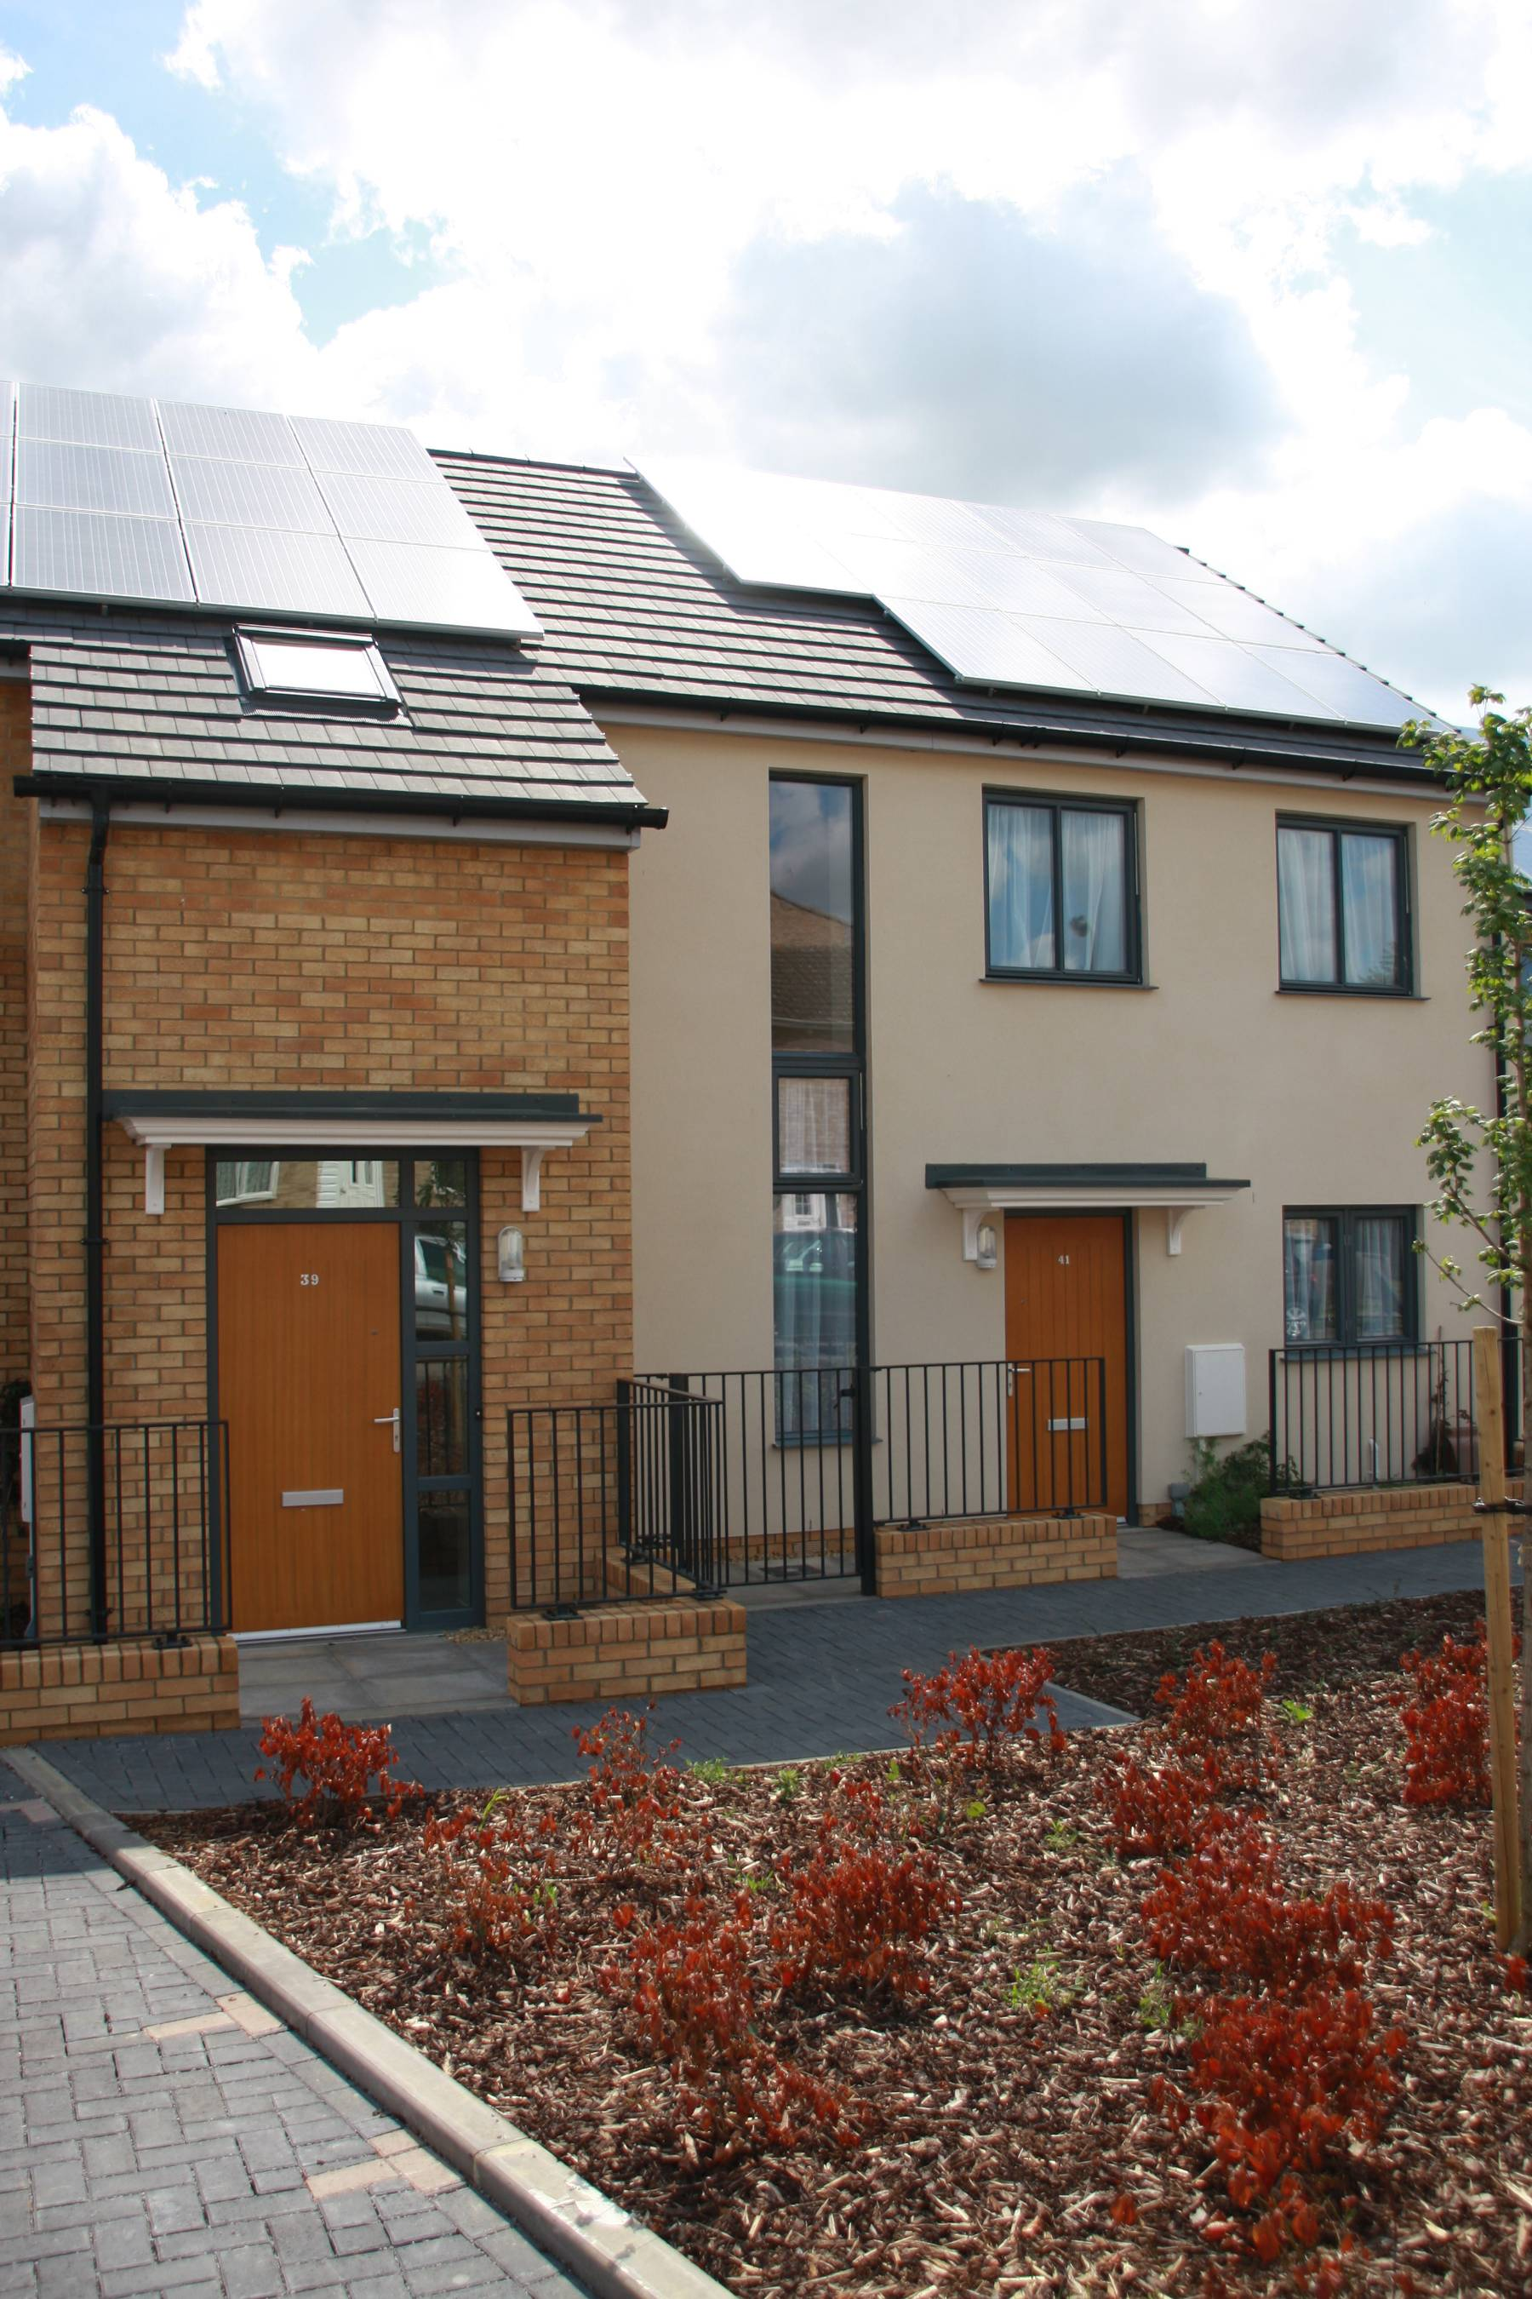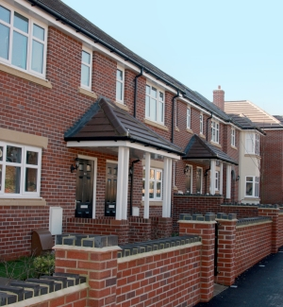
Whiteford Drive, Kettering – asra housing (CSH 5, and Green Apple Award)
Tresham, St Marys Road, Kettering – Waterloo Housing

3.3 Appendix A shows that during 2006-11 we received the second highest amount of investment in the whole of the East Midlands from the Homes and Communities Agency (HCA). During the same period we delivered the fourth highest number of grant funded homes in the East Midlands (Appendix B). These are great achievements and something that the Council can take pride in.
.
3.4 As can be seen from Table 1 below, affordable housing supply has contributed greatly to overall housing supply in the Borough over the last seven years. A significant amount of our affordable housing supply has historically been grant-funded but this type of scheme has slowed over recent years as resources for the HCA’s Affordable Rent Programme have been reduced.
 | Market | Social Rent | Shared Ownership | Other Intermediate e.g. shared equity, homebuy etc | Affordable Rent | Total Affordable | Total Affordable via s106 | Affordable as % of total completions
2006/07 | 360 | 91 | 119 | 2 |  | 212 | 74 (34%) | 37%
2007/08 | 569 | 66 | 49 | 1 |  | 116 | 84 (72%) | 17%
2008/09 | 179 | 145 | 93 | 5 |  | 243 | 58 (24%) | 58%
2009/10 | 235 | 96 | 10 | 54 |  | 160 | 39 (24%) | 41%
2010/11 | 253 | 159 | 46 | 15 |  | 220 | 2 (1%) | 46%
2011/12 | 226 | 55 | 29 | 3 |  | 87 | 2 (2%) | 28%
2012/13 | 199 | 85 | 58 | 13 | 9 | 165 | 40 (24%) | 45%
2013/14 | 440 | 34 | 21 | 0 | 45 | 100 | 25 (25%) | 23%

Table 1: Kettering Borough Housing Supply by Tenure 2006/7 to 2013/14

4. OUR TRADITIONAL APPROACH AND THE NEED FOR CHANGE

4.1 The Council’s long-term strategic approach to the development of new affordable housing in the borough is set out in the Council’s Sustainable Place Making Corporate Priorities (ref: 1D2).

4.2 Working with housing associations to build new homes

4.2.1 As part of our strategic housing function, the Council has traditionally worked with housing associations and private developers to develop new affordable housing which meets the needs of local people.

4.2.2 Many of the homes being delivered by housing associations are now at affordable rents, which generally equates to 80% of market rents. In some areas of the Borough this works well as rents are at a similar or sometimes lower level to social rent. However, in other areas, affordable rents can be considerably higher and unaffordable for local households, particularly those in receipt of benefits. In recent discussions with one housing association, the rents proposed for two bedroom houses on a new development would effectively mean a shortfall in housing benefit of £68 per month for some of our eligible applicants. There is therefore a clear need to find other ways of delivering social rented housing that is more affordable for our residents.

4.2.3 Most of our affordable housing delivery over the past eight years has been subsidised with grant funding from the HCA. In a time of austerity, we recognise that grant levels for new affordable homes have reduced, and providers will need to look at different funding models, including options such as institutional investment in private rentals, which can also cross-subsidise affordable homes.

4.2.4 We have seen a significant reduction in the amount of housing association interest in developing directly in the Borough and the level of grant funding committed has dropped. In the latest Affordable Homes Programme 2015 -2018, only one partner has received an initial allocation of £1.28m to deliver 48 affordable homes within the Borough.

4.2.5 Over the last couple of years, more and more housing associations have looked to allocate directly to their own homes as opposed to accepting nominations from local authorities. One housing association is currently proposing a revised nominations agreement allowing just 75% of nominations to the Council as opposed to the current 95%. This is a trend that we are keeping under review as it could have an adverse impact on the number of households on our housing register.

4.3 Planning gain and affordable housing supply

4.3.1 Kettering has and continues to secure affordable housing on larger private led schemes as part of Section 106 agreements. Many of these developments are on the edges of our towns and not necessarily in the locations where affordable housing is needed. Homes delivered via Section 106 are often built to a lower standard and are considerably smaller in size in comparison to grant-funded schemes.

4.3.2 The Government has also restricted the scope of Section 106 agreements by encouraging or requiring their renegotiation to address viability concerns and by making certain types of schemes (e.g. those of less than ten units) ineligible. There are significant risks therefore in relying too much on planning policies to achieve housing supply.

5. A NEW APPROACH FOR A CHANGING HOUSING MARKET

5.1 In order to respond effectively to the challenges posed by Kettering’s changing housing market we need to help develop new homes which meet local needs and to take action to ensure the long term viability of the Council’s existing housing stock.

5.2 Whilst in our enabling role we will continue to work with housing associations to build and provide new homes, this is unlikely to be enough to satisfy demand and there is a need to explore other options. Our suggested approach to meeting local housing needs has four key aspects:

i) Continuing to work with housing associations

5.3 We wish to continue working with housing association partners. Our past track record on delivery with them has been successful but due to the changes outlined above there is a need to widen our options for delivery. Housing associations will still have a significant role to play on Section 106 developments and intermediate tenures. At East Kettering, it is anticipated that 20% of the new homes will be developed by housing associations.

ii) Acquisitions

5.4 Acquisitions can deliver a fairly quick supply of new affordable homes. These could be ‘off the shelf’ acquisitions to assist with stalled sites or sites where there is no housing association appetite to develop Section 106 affordable homes or street purchases in areas where there are high levels of housing need.

5.5 Acquisition and leasing of long term empty private sector properties has two-fold benefits – tacking a problematic empty property and providing an affordable home. This approach builds upon our existing programme funded under the HCA Empty Homes Round 2 allocation where we have so far acquired four properties for the Council’s housing stock.

5.6 We are currently considering our use of retained Right to Buy receipts for one-for-one replacement affordable homes as per our agreement with DCLG. Discussions are taking place with a housing association partner to acquire six ‘street’ properties over the next year to ensure that receipts are used within the timeframe set by DCLG.

iii) Homes for the Future and Hidden Homes

5.7 As the supply of new affordable homes built by housing associations continues to reduce, we have been working on how to make better use of our own stock. In particular, we want to ensure that the council housing stock continues to provide homes where families aspire to live.

5.8 Our ‘Homes for the Future’ project is a long term programme that will focus on refurbishing the 30% of council properties in Kettering that were built before 1945. Although these properties have been modernised over the past thirty years, they now require additional substantial investment to ensure that older council housing continues to be viable, easy to let and contributes positively to the Housing Revenue Account.

5.9 The Hidden Homes project involves the conversion of existing council-owned premises to provide new homes; a recent example is the conversion of a sheltered scheme warden’s house. We will look at the conversion of further properties into smaller dwellings and conversion of non-residential accommodation into residential to increase the overall housing stock numbers.

5.10 Further information on these initiatives will be contained in a report for the November meeting of the Executive Committee on the Housing Strategy strategic aim: Decent, Safe and Healthy Homes.

iv) Considering Building New Council Housing

5.11 There is an ongoing requirement for more affordable housing in the Borough. As traditional sources of affordable rented housing such as housing associations make less of a contribution towards meeting local housing needs, there is a clear need to consider other options such as building new council housing. The freedoms provided by the HRA self-financing regime, which was introduced in 2012, now make it a realistic prospect for local authorities to consider building new homes, and many are now doing so as the financial projections within their Business Plans allow.

5.12 The new self-financing system does provide some funding headroom and flexibility over the medium term to consider this option more fully. Kettering’s initial HRA Business Plan indicated that in the period 5 – 10 years there would be flexibility to consider this option. The Business Plan is currently being refreshed and the timings may also now be more flexible.

5.13 If the Council wishes to seriously consider developing new council housing, the following are relevant considerations:

- The Council will be better able to meet emerging needs resulting from Kettering’s changing housing market and to alleviate the mismatch between supply and demand. There is a pressing need for homes for single people, childless couples, elderly and disabled people
- It will generate additional rental income for the HRA that can be invested in better services for tenants and maintenance of the existing stock.
- New affordable housing will attract additional New Homes Bonus.
- An increased supply of affordable housing will reduce pressures on the General Fund arising from the use of temporary accommodation for homeless families.
- The average age of the Council’s housing stock is 57 years. The development of new housing will help to achieve a more balanced age profile and ensure the viability of the housing stock over the long term
- The Council will be less reliant on housing associations; many of which are increasingly reluctant to accept households nominated by local authorities.
- The Council will be able to mitigate stock losses through the Right to Buy.
- Building new council homes would help to enhance the council house ‘brand’, enhancing the appearance of residential neighbourhoods and building on the success of Homes for the Future programme.
- Local people and businesses will benefit from the economic activity generated by a new build programme.

5.14 In delivering a supply of new homes, it is proposed that our strategic aims would be to:

- create homes which enhance existing communities and improve the Council’s ‘housing brand’ – much like the Homes for the Future programme;
- meet the growing need from single people and couples who now account for 60% of all applicants on the Keyways register (a need for smaller homes not readily delivered by the private sector);
- provide homes that are suitable for older and disabled tenants who are looking to downsize.

6. THE WAY AHEAD

6.1 If there are merits in the Council building new homes, there are also significant risks which need to be identified and mitigated. As a first step, the Council would need to have in place staff who can act as strong clients and skilled commissioners of construction works. Resources would also be required for specialist consultancy services. A successful new build programme would require a strong pipeline of new sites which are suitable for affordable housing. To address this at the appropriate time, the Council would need to undertake a feasibility study of potential sites within the Council’s ownership in order to evaluate their financial viability and identify any site-specific risks. It is likely that such sites would mainly comprise under-utilised garage sites.

6.2 Following the feasibility study, a Housing Development Strategy would need to be prepared. This would identify specific sites with estimated costs, programmes and site-specific issues. .Although forming part of the HRA Business Plan, the Development Strategy would also consider the merits and limitations of building outside the HRA. Such a document would need to come back to Committee for formal consideration at the appropriate time.

6.3 It makes sense to do some detailed preparatory work (subject to the Committee endorsing this report) so that the Council is in a position to consider seriously moving forward with this option in a timely manner.

7. POLICY IMPLICATIONS

7.1 The Government is currently undertaking a review into the role that local authorities can play in housing supply. The aim of the review is to:

- explore the role that local authorities could play in increasing the supply of housing;
- consider whether councils are playing a proactive role in building new homes for local people;
- examine how they are using their new freedoms under Housing Revenue Account self-financing to increase house building.

8. CONSULTATION AND CUSTOMER IMPACT

8.1 Once suitable sites for development have been provisionally identified, it will be necessary to consult ward members, local residents and the Tenants Forum.

9. FINANCIAL RESOURCE IMPLICATIONS

9.1 There will be significant implications for the Housing Revenue Account, and possibly for the General Fund, should the Council ultimately proceed with a new build council housing programme. These will be set out in detail as part of the Housing Development Strategy.

9.2 In the meantime, resources will be required for the initial site feasibility study which will include detailed soil investigation surveys for some sites. It is estimated that a budget of £70,000 will be required. This can be met from existing capital resources contained within the Social Housing Grant and the Hidden Homes capital budgets.

9.3 New affordable housing provision attracts additional New Homes Bonus

10 HR IMPLICATIONS

10.1 This work can be resourced within the Housing Strategy and Development team.

11 LEGAL IMPLICATIONS

11.1 Legal resources will be required to undertake title investigations of identified sites as well as various associated searches.

12. RECOMMENDATION
The Executive Committee is asked to endorse the strategy for increasing the supply of affordable homes, as set out in this report

Background Papers: Previous Reports/Minutes:
Date: N/A Date: N/A
Contact Officer: Katie Prati Ref:
APPENDIX A

Investment in the East Midlands 2006-11 (source: HCA)
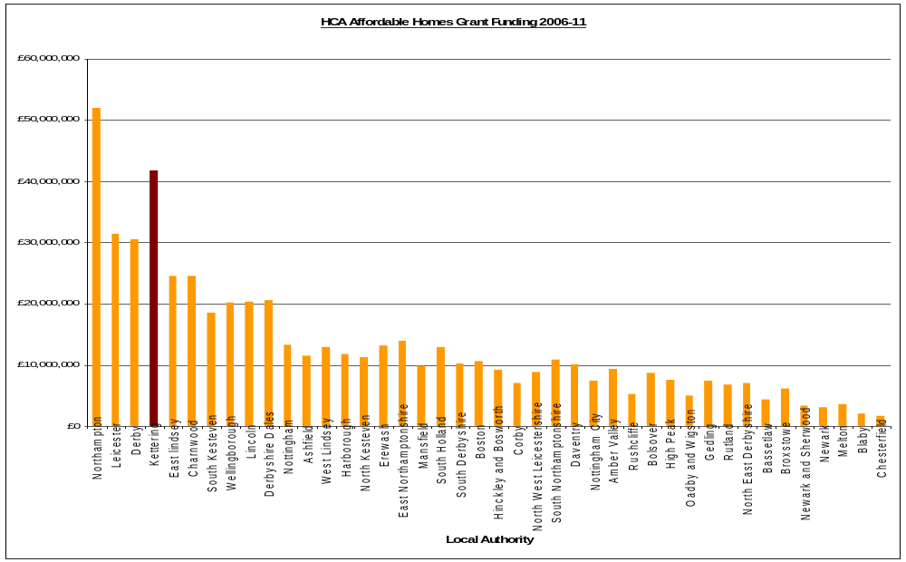
APPENDIX B

Number of grant funded new homes delivered in East Midlands 2006-11 (source: HCA)


