North Northamptonshire Joint Core Strategy Review
Briefing Note: June 2014

Introduction

The purpose of this note is to update members on the review of the Joint Core Strategy (JCS) and to outline how they can have an input before the plan is finalised. Further updates will be provided as work progresses.

The JCS sets out the strategic elements of the Local Plans in North Northamptonshire, including housing and employment requirements, infrastructure priorities and proposals for improving the environment. It provides the context for the plans prepared by the partner councils and also for neighbourhood plans.

The JCS is prepared by the North Northamptonshire Joint Committee, set up by the Secretary of State in 2005. This is made up of three members from each of the councils. The current membership is shown below.
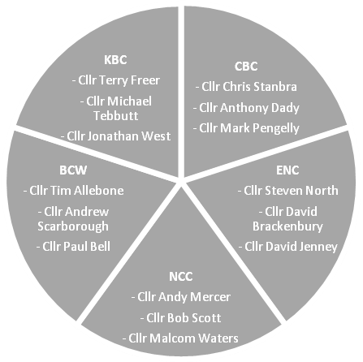

The Joint Committee is supported by a small team of officers at the Joint Planning Unit (JPU) based in Thrapston (contact details are provided at the end of this update). The work of the JPU is managed through a Steering Group of the Chief Planning Officers from the councils. As well as preparing joint plans, the JPU supports the councils with urban design advice and technical work. This well-established partnership working meets the statutory ‘duty to cooperate’ and makes efficient use of resources.

Completing the Joint Core Strategy

The Joint Committee consulted on an outline of the emerging plan in 2012 and on proposed strategic sites in 2013. The agreed structure of the plan is as follows:

Section
Introduction
Vision and Outcomes
Key Diagram
Core Policies
- Protecting and enhancing assets (Policies 1-7)
- Ensuring High Quality Development (Policies 8 – 10)
Spatial Strategy
- The Network of Urban and Rural Areas (Policies 11 – 14)
- Connections within and beyond North Northamptonshire (Policies 15 – 18)
- The Green and Blue Infrastructure Framework (Policies 19 - 21)
- Delivering Economic Prosperity (Policies 22 – 27)
- Delivering Homes (Policies 28 – 31)
- Delivering Infrastructure and Services (Policy 32)
Development Principles for Strategic Sites
Monitoring & Review

The next steps involve completing the draft plan, considering the findings of sustainability and viability appraisals and carrying out consultation on a ‘Pre-Submission Plan’. The Joint Committee will then submit the plan for examination by an independent Inspector appointed by the Secretary of State. The Inspector will make binding recommendations about any changes needed to make the plan ‘sound’ before it is adopted by the Joint Committee.

Work on the plan has been held up awaiting the Secretary of State’s decision on the Rushden Lakes retail and leisure proposal. This decision has been delayed several times. The latest Joint Committee timetable, set out below, assumes that the Rushden Lakes decision is issued at the end of May/ early June and that the councils all agree to completing the plan on the basis of that decision. Dates from submission onwards will depend on the complexity of the examination and the Planning Inspector’s approach.

Joint Committee Dates | Committee business
1st May | To agree draft development management policies for inclusion in the JCS
24th July | To consider implications of the Rushden Lakes decision and to endorse sections of JCS that are not impacted
4th September | To endorse further sections of the JCS and supporting evidence base
2nd October | To consider Pre-Submission JCS and associated appraisals
October-November | Consultation on the Pre-Submission JCS
January 2015 | To consider the consultation response and to agree to submit the JCS for examination
April 2015- September 2015 | Examination in Public including consultation on modifications
October 2015 | JPC to consider Inspector’s Report and adopt the new JCS

Whilst the delays to the JCS timetable are frustrating, they have allowed the JPU to take account of new evidence published by external agencies, and guidance including the National Planning Practice Guidance. Furthermore, the Inspector’s report on the West Northamptonshire JCS should be available in late summer, allowing the Joint Committee to take it into account in finalising the JCS. This should help to ensure that the JCS is robust and sound when it comes to examination.

Opportunities to input into the JCS

The Joint Committee consults the councils at all formal stages in preparing the JCS and additional input is sought to help with key strategic decisions such as housing and employment requirements and important local issues such as strategic sites. Briefings will be arranged for the partner councils as the plan nears completion. It is important to note that elected members are welcome to feed in views on any matters being discussed by the Joint Committee. This can be done through the council’s representatives on the Joint Planning Committee, through the Chief Planners and Policy Managers, or directly to the JPU. Please contact the JPU at info@nnjpu.org.uk if you would like any further information on the JCS or to be notified when agenda papers for the Joint Committee are available.

The JPU and officers from the partner councils are currently refining the protecting assets policies to take into account feedback from the Joint Committee and agencies including English Heritage, Natural England, the Environment Agency, Anglian Water and the Wildlife Trust. The draft policies are available for comment here (policies are at Item 5 appendix 2).

Please contact Andrew Longley or Simon James at the JPU if you have queries on this briefing note or would like to discuss any aspect of the Joint Core Strategy.

andrewlongley@nnjpu.org.uk telephone 01832 742359
simonjames@nnjpu.org.uk telephone 01832 742361

