To all Members | Direct Line: (01536) 534398  Email: anneireson@kettering.gov.uk  Our Ref: AI  Your Ref:  Date: 6th December 2011

Dear Councillor

You are summoned to a Special Meeting of Kettering Borough Council to grant the Freedom of the Borough of Kettering to the Royal Anglian Regiment. The meeting will be held in the Council Chamber, Municipal Offices, Bowling Green Road, Kettering on Wednesday, 14th December 2011 at 7.00 pm.

Yours faithfully

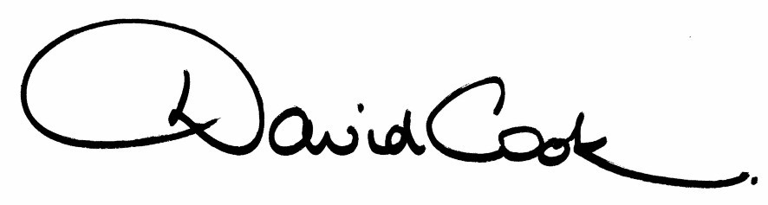
D Cook
Chief Executive

A G E N D A

1. The Salvation Army Band

2. The Mayor's Opening Remarks

3. Prayers – The Mayor's Chaplain

4. Apologies for Absence

5. Her Worship the Mayor will call for a Proposer to move the Resolution that:-

"the Council confers upon The Royal Anglian Regiment the Honorary Freedom of the Borough of Kettering, in recognition of the long and close association between the Borough and the Regiment and to record the confidence, trust and friendship existing between citizens of the Borough and the Regiment, the Council grants to The Royal Anglian Regiment and its successors the right, privilege, honour and distinction of marching through the streets of the Borough of Kettering on all ceremonial occasions with drums beating, bands playing, colours flying and bayonets fixed."

6. The Mayor will call for a Seconder to the Resolution.

7. The Mayor will put the Resolution to the vote.

8. The framed Scroll will be presented to Lt Col Ralph Wooddisse MBE, MC, who will accept it on behalf of the Royal Anglian Regiment.

9. Lt Col Ralph Wooddisse, MBE, MC, will respond on behalf of the Royal Anglian Regiment

10. Close the meeting.

Fire Alarm

All meetings shall be adjourned immediately on the sounding of the fire alarm. The alarm is a continuous two-tone siren. On hearing the alarm please leave the building by the nearest emergency exit. There are emergency exits at both ends of the corridor outside the meeting rooms. On leaving the building please cross the car park and assemble on the grassed area by the church. Do not attempt to drive out of the car park as this may impede the arrival of emergency vehicles. Please do not return to the building until you are told it is safe to do so by a Council employee.

Toilets

There are toilets in the corridor off the main entrance to the building you came through to get to the meeting room.

Breastfeeding and Baby Changing Facilities

The Council actively supports breastfeeding mothers. If you wish to use a private area please ask a member of staff. There are baby changing facilities in the corridor off the main entrance adjacent to the toilets.

.Access for Disabled People

There are allocated parking bays outside the main entrance to the Municipal Offices for disabled people. The meeting rooms are located on the ground floor and access is gained for wheelchair users via the main entrance. If you require assistance, please ask the attendant on duty in the reception area.

No Smoking

Smoking is not permitted in the Municipal Offices.

Private and Confidential Items

The press and members of the public can be excluded from business of the meeting on the grounds that it involves items of business which include the likely disclosure of exempt information as defined by Paragraphs 1-7 of the Local Government (Access to Information) (Variation) Order 2006 in respect of Schedule 12A to the Local Government Act 1972. The reason for discussing the issue in private is indicated on the Order of Business.

